CURICULUM VITAE
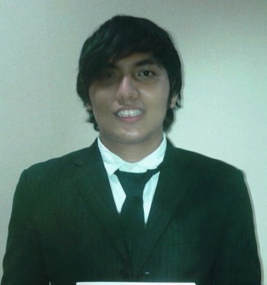

Full Name : Steven Dehard Evans
Date of Birth : Solok, May 11, 1994
Address : Gg Masjid Al-Islah Rt 004/003 No.48
Cisalak, Depok, West Java
Gender : Male
Religion : Muslim
Marital Status : Single
Nationality Citizenship : Indonesia
Mobile Phone Number : 085694126545
Email : stevendehard@gmail,com

Education

- Formal:
  - Cisalak III Elementary School, Depok 1999-2004
  - Pekayon 012 Elementary School , East Jakarta 2004-2005
  - 91 Junior Highschool, East Jakarta, 2005-2008
  - 99 Senior Highschool, East Jakarta, 2008-2011
  - Akademi Pimpinan Perusahaan, International Trade major, 2011– 2014
  - Universitas Mercubuana, Management major, 2015 - Present

- Non Formal:
  - Achievement Motivation Training on Akademi Pimpinan Perusahaan 2011.
  - Forum Orientasi Pengenalan Mahasiswa (FOPMA) APP 2011
  - Cadre Recruitment exercises I Himpunan Mahasiswa Islam (HMI) APP 2011
  - Seminar Industri Nasional Musyawarah Nasional XIV Forum Lembaga Mahasiswa Perindustrian Indonesia di Akademi Pimpinan Perusahaan 2012.
  - Seminar Nasional “Pengaruh Ekonomi Terhadap Perdagangan International” di Akademi Pimpinan Perusahaan 2012.
  - International Trade Group Discussion APP 2013
  - Creation Of Enterprises Through Formation Of Entrepreneurs on Akademi Pimpinan Perusahaan 2013.
  - International Trade Major Seminar on Akademi Pimpinan Perusahaan 2013
  - Business Game exercises on Akademi Pimpinan Perusahaan 2013
  - Export Certification from PPEI &BNSP as an export supervisor assistant

- Organization Experience :

  - Sanggar Seni Remaja (Music) SMAN 99 Jakarta
  - Founders Oozora Nihongo kyokai SMAN 99 Jakarta
  - Ketua Angkatan HMI APP 2011
  - Organizing Comitee Musyawarah Komisariat HMI APP 2011
  - Organizing Comitee Konfrensi APP 2011
  - Organizing Comitee Forum Orientasi Pengenalan Mahasiswa (FOPMA) APP 2012/2013 dan 2013/2014
  - Organizing Comitee International Trade Gathering Friends 2012
  - Organizing Comitee Pelatihan Senat Mahasiswa Perdagangan Internasional APP 2013
  - Human Resources Division Studio Wirausaha Agroindustry (SWA) APP 2013

- Qualification:

  - Operating Ms Office
  - Sketch Drawing
  - Have an export certificate from BNSP as an export supervisor assistant
  - Martial Arts
  - Active and passive english

OTHERS
Sports : Football, Basketball

Interests : Music&Guitar,Sketch drawing, Organizing event

STRONG POINT : Hard working, consistent, creative, conceptor

I declare the details stated to be true and complete

Steven Dehard Evans

Jakarta,

Attention to : Human Resources Department
Subject : Application

Dear Sir/Madam

Refferring to your information, I herewith would like to apply at your company. I am a male, energetic, young, and a fresh graduate from reputable university. I enclose herewith my curriculum vitae for your kind persual. I am available for the interview at anytime convenient to you.

I’m looking forward to hearing good news from you.

Best Regards.

Steven Dehard Evans

