CURRICULUM VITAE

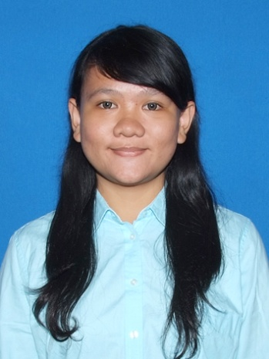

**Personal Identities**

Name : Novaulina Thresiana S.

Gender : Female

Marital Status : Single

Place of Birth : Medan

Date of Birth : November, 17th 1995

Weight / Height : 55kgs / 160cms

Address : Jalan L No. 5 RT.003 RW.011

Kec. Tebet Kel. Kebun Baru, Jakarta Selatan

Phone / Mobile :083878517425

E-mail address : novatheresiana@gmail.com

**Formal Education**

2013–Now (active student): Trisakti University

2010 – 2013 : SMA Negeri 55 Jakarta

2007 – 2010 : SMP Tarakanita

2001 – 2007 : SD Strada Tunas Harapan

2010 – 2011 : Secretary in Student Council of SMAN 55 Jakarta

2011 – 2012 : Secretary in Christian Student Organization of SMAN 55 Jakarta

2011 – 2012 : Secretary in Students’ Choir of SMAN 55 Jakarta

**Organizational Experiences**

**Achievements**

English Debate participant in Departemen Pendidikan dan Kebudayaan “Debate Competition” 2012

1st place of Tarakanita Story Telling Competition 2010

2nd place of Suku Dinas Pendidikan dan Kebudayaan Kabupaten Tangerang “Speech Competition” 2011

Singing

Reading

Writing

**Hobbies**

Language : Fluent English (written and oral)

Computer Literate : Ms. Word, Ms. Excel, Ms. Power Point, etc

**Skills**