CURRICULUM VITAE
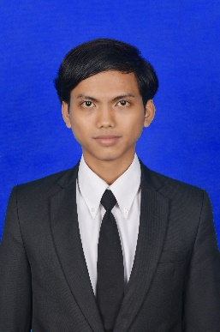

Suwanda
Place, Date of Birth: Tasikmalaya, February 25th 1995 • Sex : Male
• Email: suwannda@gmail.com • Mobile: +628111452502
• Address: Kalianyar II Street RT.14/01 No.24 11310 Jkt Barat
• LinkedIn : id.linkedin.com/in/suwannda/

Personal statement
Web Design specialist with understanding both graphic design and computer programming. Creates the look, layout, features, maintenance and addition of a website.

Core competencies include:
• Databases • Webpage scripting • Programming • Web development

Education
Bachelor of Science in Computer Science, Informatics – Mercu Buana University
Graduated soon on 12 April 2017 • GPA 3.69

Work Experience
July – August 2016 as Technical Writer at PT. Sigma Cipta Cakara (Telkomsigma)
• Determine the needs of end users of technical documentation
• Use photographs, drawings, diagrams, animation, and charts that increase users’ understanding
• Revise documents as new issues arise

February – March 2017 as IT Consultant at PT. Agro Boga Utama
• Designing, testing, installing and monitoring new systems of Agro Boga Utama’s websales using Laravel Framework.

Organization
2015 – 2016 as Vice Chairman of Student Associations of Informatics Major
• Handle many work program that involves all elements of informatics such as students, seniors, and lecturers

Proffessional Skills
• Windows 7, Windows 8, Windows 8.1, Windows 10
• Microsoft Office Word, Excel, Power Point, Access
• Adobe Photoshop, Adobe Illustrator
• Laravel, HTML, CSS, PHP, Java, JavaScript, Visual Basic
• Google Analytics including Adsense

