PORTOFOLIO

- HERB SPORT FASHION (http://herbsportfashion.com) / Onlineshop
- Create website ecommerce (adding plugin woocommerce and shipping jne Indonesia)
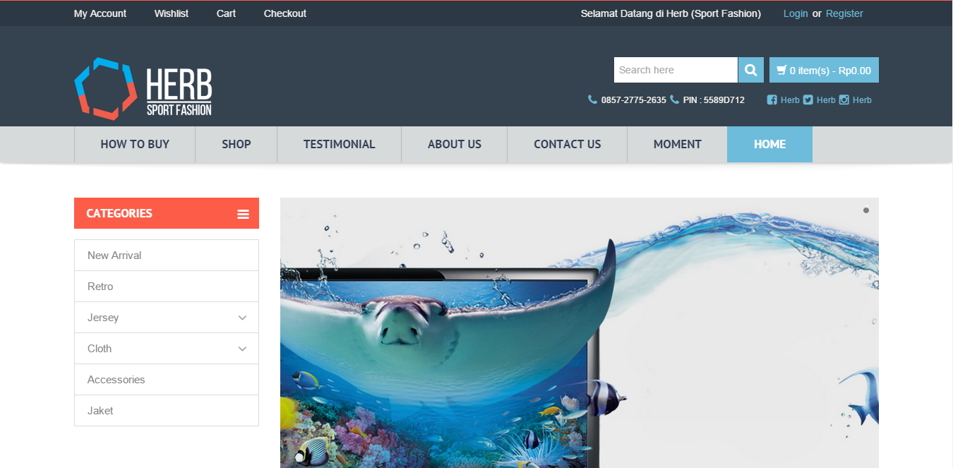

- AQUIVA GALLERY (http://aquivagallery.com) / Company website and ecommerce
- Modified/Maintenance website
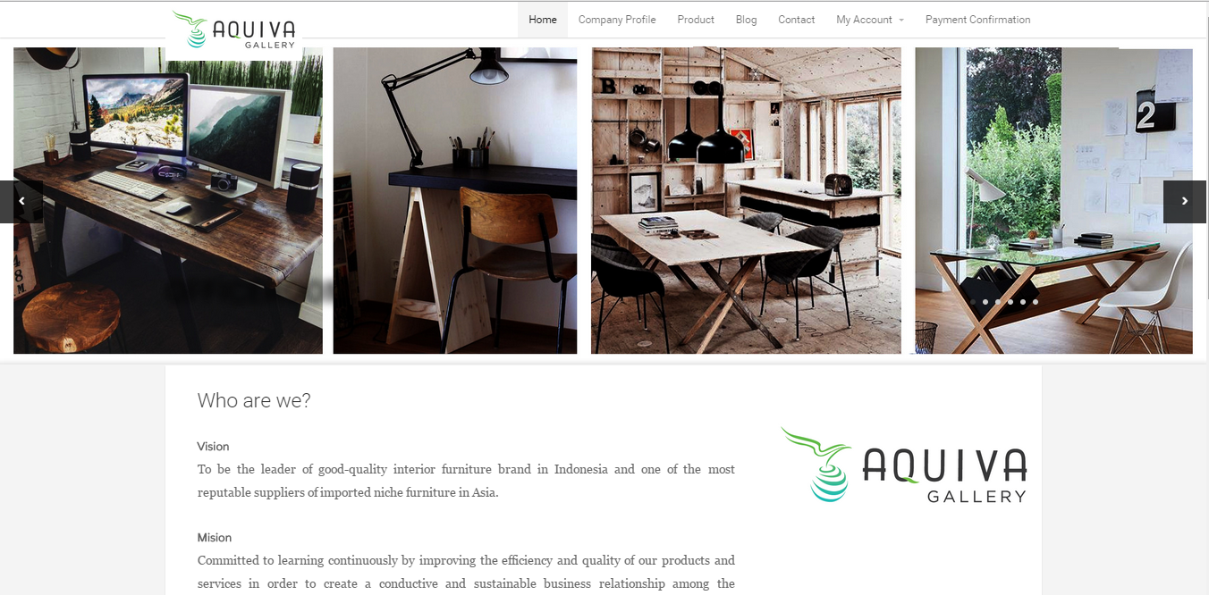

- INDONESIA MURAL ART (http://indonesiamural.com) / Company Profile
- Modified/Maintencane website
- Optimizing website and SEO
