**CURRICULUM VITAE**

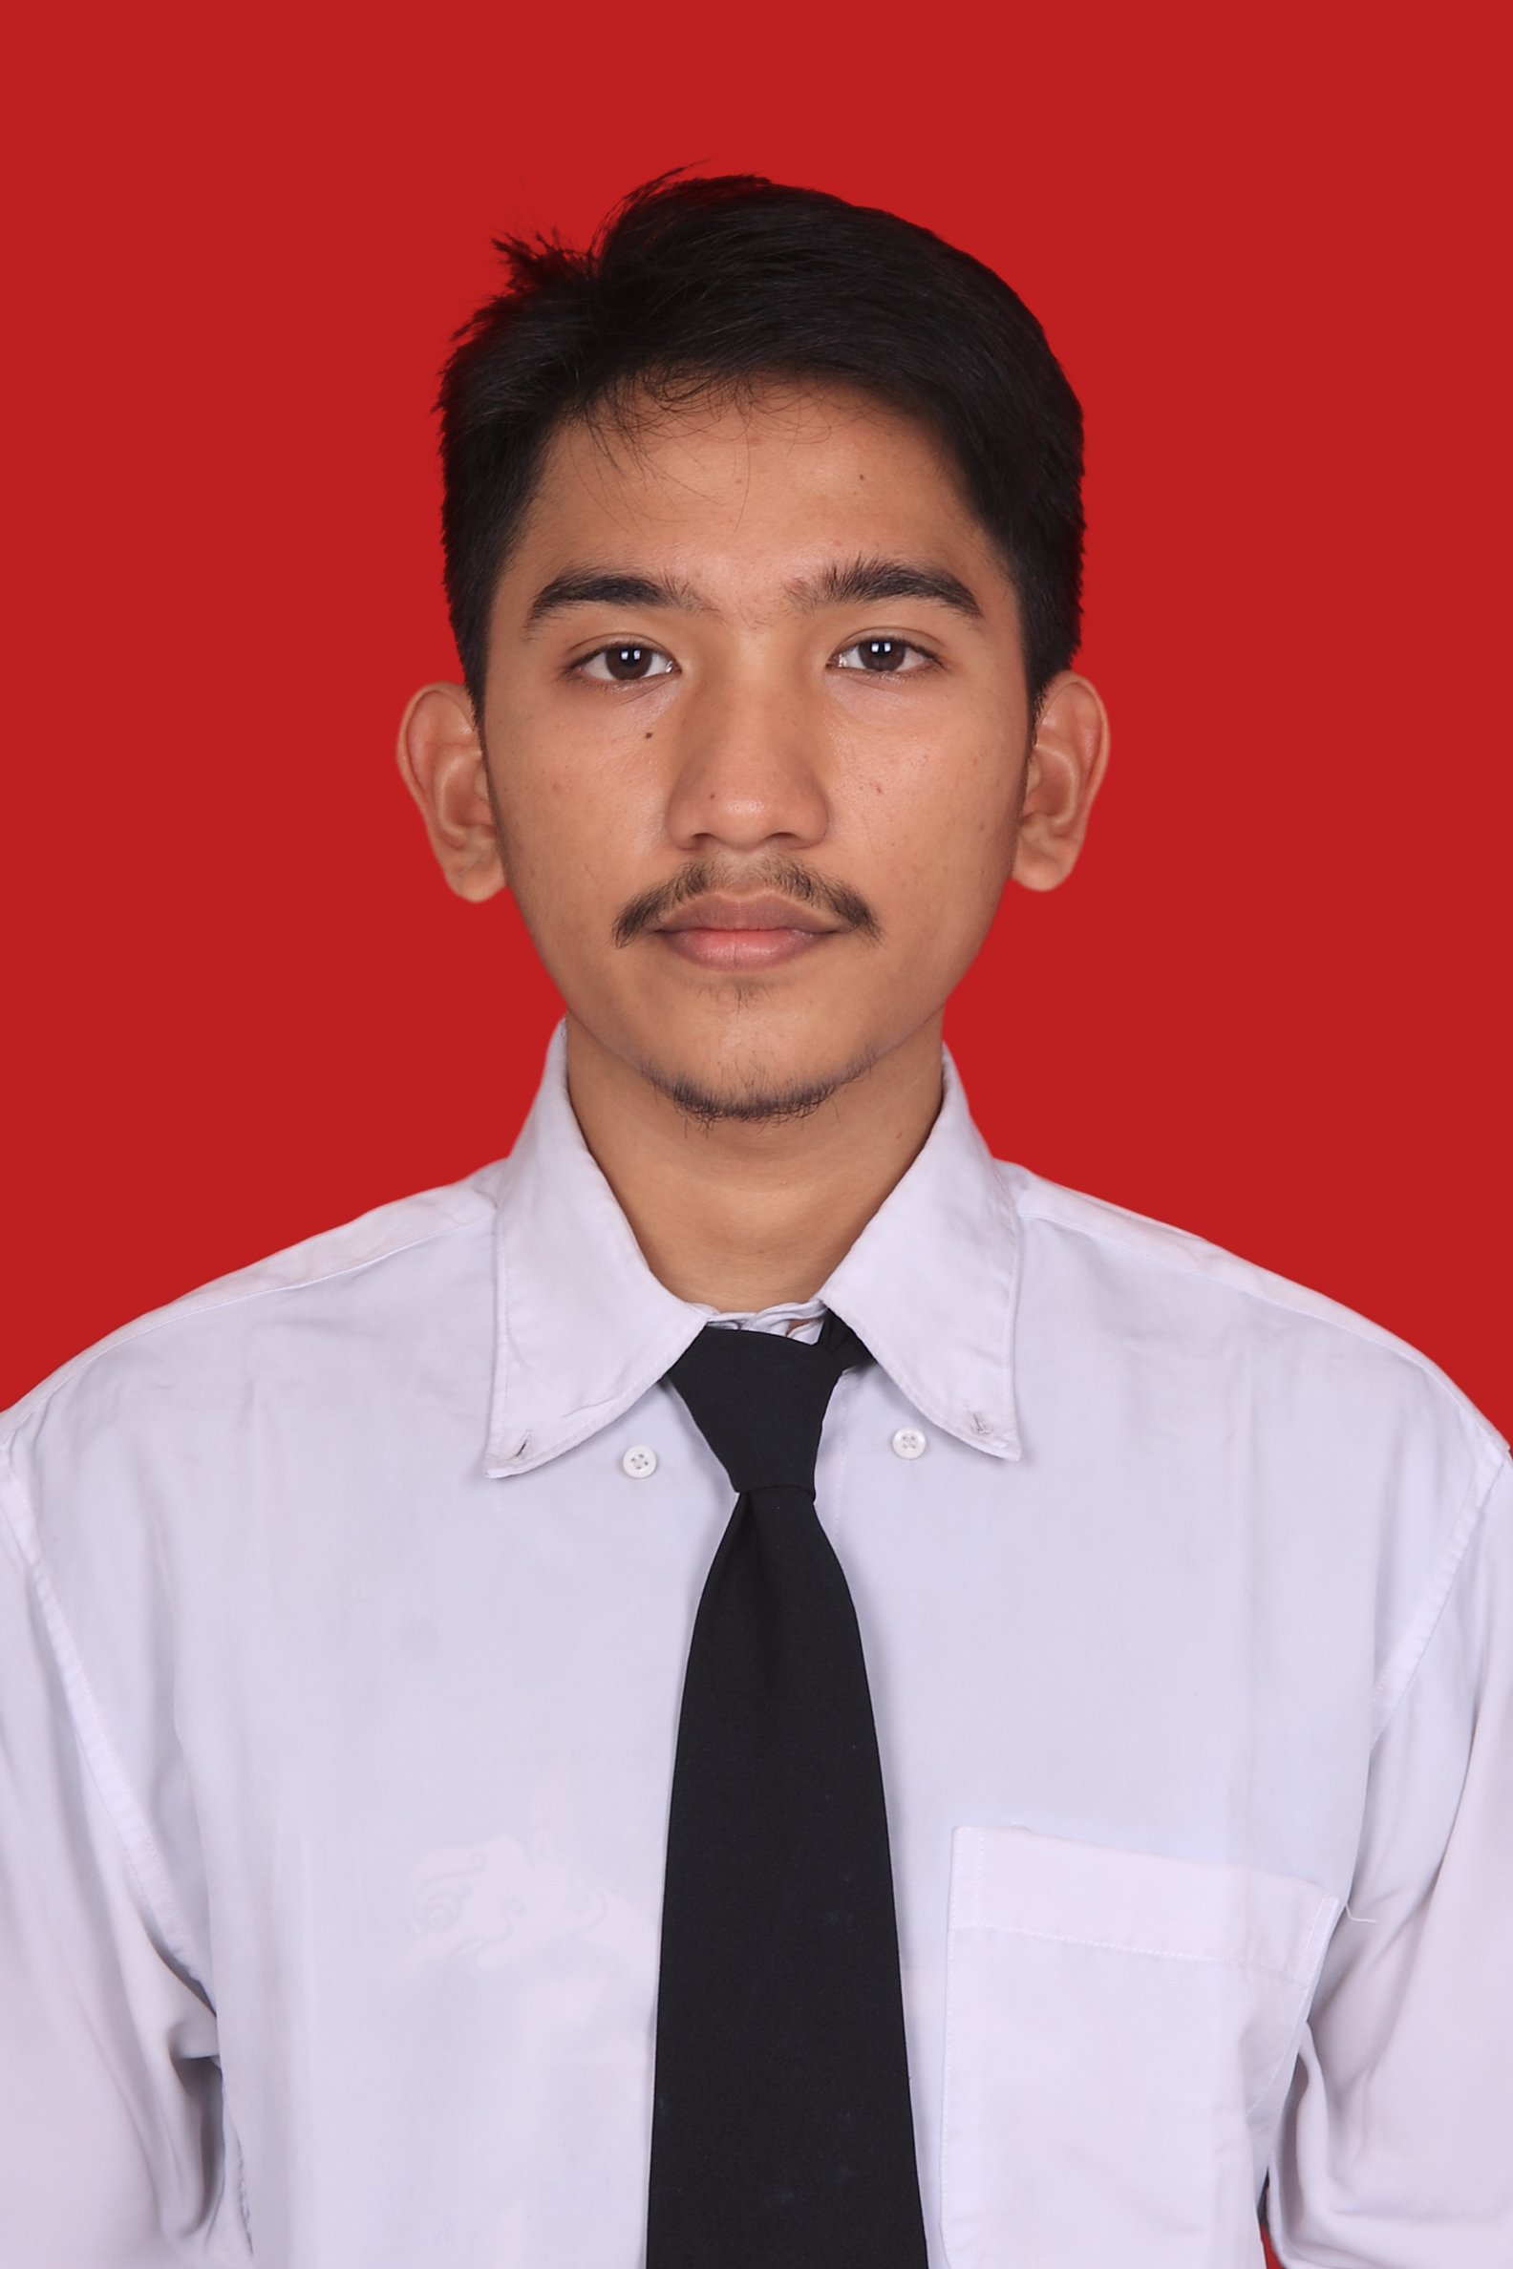

Education

Muhammad Widy Ramadhani

Mataram, NTB/ February 5th, 1996

Male/Single

Jalan Raya Cilegon Perumahan Bumi Serang Damai blok C1

no 8 , desa drangong, kecamatan taktakan, Serang-Banten

dan Pandega Duksina no 2 RT 1, RW 1 Catur Tunggal, Depok, Sleman, Yogyakarta

+6282220056883

muhammad.widy.r@gmail.com

Indonesia

Personal Identity

TK Negeri Pembina Mataram 2000-2001

SDN 07 Mataram 2001-2004

SD Sumbangsih Grogol, Jakarta 2004-2007

SMP Sumbangsih 2 Grogol, Jakarta 2007-2008

SMP 1 Negeri Kota Serang, Banten 2008-2010

SMA 1 Negeri Kota Serang, Banten (IPA) 2010-2013

University of Gadjah Mada, Faculty of MIPA Under Graduate

Major of Computer Science and Electronics

TOEFL SCORE : 525

1. Loyal, Trustworthy, Honest, Good Communication, Team Player, Takes Initiative, Fair, Determined, and Ambitious
2. Able to operate Microcontroller such as Nuvoton
3. Able to operate basic and advance use of Arduino platform
4. Able and usual to operate internet and computer (Microsoft Office, and other application)

Hobbies : Photograph, Reading, Listening to the music, Adventure, Translating document, and watching movie.

Sports : Basket ball, Martial Arts and swimming

Motto : “*Hard work beats Talent, when Talent doesn’t work hard*”

Self Competences

Organization Experiences

Entrepreneurial Divison Head of JAWARAGAMA BANTEN University of Gadjah Mada (2013-2015)

Member of HMEI University of Gadjah Mada (Students Association) (2013)

Comittee for seminar ELINSPHORIA and Overclocking (2014)

MC for seminar EBOTEC (2014)

Comittee for seminar ELINSPHORIA and Overclocking (2015)

Ketua OSIS SMA Mardiyuana Serang, Banten (2012-2013)

Anggota organisasi CAPTURE UNIVERSITAS TELKOM (FOTOGRAPHY) (2013)

Ketua OSIS SMA Mardiyuana Serang, Banten (2012-2013)

Anggota organisasi CAPTURE UNIVERSITAS TELKOM (FOTOGRAPHY) (2013)

Ketua OSIS SMA Mardiyuana Serang, Banten (2012-2013)

Anggota organisasi CAPTURE UNIVERSITAS TELKOM (FOTOGRAPHY) (2013)

Ketua OSIS SMA Mardiyuana Serang, Banten (2012-2013)

Anggota organisasi CAPTURE UNIVERSITAS TELKOM (FOTOGRAPHY) (2013)

Ketua OSIS SMA Mardiyuana Serang, Banten (2012-2013)

Anggota organisasi CAPTURE UNIVERSITAS TELKOM (FOTOGRAPHY) (2013)

Work Experience

Seminar and Workshop

1. Participant for Seminar IDE “Trends in Artificial Intelligence”(2014)
2. Participant for Seminar Rakuten (2014)
3. Participant for Seminar Drone and Quadcopter ( 2014)
4. Participant for Solve for X Indonesia (2015)
5. Participant for Seminar IDE “Intelligence Everywhere” (2015)

Freelance :

1. Work as freelance in Sribulance.com
2. Work as translator in Translatorsbase.com

Internship :

1. Work as laboratory Assistant in FMIPA UGM