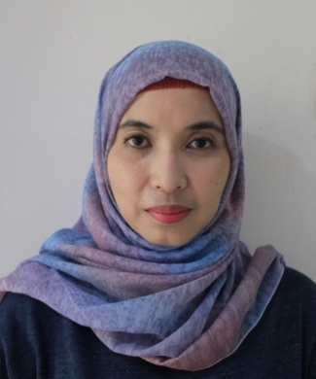
Desie Triaryani
Name : Desie Triaryani

Birth place, date : Jakarta, 9 December 1977

Address : Jalan Pualam IV no. 12 RT018/ RW02,
Sumur Batu, Central Jakarta 10640

Email : enji_77@yahoo.com

Telephone : +62-21-4260211

Mobile phone : +62-812-9004712/ +62-89699479669

Education :
1996–2002
Universitas Nasional, Jakarta, Indonesia
- Bachelor of Arts in Japanese Literature
- GPA 3.34

Experience :

2012 - July, 2016
PT. Nakakin Indonesia, Cikarang, West Java
Purchasing Officer
- Doing the buying process starting from request, quotation, preparation of administrative documents (PO) up to control the accuracy of the purchase with ERP System
- Negotiate price based on the market price analysis
- Handle local suppliers
- Control purchase reports preparations
- Support all departements to purchase requested material/ goods
- Ensure purchase spesification according to users demand and controlling delivery time.
- Organize and maintain all related records and documentations such as PO, quotation, etc.
- Conduct review and recap of purchase per month and the accuracy of the analysis based on the budget.
- Handle documents of Purchasing Dept. for ISO 9001 : 2008 and ISO 14001 : 2004

2011 – 2012
PT. Nakakin Indonesia, Cikarang, West Java
GA Officer
- Internal communications
- Official documents preparation for expatriat documents
- Documents logistics
- Assist task of HRD
- Transportation schedule coordinator

2005 – 2011
PT. Nakakin Indonesia, Cikarang, West Java
Marketing Officer
- Office documentation
- Prepare invoice
- Prepare quotation
- Set up meetings with clients and internal management
- Handle management’s requirements
- Document translation from Japanese to Indonesian vice versa
- Drivers payroll

2001 – 2005
PT. Nakakin Indonesia, Cikarang, West Java
Office Secretary
- Communication operator
- Management’s meal coordinator
- Assist director in general office preparations
- Translate document from Japanese to Indonesian vice versa
- Drivers payroll
- Stationery payroll

Language :

- Indonesian (native)
- English (fluent)
- Japanese (N3)

Interests :

- travelling
- culinary connoisseur
- office organization
- cultural diversity

