PERSONAL INFORMATION  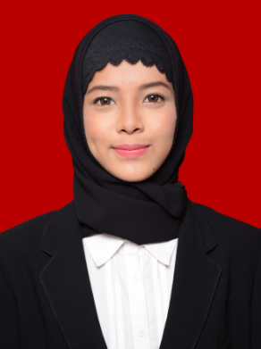 | Name : Clarinda Desvinia, S. Hub. Int  Gender : Female  Current address : Komplek Jatibening Estate, Jalan Merak V  Blok C4 No. 21, 17412, Bekasi.  Phone : +62 87878517818  Email : cdesvinia@gmail.com  Date/Place of Birth : December, 9th 1994, Jakarta, Indonesia  Marital Status : Single  Religion : Moslem
FORMAL EDUCATIONS | College  BINUS University, Bachelor of International Relations, Concentrate in Media. GPA : 2,96 (7th semester), expected graduation on December 2016.  Senior High School  SMAN 53 Jakarta | 2012-2016  2009-2012
SKILLS  PERSONALITY | - Operating Ms. Office  - Writing Article  - Operating Social Media  - English Fluency  - Make Up skill  I'm a hard worker, on time person, have an excellent time management, independent, quick learner, friendly, communicative, responsible person and goal oriented. I'm good in appearance and have a positive attitude. I like challenge anything and not afraid for something new. I have a full of spirit to pursue the goals in my life with a good strategic plan.
WORKING EXPERIENCES | - Internship as content writer in pegipegi (3 months)  - Volunteer in Mandiri Jakarta Marathon (certificate)  - First Aid Coordinator in Temu Keakraban HI Binus | 2016  2015  2014
ORGANIZATIONALS AND ACTIVITES  SEMINAR | - Participate in Ultima II Beauty Class  - Participate in TRESemmé The Runway  - Staff of Himpunan Mahasiswa Hubungan Internasional (HIMHI) Binus Univeristy.  - Participate in LKMM (Latihan Kepemimpinan Manajemen Mahasiswa) :  - LKMM DASAR Regulations  - LKMM DASAR Event Management  - LKMM DASAR Kesektariatan  - LKMM DASAR Cash Management  - LKMM PRA DASAR Communication Skill  - LKMM PRA DASAR Time Management  - Participate in Le Francais a Grande Vitese in Universitas Negeri Jakarta.  - Seminar “#2 Screening Project: Creativity Through The Screen”, Binus TV (certificate).  - Seminar “Road To Be Creative Technopreneur: Bring Your Idea Into Action” (certificate).  - Talkshow Binus IR Festival “Women as Object Transnational Marriage In Human Traficcking”. HIMHI Binus, (ceritificate).  - Seminar “Kerjasama Jurusan HI dan UNICEF”, (certificate).  - Seminar “Broadcast Knowledge B Voice Airlines”, Bvoice (certificate), | 2015  2015  2013-2014  2014  2014  2016  2015  2015  2013  2012

