CURRICULLUM VITAE
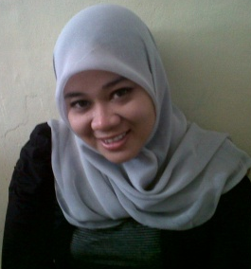
PERSONAL DETAILS
Full Name : Rian Yuliska
Place and Date of Birth : Banda Aceh, July 14th, 1989
University : Muhammadiyah Aceh University
Discipline : Architecture Engineering
Student number : 0703110430
Gender : Female
Marital Status : Single
Religion : Moslem
Nationality & Citizenship : Indonesian
Contact Address : Jl. Punge Blang Cut Lr. Keluarga I No. 52 B. Aceh
Permanent Address : Jl. Punge Blang Cut Lr. Keluarga I No. 52 B. Aceh
Phone : 085326651209
Email : rianyuliska@yahoo.com
Height : 160 cm
Weight : 65 kg
Nationality : Indonesian
Hobby : Sports (badminton, table tennis), travelling, watching, reading
Motto : Time is the success
FORMAL EDUCATION

1994-1995 TK Pancasila B. Aceh
1995-2001 Elementary School N 93 B. Aceh
2001-2004 Junior High School N 7 B. Aceh
2004-2007 Senior High School SMK N 2 B. Aceh
2007-2013 Muhammadiyah Aceh University

ADDITIONAL PROFESSIONAL ACTIVITY
WORKING EXPERIENCE
Appretince in Dinas Pekerjaan Umum Pengairan B. Aceh | 2006
Worked Satker BRR Aceh - Nias, in PU Pengairan Abdya | 2007
Freeline in CV. Penta Karya B. Aceh | 2009
Freeline in PT. Prima Perkasa Mandiri B. Aceh | 2010
Appretince in PT. PP PERSERO B. Aceh | 2011
Appretince in PT. Cipta Multi Kreasi B. Aceh | 2012
Worked in Yachiyo Engineering Co.LTD | Aug 2014

Language
English : Good
Indonesian : Excellent
Computer
Office Suite : Microsoft Office group (Word, Excel, Power Point)
Other Application : Internet, Autocad, Sketcup,3D Civil.

Personal Strength:
- Good communication skill, make a relationships with the others and active in speaking,
- Well physical strength to work at field,
- Patient and good emotion management, professional, and calm,
- High motivation.

I declare that all of the details stated is true

Rian Yuliska

