‍‍Curriculum Vitae
Personal Details
Name : Steffi
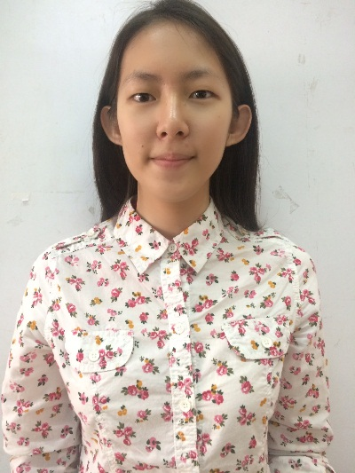
Address : JL. Taman Apel 8 no. 112 Tanjung Duren
Jakarta Barat 11470
JL. Merdeka no.99-101 Pematangsiantar
Sumatera Utara 21118
Gender : Female
Date of Birthday : 20 August 1995
Status : No Married
Nationality : Indonesia
Religion : Buddha
Phone : 089680237786
Email : steffiyang49@gmail.com
Education Information

Period | School / University
2002 - 2004 | $$TK Kristen Kalam Kudus Pematangsiantar$$
2004 - 2007 | $$SD Kristen Kalam Kudus Pematangsianatar$$
2007 - 2010 | $$SMP Kristen Kalam Kudus Pematangsiantar$$
2010 - 2013 | $$SMA Kristen Kalam Kudus Pematangsiantar$$
2013 - Now | $$Tarumanagara University, Bachelor \left(S1\right), Management$$
Experience
2013 : Modelling competation
2013 – 2014 : Member of Research and Development Department in Ikatan Mahasiswa Manajemen Tarumanagara (IMMANTA)
Oct 2014 : Coordinator of Secretary and Consumption Division in Simulasi Bursa Saham XVII
May 2015 : Staff of Event Organizer Division in Entrepreneur Talkshow
2014 – 2015 : Member of Research and Development Department in Ikatan Mahasiswa Manajemen Tarumanagara (IMMANTA)
May 2016 : Vice Coordinator of Secretary and Consumption Division in Entrepreneur Talkshow

