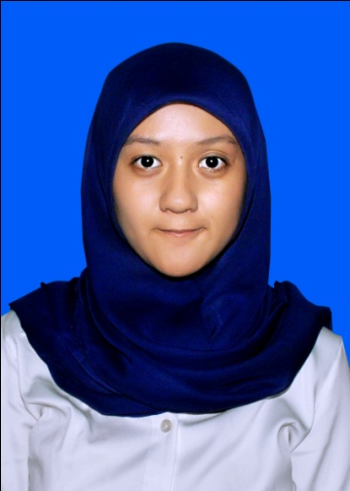
Nabilla Tashandra
Curriculum Vitae

Contact:
0227500035 / 08996188360
nabillatashandra@gmail.com

Profile | - Name Nabilla Tashandra  - Address Jl. Margawangi IV No. 58 Bandung 40287  - Birth Date November 10th, 1992  - Nationality Indonesian  - Gender Female  - Marital Status Single
Education | FORMAL EDUCATION  - 2004 - 2007 Junior High School 5 Bandung  - 2007 - 2010 Senior High School 8 Bandung  - 2010 - present Journalism Department of Communication Faculty, Padjadjaran University  INFORMAL EDUCATION  - 2004 – 2008 English course at LBPP LIA Buah Batu  - 2010 MDGs workshop at Padjadjaran University  - 2010 Online journalism workshop with vivanews.com  - 2011 Television journalism workshop with B Channel  - 2011 ‘How To Create an Amazing Event’ workshop with Adrie Subono  - 2011 & 2012 LA Lights Indie Movie workshops  - 2013 Print & Electronic journalism workshop at Padjadjaran University

Organization | ORGANIZATION EXPERIENCE  - 2004 - 2006 Marching Band at Junior High School 5  - 2010 – present Cinematography Club at Communication Faculty, Padjadjaran University  - 2011 – 2012 Journalism Student Association (Media Division)  - 2011 Photography Club at journalism department
Work | WORK EXPERIENCE  - Jan - Mar 2014 Internship at ‘Tribun Jabar’ local Newspaper as journalist  - Apr - Jul 2014 Internship at ‘Parijz Van Java Television (PJTV)’ as journalist, cameraman, script writer

Skill | PERSONAL SKILLS Communication Organization Team Work Creativity Planning OTHER SKILLS Photography Writing Social Media Design English

