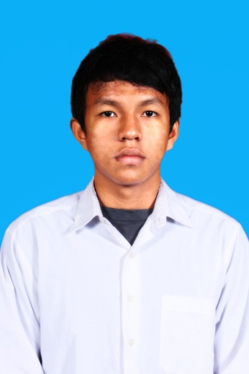
CURICULUM VITAE

PERSONAL DETAILS :
Name : Reindy Metaliano
Age & Date of Birth : 22 Years & Jakarta, 7 April 1991
Sex : Male
Nationality : Indonesia
Religion : Christian
Marital Status : Singel
Address : Tukad Citarum F1 No. 99a Renon, Denpasar - Bali
Contact Number : 0821 4451 0491
Email : reindymetaliano@gmail.com
Height/Weight : 175 cm/ 72 kg
Language Known : Bahasa Indonesia, English

FORLMAL EDUCATION
1997 – 2003 : SD Kemang Pratama, Bekasi
2003 – 2006 : Junior High School of Negeri 16 Narogong, Bekasi
2006 – 2009 : SMU Yadika 8 Jati Mulya, Bekasi
2009 – Now : Jurusan Agribisnis Fakultas Pertanian Universitas
Udayana, Bali

ORGANIZATIONS EXPERIENCES
- 2007 – 2008 : OSIS board of SMU Yadika 8 Bekasi
- 2011 - 2012 : Chief 2 Badan Eksekutif Mahasiswa Fakultas Pertanian Universitas Udayana periode 2011 - 2012
- 2011 – 2013 : Area Cordinator IV Ikatan Senat Mahasiswa Pertanian Indonesia periode 2011 - 2013

Foreign Language Profeciency
Language | Lettering | Speaking and Listening
English | Good | Good

Training Information
Student Leader Training  Training Jurnalism  National Seminar of Agriculture  National Seminar of Agriculture  National Seminar of Agriculture  Enterpreneurship Training  National Seminar of Agriculture | Udayana University, Bali  Udayana University, Bali  Udayana University, Bali  UMA, Medan  UGM, Jogja  Udayana University, Bali  Udayana University, Bali | 2009  2009  2011  2011  2012  2012  2013

Committee Experiences
National Seminar of Agriculture  Udayana’s Christmas Committee  National Seminar of Agriculture | Coordinator of Ceremony Committee  Chief  Coordinator of Steering Committee | 2011  2011  2013

Working Experiences
CFC Bali  PT. First State Futures | Kitchen Crew  Relationship Manager | 2012  2013 - 2014

Respectfully yours,

Reindy Metaliano

Denpasar, August 20, 2014
To: APMF

Dear Personnel Manager,
Based on information from the internet about a good chance to working in this company, then I would like to apply LO in your Event. I am in a good health, willing to work, have a strong analytical power, fast to learn new things and have enough basic knowledge in the banking world. Also, I can speak English well and can opperate some applications in the data analysis computer programs.
For your information, I’m a colleger of Agriculture Faculty at University of Udayana, Bali, Indonesia.

For your consideration, I here with enclose:
1. Curriculum Vitae (CV)
2. Recent colour photograph

I hope my qualifications and experiences merit to your consideration. Thank you for the kind attention, and I am looking forward to your reply.

Respectfully yours,

Reindy Metaliano

