Ronny Tandela
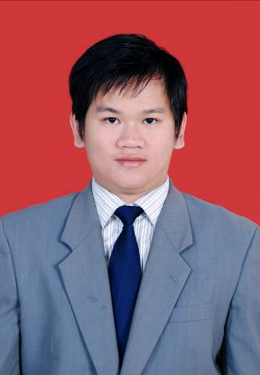
Address : 2/4 Community Road
Allen Avenue, Ikeja
Phone : +234 903 493 9319
E-mail : ronny.tandela@hotmail.com
Place / Date of Birth : Medan / November 23th, 1990
Religion : Christian

EDUCATION
Padjadjaran University, Bandung February 2013- January 2014
Apothecary Professional Degree
Cumulative Grade Point Average 3.23 / 4.00
Padjadjaran University, Bandung August 2008 – July 2012
Bachelor of Pharmacy
Cumulative Grade Point Average 3.29 /4.00
Methodist-2 Senior High School, Medan July 2005 – June 2008
Science Program
Methodist-3 Junior High School, Medan July 2002 – June 2005
Methodist-3 Elementary School, Medan July 1996 – June 2002

WORK EXPERIENCES

Kalbe International Pte.,Ltd. (Nigeria) January 2016 – Present
As a Sales and Product Manager
PT. Novell Pharmaceutical Laboratories February 2014 – January 2016
As a Product Executive
PT. CIMB Niaga, Tbk. August 2012 – February 2013
As a Marketing
Physical Pharmacy Laboratory UNPAD February 2012 – June 2012
As a lecture assistant
CHEMISTRY LABORATORY UNPAD August 2011 – December 2011
As a lecture assistant
PRIVATE TEACHER September 2010 – July 2011
Teaching Math, Physics, Chemistry and Biology

RESEARCH EXPERIENCES

Final Project January 2012 – June 2012
“Characterization and Dissolution Enhancement Atorvastatin by Microcrystallization Process”
- Minimizing particle size and enlarging the surface area of particle to increase the solubility of the drugs
- Increasing the absorption and the bioavailabilty of the drugs in human body.

Government Project February 2011 - June 2011
“Activated Carbon Granule from Cassava’s Peel (Manihot utilissima) to Overcome Adsorbable Organic Halide (AOX) in Wastewater ”
- Developing the potent surfaces activated carbon to adsorb the Organic Halide
- Developing the most efficient way to decrease a harmful substance in wastewater

Government Project February 2010 - June 2010
“Formulation Gell Antibacteria from Turmeric Stem (Curcuma longa) ”
- Using antibacteria potention from turmeric secondary metabolite.
- Developing the antibacteria gell as the most effective way to kill the bacteria on hand

Government Project August 2009 - December 2009
“Formulation Antiacne Cream from Pegagan Leaves (Centella asiatica) ”
- Using antibacteria (Staphylococcus aureus) from pegagan secondary metabolite.
- Developing the antiacne cream as a comparation from innovator.

COMPUTER SKILLS
MS Windows , MS Office, Adobe Photoshop, Adobe Ilustrator, Corel Draw

NON-ACADEMIC ACTIVITIES
Basketball Student Activity Unit January 2009 – January 2011
As a Head and Coach
First Aid & Facing Disaster Readiness - Medan April 2009
As a Participant
Boys’ Brigade Drill Camp - Semarang May 2010
As a Trainer
First Aid & Facing Disaster Readiness - Medan August 2010
As a Trainer
Paramedics Merapi Mountain Eruption - Jogjakarta October 2010
As a Volunteer
Boys’ Brigade Drill Camp - Semarang May 2011
As a Trainer

HOBBIES AND INTERESTS
Reading, Indoor/Outdoor Sports (Basketball, Badminton, Futsal), Self Defense (Aikido), Research (Action, Applied, Basic, Clinical Trials, Epidemiological, and Literature Review)

LANGUAGE SKILLS
Fluence in Hokkian, Mandarin , Bahasa Indonesia, English and French (beginner)

