- PERSONAL INFORMATION

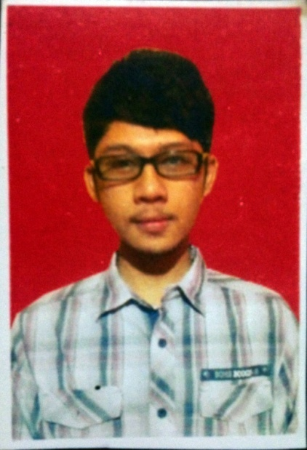 | Full name | : | Fahreza Adhika Putra | Employee ID : | 400.0732
 | Position | : | System Engineer
 | Birth date | : | 25 April 1995
 | Address (as per ID Card) | : | Jl. Jenggala Raya no.13 Perumnas 3 Karawaci
 |  | : | KecamatanKelapaDua  Kelurahan Bencongan
 | Contact Number | : | 089658990795
 | Email | : | fahreza.putra@multipolar.com

- SUMMARY OF QUALIFICATION
Fahreza is a System Engineer in Solution Delivery group of PT Multipolar Technology Tbk in Indonesia.
Fahrezarole at MLPT is to :
- To help Customer meet their requirements in servers (IT) area
- To do analysis / capacity planning in servers area
- To involve setting new p-Series infrastructure, resetting configuration, and migration to a new machine including verification of running application.
- To provide installing and upgrading operating system ( AIX ), Virtualization, Clustering.
- To involve in installing and setting Vision Solutions application replication Double Take Recover Now for AIX
- To Involve in setting new and upgrade storage area network ( DS Series and Storwize )
- To help solving customer problem

- WORKING EXPERIENCES / EMPLOYMENT HISTORY (start from current employment to past –until after graduation)
No. | Company & Position  (Year – Year) | Summary of Responsibility& Reports to | Achievements | Number of Subordinates | Financial Responsibility

- EDUCATION, CERTIFICATION / TRAINING, OTHER QUALIFICATIONS(list only those related to career aspiration, start from recent to past)
  - Academic Qualifications (Education Institution, Study Program / Major, Year of Graduation)
- SMKN 3 Tangerang,major: Computer Engineering / Network Engineer, graduated in 2013

  - Training(Training Title, Institution, Year of Training - up to the last 15 years)
- AN12G – PowerSystems for AIX II: AIX Implementation and Administration, Avnet Academy, 2016
- AN102G – Power 8 and AIX Enhancement Workshop, Avnet Academy, 2016

  - Certification (Certification Title, Institution, Year of Certification)
- IBM Certified Sales Specialist - Power Systems with POWER8 V1, 4 April 2016
- IBM Certified Specialist - Power Systems with POWER8 Scaleout Technical Sales Skills V1, 7 Juni 2016
- IBM Certified Specialist - Enterprise Storage Technical Support V4, 15 Juni 2016
- IBM Certified Technical Sales Specialist - Power Systems with POWER8 Enterprise V1, 20 Juli 2016

  - Skills Summary
- Operating system : Unix , Linux, Windows,
- Understanding of Administration Server ( Linux )DNS, DHCP, FTP, Proxy server
- Microsoft Office : MS Word, MS Excel, MS Power Point
- Understanding of computer design 2d ( Corel Draw, Photoshop, Adobe Illustrator )

  - Language(excellent, fluent, moderate, passive, beginner) and other special abilities
- Indonesia, excellent
- English, moderate

Regards,
15 Juni 2016

Fahreza Adhika Putra

