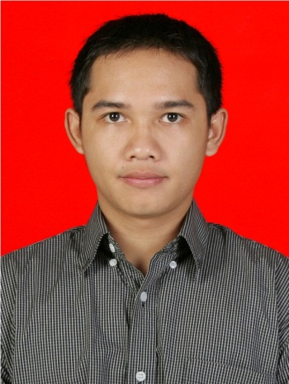
CURICULUM VITAE

Name : Lintang Anindia Zikrillah
Date of Birth : Depok, March 14, 1987
Address : Ds. Sanja RT.001 RW.005 No. 240 Kel. Sanja, Kec. Citeureup
Phone : 0856-1894909
Sex : Male
Nationality : Indonesia
Marital Status : Married
Religion : Moslem
Email : Lintang.anindia@yahoo.com

Educational Background

- Formal Education :
- SD N Tonjong 1 (1993-1999)
- SMP Negeri 1 Depok (1999-2002)
- SMA Negeri 3 Depok (2002-2005)
- Diploma at University of Indonesia Majoring Taxation (2005-2009)
GPA 2.96
- Bachelor Degree at University of Indonesia Majoring (2009-2011)
Fiscal Administration GPA 3.05

- Informal Education :
- LBPP LIA Depok (Post Higher Advance III)
- Zahir Accounting
- Tax Talk (Seminar)
- Tax Planning (Seminar)

Qualification

- Able to operate Microsoft Office (Word, Excel, Power Point)
- Tax Ability
- Payroll Ability
- Able to speak English both oral and written

Working Experience

- PT. Nawakara Persada Nusantara (Feb 2009 – June 2011)
Position Title (Level) : Human Resources Information System (HRIS)
Specialization : Network/System/Database Admin
Industry : Security Services

Work Description
Responsibility :
- Employee data updating
- Data filling
- Payroll
- Salary payment and transfer
- Employee database administrator
Experiences :
- Understand the work related to HRD administration, in particular related to the database system staff.
- Know the process of calculating, payment, and salary distribution

- PT. Fajar Mitra Indah (January 2012 - Now)
Position Title (Level) : HR Operational
Specialization : Database, Payroll, Government Relation, Bennefit)
Industry : Retail

Work Description
Responsibility :
- Collect and keep Employee data update
- Proceed employee payroll, overtime, and other incentive based on policy
- Reporting operational activity
- Create Jamsostek report and tax
- Liase with Government partly for “Wajib Lapor” and update government policy.
- Give notification for employee probation periode, employee status, and performance evaluation.
- Reference Letter for all employee.

