CV. AHMAD HISYAM

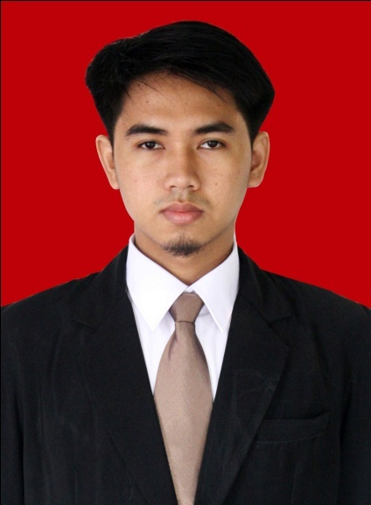
Personal Details
Full Name : Ahmad Hisyam
Sex : Male
Place, Date of Birth : Bogor, December 31, 1991
Nationality : Indonesia
Status : Single
Religion : Islam
Address : Jl. Riverside Golf No.52, Kp. Cikuda, Ds.BojongNangka, Kec. GunungPutri, Bogor, 16963
Mobile : 08998504787
Email : iam.ahmadhisyam@gmail.com
Facebook : facebook.com/ahisyaam

Educational Background
1997-2003 : SDN Cikuda 03
2003-2006 : Boarding School SMPIT Al-Kahfi
2006-2007 : Boarding School MA Al-Hamid
2007-2009 : MA NEGERI 2 Bogor
2014 : Informatics Engineering of faculty Science and technology at
Universitas Islam Negeri (UIN)Syarif Hidayatullah.
graduate at November 2014

Qualifications
Programming : HTML, Java, PHP, SQL, LUA, Javascript
Multimedia : Photoshop, Corel Draw
Web : Codeigniter, Jquery
Database : SQL Server, MySQL

Hobby : Listening Music, Travelling, Reading

Experience

Company | Description
Badr Interactive  (Software House) | - Apprentice as mobile developer  - 3 month
Komunigrafik  (Software House) | - work as web application developer  - from oct 2013 until now

Portfolio
Project | System
Jayaproperti (BX-Rink)  local | - Access Gate Control System  - System Information of Skate Academy  - Reporting
Erlangga  http://erlanggaexam.com/beta | - Questions Generator For teacher  - Backend Application

