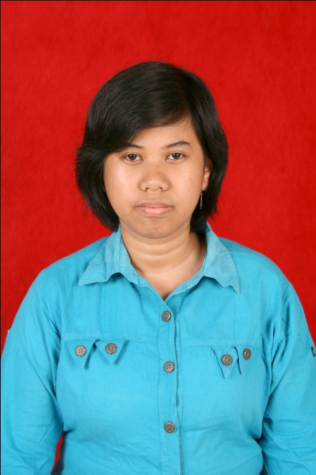
Curriculum Vitae

Personal Details
Full Name : Dewi Permata Sari
Place, Date of Birth : Balikpapan, 24 December 1991
Sex : Female
Marital Status : Single
Religion : Islam
Hobby : Reading and Listening to the music
Address : Jl. Inpres 2 Rt. 023 No.101 Kelurahan Muara Rapak
Balikpapan
Phone Number : 0812 5811 8924
Email : dewipermata.sari91@gmail.com

Education Background
1997 – 2003 : Elementary School, SDN 016 Balikpapan
2003 – 2006 : Junior High School, SMPN 9 Balikpapan
2006 – 2009 : Senior High School, SMKN 2 Balikpapan
2009 - 2013 : STIE Widya Wiwaha Yogyakarta
Majoring Accounting

Qualifications
- Accounting Skills
- English (Pasif)
- Computer Literate (Ms. Word, Ms. Excel, Ms. Power Point, Ms. Access, Internet)
- Software (MYOB & Accurate)

On the Job Training
- May – September 2008 : As a Analysis Credit at Bankaltim
- July – August 2010 : As a Finance at PT Pandu Siwi Sentosa (Data Entry)
- July – October 2011 : As a Administrasi A/R at PT. Patra Darma Wijaya

Experience
- May 2012 – Now : As a Accounting Staff at PT. Hidup Baru Perdana Abadi

