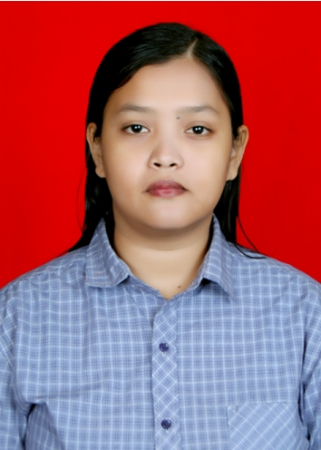
Curriculum Vitae
Personal Data
Name : Indah Nurul Fitria
Sex : Female
Date of Birth : May 17, 1988
Place of Birth : Sanga-sanga (East Borneo)
Citizenship : Indonesia
Address : Komplek PCI Blok D24 No.5
RT 5 RW6. Harjatani. Kramatwatu.
Serang – Banten. 42161
Phone Number : +6281223786215
E-mail Address : inurulf@gmail.com

Formal Education
2006 – 2013 : English Department
Faculty of Humanities
Universitas Padjadjaran
Bandung
IPK 2,99/4,00

Work Experience
Freelance
2009 – Present
Translator and Transcriptionist
- Translating various texts from English to Indonesian and vice versa
- Transcribing audio files into written form
- Editing and Proofreading translation works

December 2014 – Present
Independent Consultant at Leapforce
- Evaluating the quality of search engine’s landing page

November 2014 – Present
Freelance Editor at Unbabel.com
- Editing and/or re-translating machine-translated texts

January 2014 – Present
Independent Consultant at Appen™
- Translating various texts from English to Indonesian
- Transcribing audio files into written form
- Evaluating the quality of search engine’s landing page

Additional Experience
October – November 2010
Stage Manager for William Shakespeare’s The Tragedy of Macbeth
Theater of GEMASI (English Department Student Organization)

April – June 2010
Stage Manager for Tom Stoppard’s The Real Inspector Hound
Theater of GEMASI (English Department Student Organization)

2008
Logistics Division of English Days
English Department Student Organization

2008
Logistics Division of GEMASI's Annual Threshold Educational Sessions (GATES)
English Department Student Organization

2007
Event Division of Piala Rektor
Universitas Padjadjaran Football Club (USBU)
Universitas Padjadjaran

2006
Typist of GEMASI General Assembly

