CURICULUM VITAE
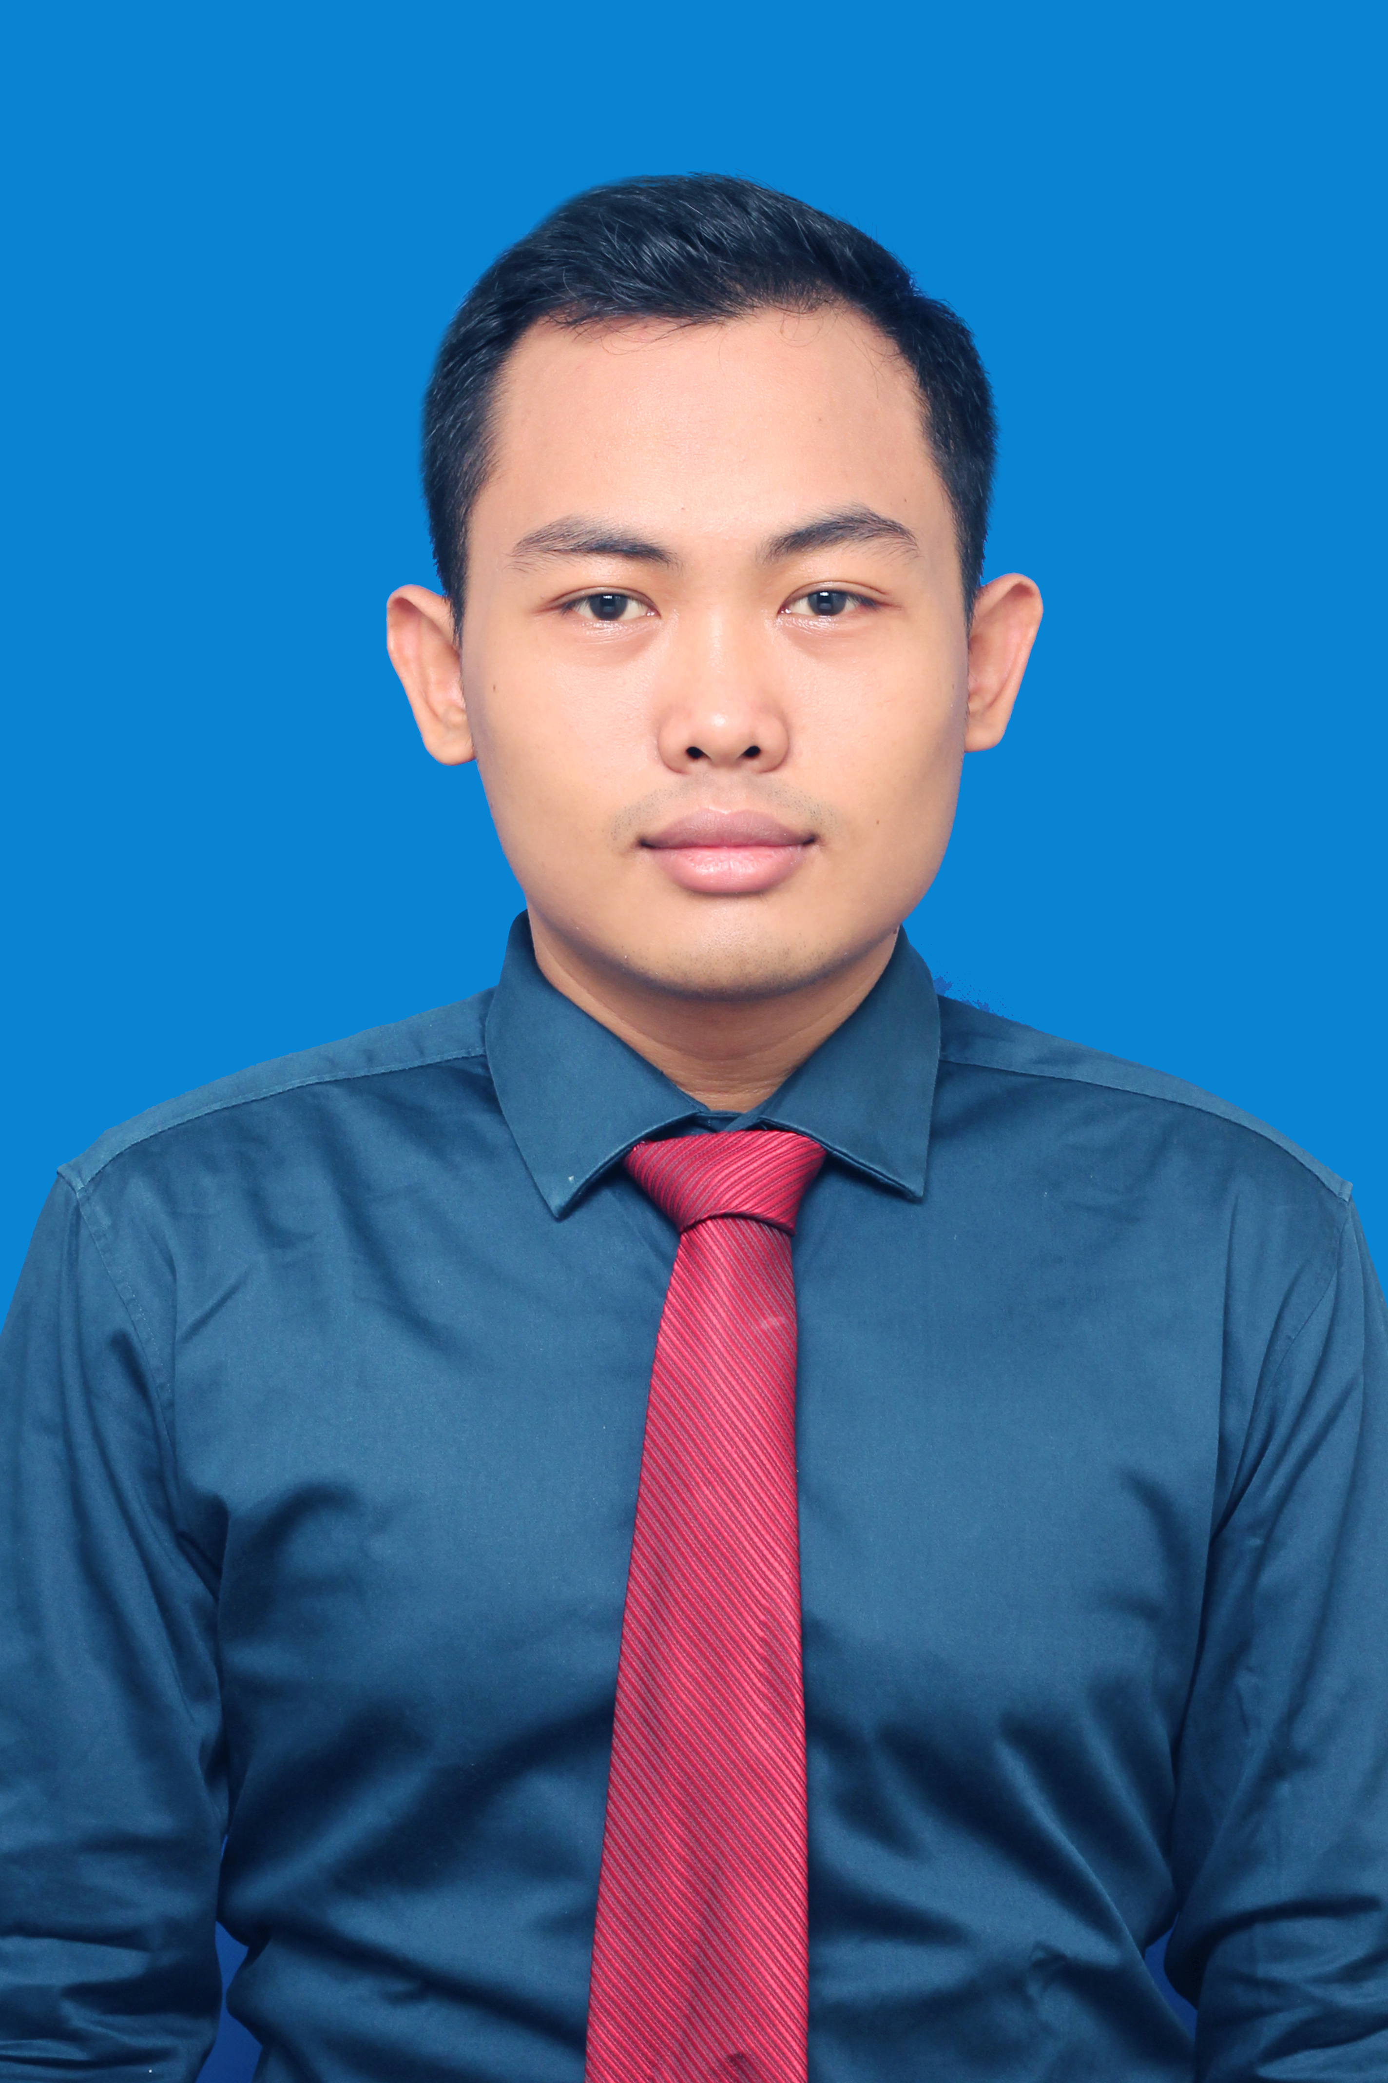
Personal Details
Name : Fardo Rahmandika
Place, Date of Birth : Yogyakarta. February 9th 1991
Sex : Male
Marital status : Single
Nationality : Indonesian
Religion : Moslem
Height/weight : 168 cm / 68 kg
Address : Jl Tegal Lempuyangan DN III no. 157 Yogyakarta 55211
E-mail and phone number : fardo.rahmandika@gmail.com / 0857-2995-0295

Personal Profile
I am a fresh graduate from International Relations, University of Muhammadiyah Yogyakarta with a little bit of working experience. I am a responsible person and have a strong passion in learning something new.

Academic Qualifications
- International Relations Department at University of Muhammadiyah Yogyakarta in 2010-2014
- Muhammadiyah 2 Yogyakarta High School in 2006-2009
- Public Middle School of 15 Yogyakarta in 2003-2006
- Elementary School of Lempuyangwangi III Yogyakarta in 1998-2003

Working Experience
- 2013-2014 as English Facilitator (mentor) at Self Access Center, Language Training Center, University of Muhammadiyah Yogyakarta
- 2011 as a surveyor for Yogyakarta’s mayor election (freelance).
- 2010 as a operator in internet cafe “BlangkonNet” (part time).
Workshop Experience
- Workshop “CV Writing” in 2014 held by Self Access Center, LTC, UMY.
- Workshop “Motivation Letter Writing” in 2014 held by Self Access Center, LTC, UMY.
Achievment
- One of Funded-Selected Article in Student Creativity Program (PKM-AI) 2013 from DIKTI entitled “Hubungan Antara Ideologi Organisasi Pergerakan Mahasiswa Islam di Yogyakarta terhadap Perumusan Agendanya (The Relations Between Islamic University Student Movement Organization Towards Their Agenda Forming).”
Basic Skill
- Computer
Able to use Microsoft Office .
Able to use internet, email, etc.
- Language
English.
TOEFL Like-test score : 590

I hereby declare that the above written particulars are true to the best of my knowledge and belief.

