V

Venny Christayani Rahardjono
Rejosari Tengah 2 no. 44, Semarang, Central Java, Indonesia (Postal code: 50125)
vennychristayani@gmail.com
+62(0)85641231212

Career Objectives
To obtain a position as a translator / news reporter / journalists / related fields in English
Education

Faculty of Language and Literature, Satya Wacana Christian University Salatiga, Central Java, Indonesia | Graduate: October 2016
GPA: 3, 88
Courses Included:
- Public Speaking (A)
- Expository and Argumentative Writing (A)
- Narrative and Descriptive Writing (A)
- Introduction to Public Relation (A)
- Advanced Grammar (AB)
- Teaching and Learning Strategies (A)
- Curriculum and Material Development (A)
- Teaching English as a Foreign Language (AB)
- English-Indonesia Translation (A)
- Thesis (A)
Experience
- Proficient in English Language Teaching Education (ELT)
I have passed several courses related to English Language Teaching (ELT) such as Micro Teaching, Teaching English as Foreign Language, Teaching and Learning Strategies, and also Curriculum and Material Development with satisfactory results as shown above.
- Completed a three-month teaching practicum in SALATIGA LAB (2015)
I have done my teaching practicum last semester for three months in one of the Private Institution in Salatiga, Salatiga Lab. During those time, I have taught many students from 3 years old to 50 years old whose characteristics and English proficiencies were different from one to the other student. I have received outstanding score throughout my experience in Salatiga Lab.
- Participated in East Asia Student Encounter (EASE) exchange program in Kwansei Gakuin University (KGU), Japan. (October 21st – September 3rd, 2016)
I was chosen to be one of the ten students from Satya Wacana to represent the university on a short exchange program in KGU, Japan. My job desk was to coordinate the members in the food sharing event.
- Liaison Officer at International Indonesia Culture Festival (IICF) Event on Satya Wacana Christian University Salatiga (April 18th- 24th 2015)
IICF was an international culture exhibition event held by Satya Wacana Christian University which involved 30 ethnics around Indonesia and also international culture such as Taiwan and Chinese to show their talent in the exhibition. I was responsible to organize many different ethnics and ensuring that the event would run smoothly.
Others
- Third winner in the ALSA Central Java English Competition as a participant of News Casting competition in Diponegoro University, Semarang (November 10th - 12th , 2012)
I was participating in a regional wide news casting competition and managed to become the third winner in this competition. I was responsible to deliver live news and doing a weather news report.
- Top five in the 18th ALSA National English Competition as a participant of News Casting competition in University of Indonesia, Jakarta (April 24th – 29th, 2014)
I was participating in a nationwide news casting competition and managed to get into the final round and be in the top 5. I was responsible to deliver live news and doing a live talk show with Raisa Adila Andomi (Miss Intelligence Puteri Indonesia 2014). Therefore, I believe that I am proficient and eligible enough to teach English speaking skill to students
- Participating in the 2013 Asian English Olympic “Asia In Tune” as a participant of News Casting competition in Bina Nusantara University, Jakarta (February 17th – 21st, 2013)
I was participating in a news casting competition of Asian wide level. I was responsible to deliver news in a studio and doing a live report of sport news with a Malaysian partner from Petronas University (Kuala Lumpur, Malaysia).
- Master of Ceremonies and news casting performer in English Competition Club Showcase (March 24th , 2014)
English Competition Club (ECC) Showcase was an exhibition to introduce ECC to students from my major so they will be interested to join the club. I was responsible to host the show.
- Translator at the exhibition of Beijing Language Culture Institute (BLCI) in Horizon Hotel Semarang (May 10th -11th 2011 and April 18th – 19th 2012)
BLCI is an education exhibit held by the Chinese government in Indonesia in order to promote their universities. I was responsible to explain the requirements that were necessary for those who were interested to study abroad in China. I was invited to become their translator in 2011 exhibition, and again was I invited in 2012.
Seminars and Workshops
- National Seminar: Lead Yourself and Get Your Future (March 13th, 2013)
- English Department Writing Workshop (March 14th, 2014)
Skills
- Language: Fluent in both English and Indonesian language
- Typing: 60 w.p.m
- English Teacher
- News Anchor
- Computer: Microsoft Word, Microsoft Power Point, Microsoft Excel
- TOEFL score : 616,67
Interests
- Strong passion in teaching English
- Reading (International Journals, Poetry, Novels, Magazines)
- Writing (Translating English-Indonesian / Indonesian-English both oral and written)
- Traveling
- Politics
- Science
- Music
- Culinary
Teaching Practicum Certificate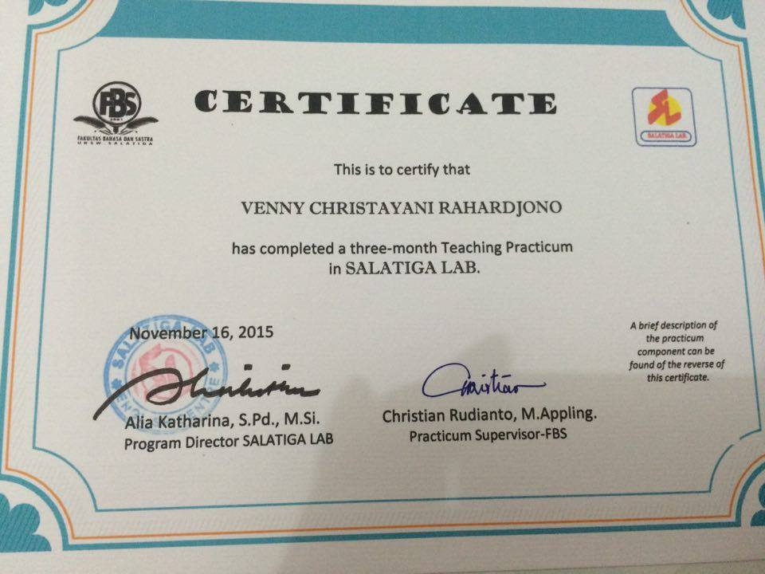
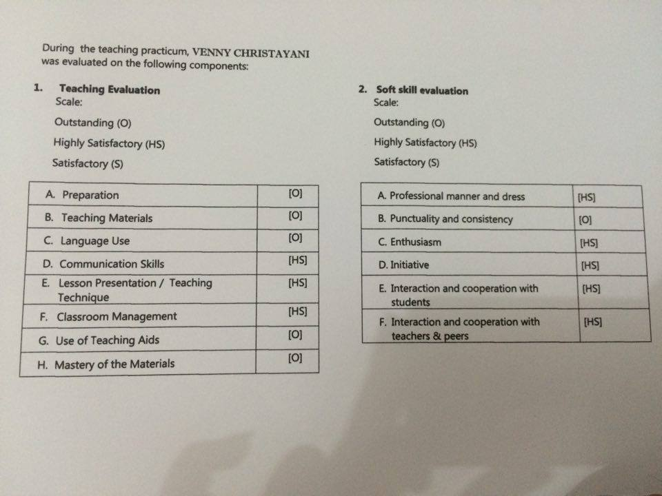
Study results in Satya Wacana Christian University