CURRICULUM VITAE
NATALIA SAGITA
Asam-asam, Kalimantan Selatan

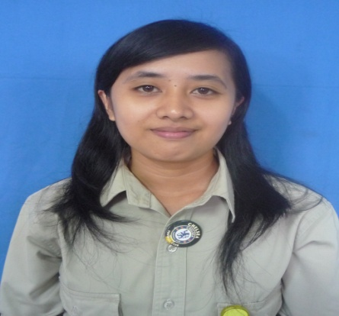

PERSONAL INFORMATION

Name : Natalia Sagita
PLACE, DATE OF BIRTH : Sepapah, 04-12-1984
ADDRESS : Jl. Raya Banjarmasin – Kotabaru, Gang Raja Toba
PHONE : 085345456742
RELIGION : Kristen Protestan
SEX : Female
Health Condition : Excellent
STATUS : Married
EMAIL : nsagita79@gmail.com

EDUCATION

2000 – 2003 : Graduated from Senior High School, SMU 2 Banjarbaru, Kalimantan Selatan
1997 – 2000 : Graduated from Junior High Scholl , SMP 1 Banajarbaru , Kalimantan Selatan
1991 – 1997 : Graduated Elementary Scholl, SDN Sepapah, Kalimantan Selatan

SPECIAL SKILLS

Core competence:
- Have Self motivation and fast learning
- Good team work
- Able for independent job
- Highly Motivation to Achieve on Team goals

Computer and Multimedia :
- Familiar with Microsoft Office (Word, Excel, Power Point, Access)
Language :
- Indonesian and English, written and spoken
TRAINING

- Microsoft Excel (Basic, Intermediate)
- Microsoft Access (Basic and Intermediate)
- General and Business English Session

WORK EXPERIENCES

December 2009 – May 2010 PT. PUTRA BORNEO MANDIRI SEJAHTERA
Admin Coordinator
Job Responsibility :

- Prepare daily coal hauling report
- Fuel and oil data entry
- Prepare timesheet report
- purchasing

September 2010 – 2012 PT. Wijaya Karya (Persero),Tbk

Secretary
Job Responsibility :

- Project's data updating;
- Business correspondences;
- Expatriates documentation filling & follow up;
- Translation;
- Appointment arrangement;
- Filling and data updating;
- Arranged of business trip schedule

Juni 2013 - Present PT.Zircon Inti Persada

HRD Officer
Job Responsibility :

- recruitment;
- pay;
- conditions of employment;
- negotiation with external work-related agencies

