CURRICULUM VITAE
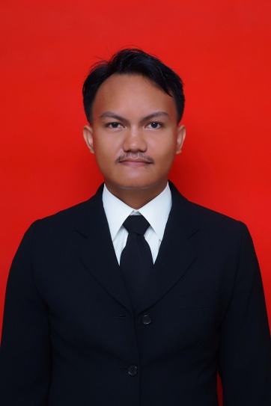
PERSONAL DETAILS
Name : Jakup Ginting
Place/Date of birth : Kabanjahe/April, 6th 1991
GPA : 3,45
Nationality : Indonesia
Gender : Male
Religion : Christian-Protestant
Marital Status : Single
Address : Jl.Raharja Gg.Sehati No.22,Tanjung Sari Medan Selayang
20132,Sumatera Utara.
Mobile : 085270625692
Email : jakup.gintings@gmail.com
Blog : http://jakupsinusinga.wordpress.com/

FORMAL EDUCATION
- 1996 to 1997 TK Sint Xaverius Kabanjahe (kindergarten)
- 1997 to 2003 SD Sint Yoseph Kabanjahe (elementary school)
- 2003 to 2006 SMP RK Sint Xaverius 1 Kabanjahe (junior high school)
- 2006 to 2009 SMA Negeri 1 Kabanjahe (senior high school)
- 2009 to 2014 S1 Ilmu Komputer USU (computer science)

SEMINAR/TRAINING/WORKSHOP
- Participant in Diskusi & Bedah Buku “Trik Dahsyat menjadi Animator 3D Andal” at Departemen Ilmu Komputer USU 2010
- Participant in Diskusi Panel Sains Interdisipliner Dunia Terkini: “Pengenalan Agent Based Model dan Aplikasinya” at Fakultas Teknik USU 2010
- Participant in Workshop Teknik Hacking at Gelanggang Mahasiswa USU 2010
- Participant in Seminar Teknologi Informasi The Development of Modern Operating System Technology at Gelanggang Mahasiswa USU 2011
- Participant in Seminar Sehari Robotika dan Informatika at Fakultas MIPA USU 2011
- Participant in Pelatihan Penulisan Proposal Program Kreativitas Mahasiswa at Fakultas MIPA USU 2010
- Participant in Seminar TOEFL at Fakultas Ilmu Budaya USU 2011
- Participant in Seminar Nasional "Membentuk dan Mengintegrasikan Karakter Bangsa Melalui Kebudayaan” by ILP2MI at Auditorium USU 2013

ACHIEVEMENT
- The Second Winner in Seminar And TOEFL Prediction Test at Ikatan Mahasiswa Sastra Inggris’s 30th Anniversary 2011
- The Third Winner in Programming Contest at Porseni IMILKOM USU 2012

ORGANIZATION EXPERIENCE
- Member of Departemen Dana dan Usaha for Ikatan Mahasiswa S-1 Ilmu Komputer (IMILKOM) USU from 2011 to 2012
- Vice Chairman for Komunitas Mahasiswa Kristen Ilmu Komputer USU from 2011 to 2012
- Member of Komisi Peralatan for UKM Kebaktian Mahasiswa Kristen USU Unit Pelayanan Fakultas MIPA from 2011 to 2012
- Member of Komisi Pembinaan for UKM Kebaktian Mahasiswa Kristen USU Unit Pelayanan Fakultas MIPA from 2012 to 2013
- Chairman of UKM Kebaktian Mahasiswa Kristen USU Unit Pelayanan Fakultas MIPA from 2013 to present

COMMITTEE
- Equipment staff for Porseni Imilkom 2011 at Program Studi Ilmu Komputer USU
- Equipment coordinator for Penyambutan Mahasiswa Baru S-1 Ilmu Komputer USU 2011 at Program Studi Ilmu Komputer USU
- Equipment coordinator for ArTechno Competition,Seminar,Workshop and Baazar 2011 at Program Studi Ilmu Komputer USU
- Equipment staff for ICT Contest 2012 at Program Studi Ilmu Komputer

JOB EXPERIENCE
- Lab Assistant for Computer Architecture and Organization from 2011 to present

SKILLS AND INTERESTS
I am willing to learn new things and work hard, communicating with new people, have a good sense of humor, well talking in English, playing football, playing computer games and reading manga.
My programming language skills:
- C++
- C#
- Delphi
- Matlab
- MySQL

