CURRICULUM VITAE
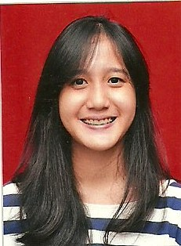
- Personal details
Full name : Chasimira Amadea
Place, date of birth : Jakarta, 15 March 1994
Home address : Bona Indah blok A6/21, Lebak Bulus, Jakarta Selatan
E-mail address : chsmramadea@yahoo.com
Tel. / HP No. : 081288480469
Marital status : Single

- Education
Formal
2012 – present : Atmajaya Catholic University majoring in Communication
2009 – 2012 : SMA Al-Izhar Pondok Labu
2006 – 2009 : SMP Al-Izhar Pondok Labu
2000 – 2006 : SD Al-Izhar Pondok Labu

Job Training
At REDmark Agency responsible in media social, from May 2014 to January 2015

Organization Activities
As Documentation Committee on MAFIASCO, 2012
As Financial of Makrab Fiabikom ‘FINCH’, 2012
As Event Committee of Al-Izhar Olympic 6, 2011
As Liason Officer of Closing Al-Izhar Olympic 6, 2011
As Ticketing Department on HOPEFEST, 2011
As Language Committee on Al-Izhar Olympic 5, 2010

- Skills
Language
English : Oral: good Written: good

Computer
Microsoft Office (e.g Ms. Word, Power Point, Ms. Excel)
Internet Skill

- Hobbies/Interests
Traveling, listening to music, swimming, browsing

Jakarta, 6 Mei 2015
Chasimira Amadea

