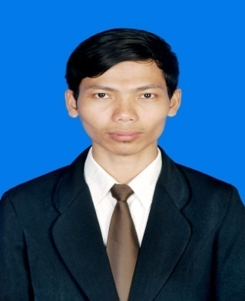
Personal Details :
Full Name : Al Muttaqin
Nick Name : Aal
Sex : Male
Place, Date Of Birth : Cilacap, December 29, 1986
Nationality : Indonesia
Marital Status : Married
Height, Weight : 170 cm, 65 kg
Health : Perfect
Religion : Islam
IPK : 3.11
Address : Jln Pemuda, No. 29, RT 01/04, Dondong, Kesugihan, Cilacap, Jawa- Tengah, Kode Pos 53274
Mobile Phone : 082191300799 / 085756202733
E-mail : smart_aal@yahoo.com

Educational Background :

2005 – 2008 : Islamic Senior High School (MAN 1), Cilacap, Central Of Java.
2008 – 2012 : Information System Departement at the STMIK AMIKOM Yogyakarta, Central of Java.

Qualifications :
- Administration Skill (Jurnal Printing & Calculation, Cash Payroll & Calculation, Inventory Controls, Project Data Updating, Teller, Salary Calculation etc)
- Computer Skill ( Install, Hardware, Software, Service and Maintenance)
- Computer Software Skill (MS Word, MS Excel, MS Power Point, MS Acces, MS Outlook, Printing and Scanning)
- Website Literate ( Blogging, XAMPP, PHP MySQL, CSS, CMS, Java Script etc)
- Multimedia Literate (Adobe Photoshop, Corel Draw, Adobe Flash CS3, Adobe Flash Player CS3)
- Internet Literate

Languages :
Fluency in Arabic, English, and France

Working Experience :
- Company Name : CV. Karunia Teknik.
Project Location : Kota Baru, Yogyakarta
Clasification : IT Staff
Period of service : December 2011 – August 2012
Purpose : Outsorce Working
Job’s Description:
- Troubleshooting computer hardware, software, and maintenance.
- Installing windows (XP, VISTA, Windows 7, Server 2003, 2008)
- Service and maintenance, installing Linux (Desktop version),
- Installation Hotspot area,
- Installing Scanner and printer, service and maintenance,
- Developing comercial website, and make a grapic design.

- Company Name : PT.Bangun Bejana Baja.
Project Location : Terminal LPG Bosowa Project, Makassar
Clasification : Administration & IT Staff
Period of service : September, 2012 – June, 2013
Reason for leaving : Job Completed
Job’s Description:
- manage employee working hours policies,
- procedures Implement financial policies,
- invoices and employee payroll arrangements,
- budget meetings,
- Ensuring transaction has been recorded and entered into the system,
- computerized accounting,
- business correspondence,
- business travel schedule,
- inventory control,
- preparing presentation materials,
- installation and maintenance of scanners and printers,
- send email, create a report with MS Word and excel.

- Institution Name : SMK Al Mu’allim Kesugihan.
Location : Nusa Inndah, Kesugihan, Cilacap.
Clasification : Teacher of Komputer, IT Maintenance
Period of service : July, 2013 – February, 2014

- Company Name : PT.Bangun Bejana Baja.
Project Name : Senoro Gas Development Project, Luwuk Banggai, Sulawesi
Clasification : Logistic / Warehouse Departement
Period of service : April, 2014 – Marc, 2015
Reason for leaving : Job Completed

References
Will be furnished upon request.

Cilacap, May 2015

Sincerely yours,

Al Muttaqin.

