Anisa Osariana, S.E. 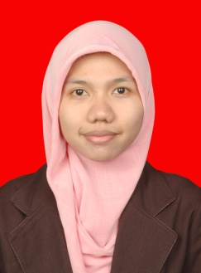
Personal Detail
Name : Anisa Osariana
Place and Date of Birth : Bekasi, 4th January 1992
Address : Perum. Medang Lestari Blok A.IV/C.2
Pagedangan-Kab. Tangerang
Nationality : Indonesia
Marital status : Single
Phone Number : 081289774748/081807962462
Email : osarianaa@gmail.com
Social media account : https://www.facebook.com/anisa.osa
https://twitter.com/anisaosa
http://instagram.com/osariana
Objective
I am willing give total support the organization that I am in, with the experience and capability that I have, in order to achieve organization’s goals also create mutual benefits.

Key Skills
Marketing Background, Good Speaker, Good Communicator, Organization and Leadership, Analytical Thinker, Dynamic, Perfectionist.

Summary of Qualifications
              - Self Motivated; have a capability to set effective priorities and decisions to achieve immediate and /or long term goals and meet operational deadlines.
              - Good in communications and leadership.
              - Good in individual or team work.
              - Open minded and interested to learn.
              - Interested in copywriting and scriptwriting.
              - Interested in social media marketing.
              - In strong problem solving ability, accurate data entry skills, also Perfectionist on result.
              - Knowing and understand about marketing concept and marketing strategic.
              - Common with PC, Ms. Office, Ms. Visio, Outlook, Corel Draw, Internet.

Education
2010 – 2014 Trisakti School of Management (Marketing Concentration) Jakarta
2007 – 2010 Vacational High School at SMKN 3, Bekasi
2004 – 2007 Junior High School at SMP An-Nadwah, Tambun Selatan
1998 – 2004 Elementary School at SDN. Bunul Rejo 4, Malang

Organizational Experience
2008-2009 Ketua OSIS SMKN 3 Kota Bekasi
2012-2013 Ketua Keputrian Unit Kegiatan Kerohanian Islam (UKKI)
Trisakti School of Management
Experience
October 2013 – Now PT. Media Televisi Indonesia ( METRO TV )
As freelance-scriptwriter for “Cerdas 5 Menit”
October 2013 – March 2014 AITINDO
As Social Media Specialist for Combiphar Indonesia
August -September 2012 Promotion Team in Ekomando Picture
Work as Social Media Conceptor and Operator for a new release film
January - April 2009 PT. Telkom Indonesia
Apprentice as Telemarketing for Speedy Internet Provider

