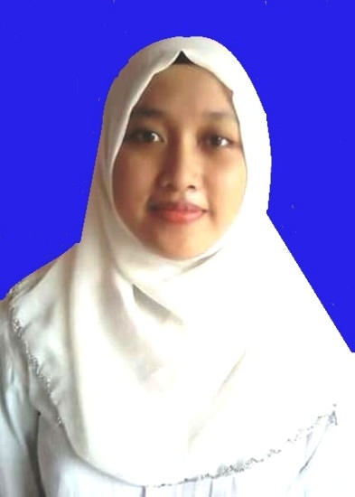
Curriculum Vitae
Name : Sartika
Sex : Female
Address : Jl. Supriyadi Gg. H. Nadi 007/03 Tanah Tinggi – Tangerang
15119
Date of Birth : Tangerang, 15 Desember 1994
Religion : Islam
Nationality : Indonesia
Marital Status : Unmarried
Phone Number : 089654763072
Email : tykasartika77@gmail.com/tykasartika77@yahoo.com

EDUCATION
UNIVERSITAS NEGERI JAKARTA 2012-2016
SMK PANCAKARYA TANGERANG 2009-2012
SMP PGRI 1 TANGERANG 2006-2009
SDN TANAH TINGGI 1 TANGERANG 2000-2006

SKILLS
Languages : English (College Level)

HOBBIES
Watching Movies, Reading Books

ACHIEVEMENTS
The Second Best Student 2009 in SMP PGRI 1 Tangerang
General Champion of Accountancy 2012 in SMK Pancakarya

WORKING EXPERIENCES
Administration staff at STMIK Global Tangerang 2011
Teacher in KKN program on Desa Tanggulun Timur, Subang 2015
English-Private Teacher at lesprivatkerumah.com 2015-2016
Translator at English Department of UNJ 2015-Now

