1. Language Expert

* Indonesia (Native)
* Javanese (Native)
* Japanese (Fluent)
* English (Good)

1. Attitudes

* Works well with others
* Has a good responsible
* Loves to improve recent ability to be better
* Has creative ideas
* Optimist

1. *A good public speaker*
2. High School 1 Trenggalek

2008-2011

Student of the socialscience program

1. Has completed Practical Teaching in Senior High School held by Surabaya State University.
2. Has completed Japanese-Language Education Capacity Building’s training and college course program in Japanese-Language Institute Kansai, Japan in 2014
3. Graduated from State University of Surabaya (Japanese Language Education Program)

2015

1. Has successfully achieved the international recognized JLPT (Japanese Language Proficiency Test) N4 certificate in 2013 (score : 118)
2. Has succesfully achieved the TEP (Test of English Proficiency) held by State University of Surabaya, certificate in 2013

(score:440)

1. Has successfully achieved the international recognized JLPT (Japanese Language Proficiency Test)N3 certificate in 2014 (score : 110)

Skills

**CURRICULUM VITAE**

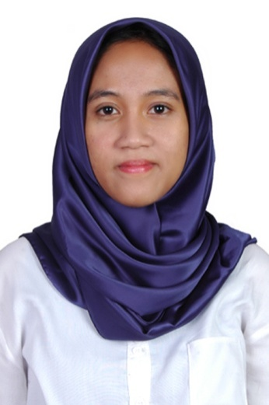

**Eka Permata Sari**

Educations

**Date of Birth:**

**October, 25th 1993**

**Location:**

**Surabaya - East Java**



**Addresses:**

**Rt.04 Rw.02 Desa Pakis,Durenan, Trenggalek**

**Now:**

**Jalan Menganti Kramat 24**

**Rt.02 Rw.04 Wiyung**

**Contact:**

**+6283831886352**

**ekap768@gmail.com**

1. Surabaya delegate for *“Japanese-Language Education Capacity Building Southeast Asian Teachers’ Training College Course in Japan (for Indonesia) 2014*”
2. Graduated from State University of Surabaya in September 2015 with cum laude designation
3. Private teacher (2012-now)

Teaching all school subjects except Mandarin for elementary and junior high school, read Qur’an.

1. Teacher (recent April 2016)

Teaching Japanese-Language in Jasmin Japanese Language and Cultere Centre in Surabaya.

1. Translator (Japanese-English-Indonesian)

Freelance translator for novels, short stories, documents, and articles from any field.

**Eka Permata Sari**



**Addresses:**

**Rt.04 Rw.02 Desa Pakis,Durenan, Trenggalek**

**Now:**

**Jalan Menganti Kramat 24**

**Rt.02 Rw.04 Wiyung**



**Contact:**

**+6283831886352**

**ekap768@gmail.com**

Achievements

Part Time Job

Experience