CURRICULUM VITAE

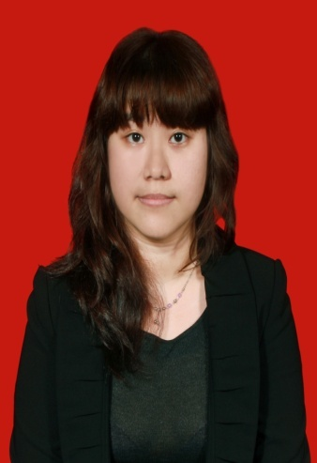Personal Information
Name : Grace Aditya Gunawan
Address : Daan Mogot Estate block JA no.5
Jakarta Barat, Jakarta 11720
Phone Number : +6221 – 5412841
Cell Number : +62877 888 92 211
Email Address : grc_gnwn@windowslive.com
Place, Date of Birth : Jakarta, August 6th, 1992
Nationality : Indonesian

Educational Backgrounds
2010 – 2014 Swiss German University (SGU) Faculty of Business Administration, Department of Hotel and Tourism Management
2007 – 2010 Dian Harapan High School
- Graduated from Science Class.
- Activities: Student Committee
Work Experience
January, 2015- present Fiwi Lestari International (Avia Tour)
Jakarta, Indonesia
Position: Web Admin Support
- Forwarding emails from guest to respective department
- Handling customers’ requests and complains (via email)
- Assisting manager on handling customers
March, 2013- August 2013 Langwieder See Hotel, OHG
Muenchen, Germany
Position: Server- On the Job Training
- Food and beverage serving
- Taking orders
- Preparing tables
- Helping in banquet service
August 2011- February 2012 Ritz Carlton Jakarta Pacific Place
Jakarta, Indonesia
Position: Butler Service- On the Job Training
- Answering phones from inside and outside
- Transferring call
- Solving internet problems
Position: Guest Recognition Agent- On the Job Training
- Escorting guests to the room
- Check reservation
- Writing welcome cards
April 2010 Hypermart Puri Indah
Jakarta, Indonesia
Position: Cashier- On the Job Training
- Cashiering
Position: Baker- On the Job Training
- Baking cakes, cookies, bread
Informal Educations
2010 – 2013 A2 level at EURO German Course, BSD, Tangerang

Volunteer Experience
April 2010 Pangudi Luhur, SLBB
Position: Teacher assistant- On the Job Training
- Assisting teaching disable teenagers
Language Skills
- Indonesian (Mother Tongue)
- English (Level: Upper Intermediate; Good Spoken and Writing)
- Deutsch (Level: A2 teil 1; Good Spoken and Writing)
- Mandarin (basic conversation)
Computer Skills
- Microsoft Office (Word, Excel and PowerPoint)
- Micros Fidelio
- Opera
- Micros
Interests
- Traveling
I do really love traveling, it is not only relaxing but it also makes me learn a lot of things. Cultures, culinary, adventure, history from different places in this world are interesting to learn. Meeting new foreign people and becoming friends is interesting for me.
- Singing
I do sing a lot every single day because I just love music even I can’t play any music instruments. This is the only hobby that last since I was a kid because back then and in high school I joined choir club.
- Watching
Besides from traveling, I also learn a lot from movies. By watching, it is not only adding my vocabulary and it also help me learn several languages. I usually learn foreign faster by watching and hearing from movies.

