Curriculum Vitae

Herlina Natalia
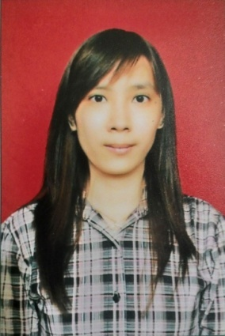
PERSONAL INFORMATION
Place of Birth : Jakarta
Date of Birth : December 25th, 1990
Marital Status : Single
Nationality : Indonesian
Address : Jl. Gambir No. 16
Pekanbaru - Riau
Mobile Phone : +62 813 7216 3737
E-mail address : lina_chan2512@yahoo.co.id

EDUCATION
- 2008-2012 : Polytechnic of Caltex Riau, Pekanbaru
      - Major: Information Technology (GPA 3.60/4.00)
      - Predicate : Cum Laude
- 2005-2008 : Santa Maria Senior High School, Pekanbaru
      - Major: Natural Science
- 2002-2005 : Santa Maria Junior High School, Pekanbaru
- 1996-2002 : Santa Maria Elementary School, Pekanbaru
WORKING EXPERIENCE
2013 – Now : Image Printing Solutions
Accounting
2012 – 2013 : PT. Cipta Agro Sejahtera
Accounting

ORGANIZATIONAL EXPERIENCE
- 2008 – 2012 : Member of Permadhis (Persaudaraan Mahasiswa Buddhis), Polytechnic of Caltex Riau
- 2008 – 2012 : Member of ITSA (Information Technology Student Association), Polytechnic of Caltex Riau

COMMITTEE
- 2010 : Applied Engineering Seminar
- Position: Staff of Consumption Division
- 2009 : New Members (2009 generation) Inauguration ITSA of PCR
- Position : Staff of Event Organizing Division
- 2008 : New Members (2008 generation) Inauguration Permadhis of PCR
- Position: Staff of Event Organizing Division

LANGUAGE
Language | Reading | Writing | Speaking | Listening
English | Good | Good | Good | Good

SKILL AND INTEREST
I have some skills in using computer, they are:
- Office & Editing tool: - Microsoft Office
- Programming Language : - Java
- ASP.net
- VB.net
- HTML
- Graphical Design Tool : - Adobe Photoshop

