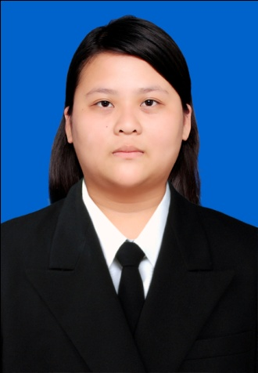

Michelle Cynthia Septriliana, S.E
Kp. Sewu Jl. Masjid rt. 01/rw. VI no. 23, Jebres, Surakarta, 57123
Central Java, Indonesia
Contact Number:
HP: (+62)8563934499/(+62)82225846090; Home: (+62271) 656525
Email:
cynthia_lie91@yahoo.com

P e r s o n a l D e t a i l s :
Sex | : | Female
Place of Birth | : | Surakarta, Jawa Tengah, Indonesia
Date of Birth | : | September 15th, 1991
Marital Status | : | Single
Religion | : | Christian Protestan
Nationality | : | Indonesia
GPA | : | 3.3034 (scale of 4.00)
Thesis Title | : | The Impact Of Corporate Social Responsibility Disclosure Toward Institutional Ownership Of Indonesian Public Listed Companies

E d u c a t i o n a l B a c k g r o u n d :
School |  | Place | Period
University | : | Bachelor’s Degree (S1) of Universitas Atma Jaya Yogyakarta, International Business Management Program, Faculty of Economy | 2009 - 2013
Senior High School | : | SMA Kristen Kalam Kudus, Surakarta | 2006 - 2009
Junior High School | : | SMP Pangudi Luhur Bintang Laut. Surakarta | 2003 - 2006
Elementary School | : | SD Kristen Widya Wacana VI, Surakarta | 1997 - 2003

S e m i n a r a n d T r a i n i n g C o u r s e :
- Participant in the initiation at Atma Jaya Yogyakarta University in 2009
- Participant in the personal development and training at Atma Jaya Yogyakarta University in 2009, materials of the training are adversity quotient, goal setting and commitment
- Involved in community service at Gunungkidul, Yogyakarta for one month developing the village with six programs, such as village’s natural resources potential mapping, health, education, cencus and gateway designing.
- Certificates of joining the seminars:
  - “Mendorong Terwujudnya Yogyakarta Incorporated”
  - “Mahasiswa Berinvestasi di Pasar Modal, Siapa Takut?‼!”
  - “The Role of Public Universities to Sustain Global Competitive Advantage: A Malaysian Perspective” and “Organisational Learning as An Antecendent of Technology Transfer and New Product Development: A Study of Manufacturing Firms in Malaysia”

I n v o l v e m e n t i n E x t r a C u r r i c u l u m A c t i v i t i e s :
- Gathering night committee at Atma Jaya Yogyakarta University gathering night for International class student in year 2011
- Committee of BRI 3 on 3 Rebound at Universitas Sanata Dharma in year 2011
- Secretary of community service group for year 2013

P e r s o n a l P r o f i l e :
- Enthuastic, eager to meet challenges and quickly assimilate the newest and latest knowledge of skills, concepts, and ideas.
- Strong leadership and partnership builder with exceptional interpersonal and communication skills.
- Person who can work independently and handle multiple priorities and deadlines.
- Quick learner who can rapidly master all aspects of job with limited training.

W o r k i n g E x p e r i e n c e s :
Position |  | Company | Period
Exim Staff | : | PT. Sri Rejeki Isman Tbk., Sukoharjo, Solo | March 2014 - Present

F o r e i g n L a n g u a g e:

Language | Specification
English | Oral and Writen

I hereby, declare that all information above is true and correct to the best of my knowledge.

Surakarta, April 15th, 2015
Regards,

Michelle Cynthia Septriliana, S.E

