CURRICULUM VITAE
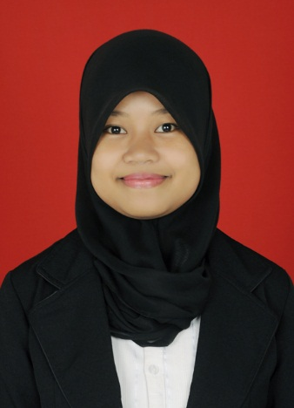

- PERSONAL DETAILS
Name : Wiska, S.S.
Place, Date of Birth : Bunne, 01 June 1993
Sex : Female
Nationality : Indonesia
Religion : Islam
Marital Status : Single
Height, weight : 150 cm, 43 kg
Last Education : Undergraduate
Address : Jln. Sultan Alauddin, Makassar
Phone Number : 085299161304
Email : wiska.azisani@gmail.com
TOEFL Score : 527

- EDUCATIONAL DETAILS
1999 – 2005 SDN 151 Bunne, Kab. Soppeng
2005 – 2008 SMPN 4 Marioriwawo, Kab. Soppeng
2008 – 2011 SMAN 1 Liliriaja, Kab. Soppeng
2011 – 2015 Universitas Negeri Makassar,
Fakultas Bahasa dan Sastra,
SASTRA INGGRIS.

- COURSE & ORGANIZATION EXPERIENCES
2015 (August - November): English Community of Kediri
2015 : Member of Hello Private Institute

- WORK EXPERIENCES
2016 (February) : 4JO Operation (Training for Teacher Position)
2016 (March – now) : Maesa Management (Freelance English Teacher)

- BASIC SKILLS
Languages : Indonesia (active)
: English (active)
: Buginese (active)
Computer : Ms. Word
: Power Point
: Internet

