 | Indra Kusmawan
2/10/2016
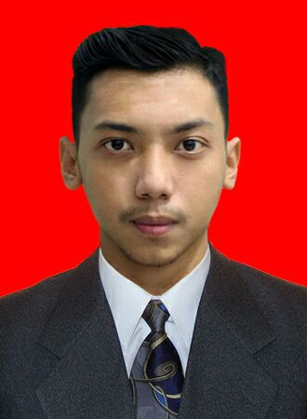 | Address : Jl. H. Baping Gg. Setia Rt03/09 No.77 Ciracas, Ciracas, Jakarta Timur  Contact Number : 08996830168  Email Address : Indrakusmawan83@gmail.com  Place and Date of Birth : Jakarta, 24 September 1997

Objectives
Hard worker, be able under pressure condition and high spirit, Enjoys working in team
Education
University : Mercu buana University, Information System 2015 - Present
Vocation High School : SMKN 51 Jakarta, Broadcasting 2012 - 2015
Junior High School : SMPN 174 Jakarta 2009 - 2012
Elementary School : SDN Ciracas 07 2003 - 2009
experience
Camera Person | Agro Tv Indonesia
13 Juni 2015 – Present
Freelancer Video Editor & Videographer
2012 - Present
skills
- Be Able operating Camera Video and DSLR
- Be Able operating Adobe ( Adobe Premiere,After effect, Photoshop)
- Be Able operating Microsoft Ofice ( MS.Word, MS. Excel, Power Point )
- Installating Operating System and Software
- Analysis and troubleshoot Computer

Seminar and training
• Workshop LA Indie Movie (2013)
• Workshop Kine Club (2013)
• Workshop Eagle Junior Documentary (2013)
• Workshop Anti Narkoba (2013)
• Field Practice In SCTV Televisi as Production assistant, Floor Director, And Camera Person (2014)
Languange Skill
Nativ : Indonesia
Foreign : English
Hobby
• Playing Futsal
• Playing game
• Swimming
Awarded and achievment
• 5 Finalist Festival Film Pendek Kompas TV 2015 Title film “ Kota Pusaka” as director
• General Champion In Broadcasting SMKN 51 Jakarta

