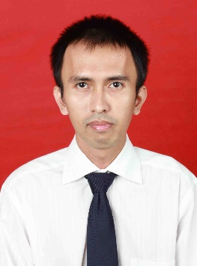
Curriculum Vitae

Personal Details
Full Name | Douglas Maruhum Asido Pangaribuan
Nick Name | Douglas
Gender | Male
Place and Date of Birth | Medan, 30 November 1988
Religion | Christian
Blood Type | A
Address | Karya II Sei Agul Komplek Pemda No. 36, Medan
Phone Number | 081912756776
E-mail Adress | amarant.flaming@live.com
Facebook | Douglas Pangaribuan
Marital Status | Single
Nationality | Indonesia
Interested In | Foreign Language, Japanese Cultural Studies, World History, International Politics

Educational Background

- FORMAL
Year | Education
1992 – 1994 | Kalam Kudus Christian Kindergarten, Ambon
1994 – 1995 | Kalam Kudus Christian Elementary School, Ambon
1995 – 2000 | Immanuel Christian Elementary School Pontianak, West Borneo
2000 – 2003 | Immanuel Christian Junior High School Pontianak, West Borneo
2003 – 2006 | Immanuel Christian Senior High School Pontianak, West Borneo
2006 – 2013 | Padjadjaran University Faculty of Social and Political Science Department of International Relations

- INFORMAL
Year | Education
2002 – 2003 | Ganesha Operation Education Course
2005 – 2006 | Ganesha Operation Education Course
2007 | Christian Leadership Training, held by Christian Student Communion of Social and Political Science Faculty

Achievements
Year | Achievements
2003 | English Speech Contest Senior High School Level , 3rd place

Organization Experience
Year | Organization | Position
2007 – 2008 | Christian Student Communion of Social and Political Science Faculty | Vice-Chief of Music Division

Committee Experience
Year | Event | Position
2008 | Christian Freshmen Students Orientation | Chief of Committee
2008 | Christmas Event in Christian Student Communion of Social and Political Science Faculty | Chief of Transportation and Logistics Division

Skill
- Microsoft Office Word
- Microsoft Office Excel
- Microsoft Office Power Point
- Microsoft Office Access
- English (fluent in speaking and writing with latest TOEFL score 568), and Japanese (passively restricted to daily conversation)

Ability
- Able to work in a team
- Able to make organized schedule
- Public speaking
- Quick learner by self-taught

Best Regard,

(Douglas Maruhum Asido Pangaribuan)

