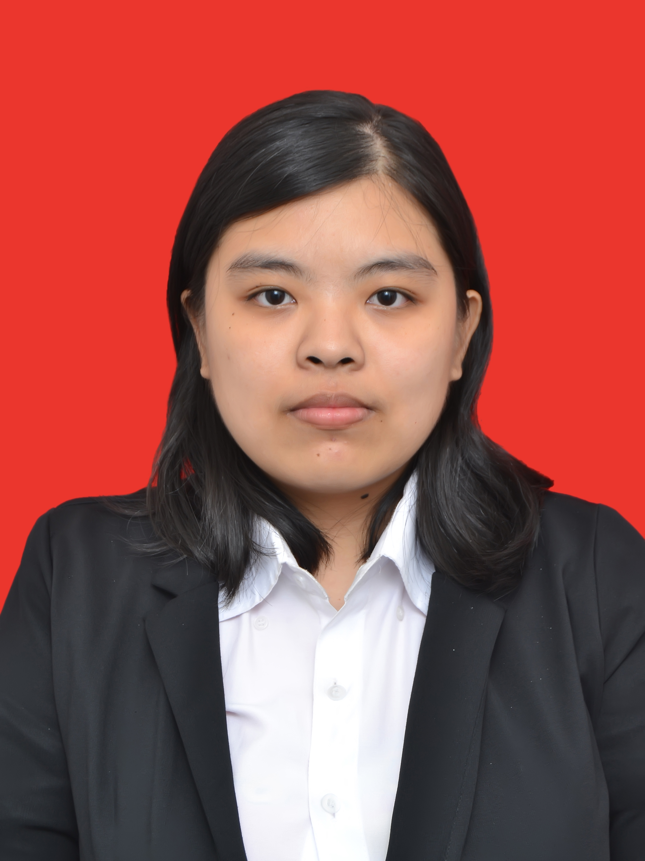

Nama : Narumi Hartandi
Tempat, Tanggal Lahir : Jakarta, 28 Juli 1995
Jenis Kelamin : Perempuan / Female
Alamat : Jl. K.H. Syahdan Gg Keluarga no 36 A RT 06 / RW 12
Kemanggisan, Palmerah, Jakarta Barat
No. Handphone : 085892167989
Agama : Budha
Status Kewarganegaraan : WNI
Status Perkawinan : Belum Menikah
NIM : 1701304651
Email : nana_hartandi@yahoo.com / narumeow1995@gmail.com
Universitas : Universitas Bina Nusantara
Jurusan : Teknik Informatika

Latar Belakang Pendidikan / School Background
Pendidikan Formal / Formal Education
1999 – 2001 -> TK Petra Alpha School, Jakarta Barat / Preschool.
2001 – 2007 -> SD Petra Alpha School, Jakarta Barat / Primary School.
2007 – 2010 -> SMP Petra Alpha School, Jakarta Barat / Junior High School.
2010 – 2013 -> SMAK Penabur, Bandar Lampung / Senior High School.
2013 – Sekarang -> BINUSIAN 2017 – BINUS University, School of Computer Science, IT.

Keahlian / Skill
- Kemampuan Pemrograman / Programming Skill
- Web Programming – Front End Developer;
- C, C++, C#, Java.
- Desain / Design
- Adobe Photoshop;
- Adobe Illustrator;
- Adobe Indesign.
- Kemampuan Menulis / Writing Skill
- Story Writing and Short Story Writing;
- Technical and Documentation Writing;
- Article Writing;
- Blog Writing;
- Synopsis Content Writing;
- Journalism Writing;
- Creative Writing.
- Kemampuan Berbahasa / Foreign Language Skill
- Bahasa Indonesia – Lancar / Indonesia Language – Fluent;
- Bahasa Inggris – Lancar / English Language – Fluent;
- Bahasa Mandarin – Dasar / Chinese Language – Beginner.

Pengalaman Kerja / Work Experience
- 2015
- Private Tutoring Teacher – Mandarin Language and English Language for 5th Grade.
- Social Media Specialist – Leeshoeshop.
- 2016
- Internship (1st March 2016 – 28th Feburary 2017) – PT Sola Interactive.
- Social Media Specialist – Leeshoeshop.
- Editor – Leeclothingshop.
- Private Tutoring Teacher – Physics and Mathematics for 8th Grade.
- Private Tutoring Teacher – Physics and Mathematics for 9th Grade.
- Freelance – Data Entry at Magna Digital Lab
- Freelance – Data Entry at Qlapa.com

Pengalaman Organisasi / Organization Experience
- 2013 – 2014
- Teach For Indonesia 3rd Generation
- Volunteer and Committee (Pengurus) Education Division (Divisi Pendidikan).
- BNMC (Bina Nusantara Mandarin Club) 15th Generation
- Candidate Activist MIT, Design Division.
- KMBD (Keluarga Mahasiswa Buddhist Dhammavaddhana) 25th Period
- Activist at Information and Technology Division 4th Division, Sub-division Design.
- BNCC (Bina Nusantara Computer Club)
- Activist at File-Magz.
- Buddy Coordinator Freshmen Enrichment Program 2018
- Buddy Coordinator in Class (5th Batch).
- 2015
- Teach For Indonesia 4th Generation
- Volunteeer and Vice President of Structural Teach For Indonesia 4th Generation.
- Buddy Coordinator Freshmen Enrichment Program 2019
- Buddy Coordinator in Class (1st Batch and 6th Batch).
- Mobile Buddy Coordinator(3th Batch).
- KMBD (Keluarga Mahasiswa Buddhist Dhammavaddhana) 26th Period
- Committee at Information and Technology Division 4th Division, Sub-division Maintenance.

Pengalaman dalam Acara / Event Experience
- 2013
- Teach For Indonesia Sharing Culture 2013 – Volunteer.
- Teach For Indonesia PKPT (Pekan Keanekaragaman Permainan Tradisional) 2013 – Committee.
- Teach For Indonesia Garage Sale 2013 - Committee
- 2014
- KMBD (Keluarga Mahasiswa Buddhist Dhammavaddhana) Magha Puja 2014 – Member of Design and Documentation Division.
- BNMC (Bina Nusantara Mandarin Club) National Mandarin Competition 2014 – Member of Competition Division
- KMBD (Keluarga Mahasiswa Buddhist Dhammavaddhana) Buddhist Festival 2014 – Member of Funding Division.
- BNMC (Bina Nusantara Mandarin Club) Charity 2014 – Master of Ceremony.
- Teach For Indonesia ‘Bunga Rampai dan Expo’ 2014 – Project Manager.
- Indonesia Independence Day Event at Binus University – Volunteer.
- Africa Humanitarian Mission 2014 from Yayasan Amitofo Centre – Volunteer.
- Teach For Indonesia Garage Sale 2014 – Volunteer.
- Jakarta Marathon 2014 – Volunteer and Coordinator Volunteer for Race Pack Collection and VIP Lounge.
- KMBD (Keluarga Mahasiswa Buddhist Dhammavaddhana) Kathina Puja 2014 – Member of Choir for Sangha Dana.
- KMBD (Keluarga Mahasiswa Buddhist Dhammavaddhana) Dhamma Talk 4th Division ‘Mempraktikan Sila di Era Digial’ 2014 – Coordinator of Reception Division.
- Teach For Indonesia PKMN (Pekan Keanekaragaman Makanan Nusantara) 2014 – Coordinator of Consumption Division.
- Waisak Tzu Chi 2014 – Volunteer.
- 2015
- KMBD (Keluarga Mahasiswa Buddhist Dhammavaddhana) ‘Berkarya, Berseni, Membantu’ 2015 - Member of Design and Documentation Division.
- Jakarta Marathon 2015 - Coordinator Volunteer for Race Pack Collection.

Tambahan Informasi/Additional Information
- Author
- 2011 – Sekarang/Now
- Author name: nanashiningprincess
- Personal wordpress : mysuperkpopstory.wordpress.com
- Author at Readfanfiction, Fanfiction Community at Wordpress

