Especially for Book Lovers: How to Utilize Books for Home Decoration

Dear book lovers, we understand your feelings! Every time you passed a bookstore, you just can’t keep the urge to buy new books, yet you keep on loosing space to store it back home. Each and every book is an important collection, which needs to be preserved and kept. Every single day, you dream of having a tranquil place to store and read your books peacefully.
And here we come with some ideas on how to use your mountainous pile of books into an artistic part of your home decorations. It will help to avoid having unplanned clutter of books or magazines at every corner of your house. We believe a tidy and neat house will bring peace and serenity to its users as well. Get inspired by these beautiful book shelves and clever book storage ideas:
- Divider for different space function
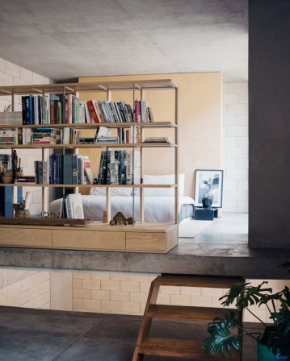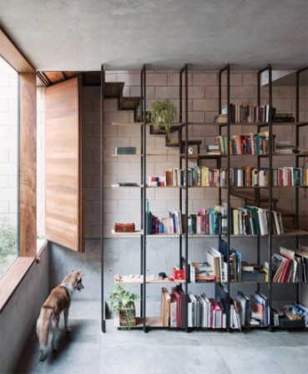
Photos from: dezeen
Bookshelf is a perfect divider of space if we aim for open space living. Often happened, we create unnecessary walls or partition to separate different space function. Which in the end makes a space looks smaller, darker, and heaty; cause a solid material blocks one’s eyesight, light, and air flow. Having a bookshelf with some porous in it enable users to differentiate space function while still maintaining those important quality in space.
- Along the hallway
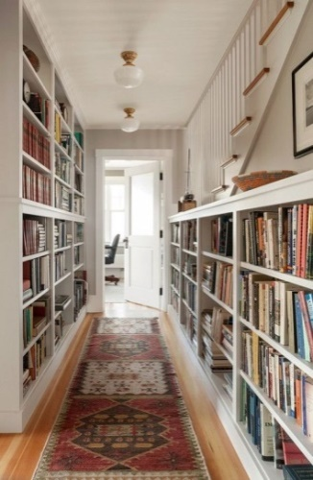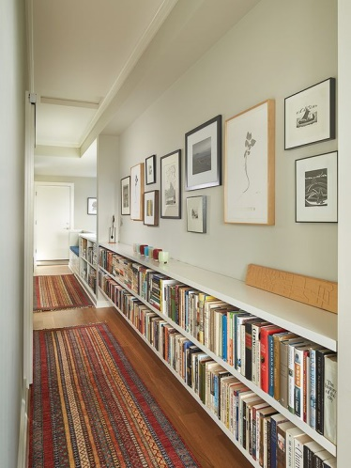
Photos from: Homedit, rb-a
Only by adding few additional inches on your hallway, you can dramatically add space for book storage by installing beautiful bookshelf. Not only it’s aesthetically pleasing, having it on the hallway avoid the confusion of furniture arrangement options that might occur on living area or bedroom.
- Functional stairs
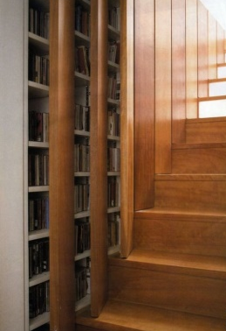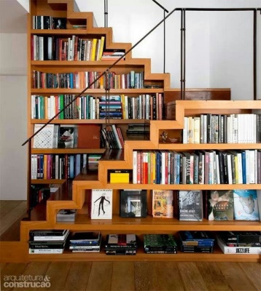
Photos from: Homebeautiful, Arquitetura&Construcao
Whether you want it as a hidden storage by installing wooden covers or exposed your great collection of books, space beside the stairs is always an ingenious solution for book storage problem.
- Make a nook beside a window
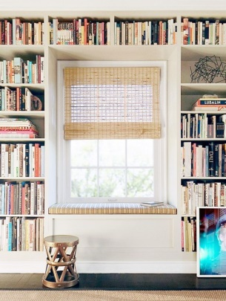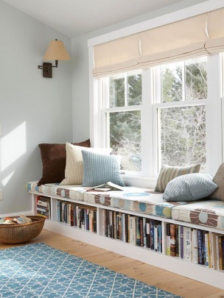
Photos from: MyDomain, BHG
If you have a spare in the living room, having this comfortable reading nook beside the window is perfect for book lover’s sanctuary. Using the window seat as secret storage cabinet underneath is a clever idea to make use each space provided.
- Camouflage for a secret room

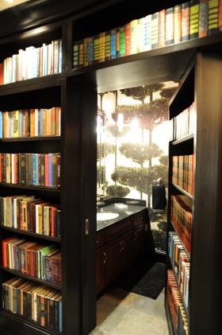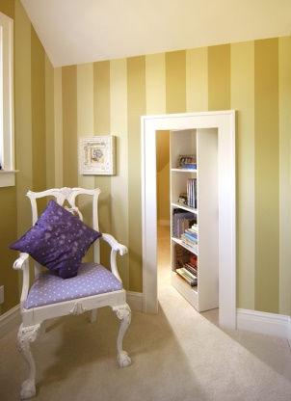
Photos from: Huffingtonpost
Hidden room is the coolest home feature, for sure. Who wouldn’t want a bookshelf that conceals a secret passageway or a door opens to a tiny-jewel box-like space? We’ll never get tired of peeking through these surprising rooms.
- Reuse recycle material
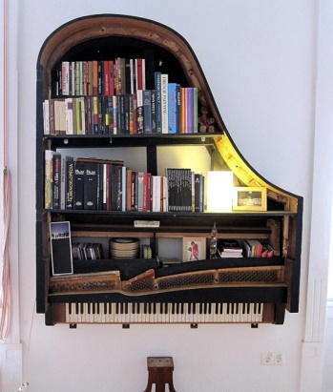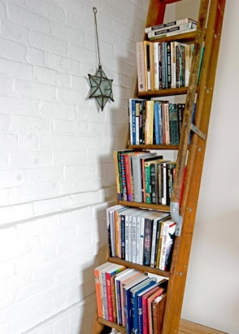
Photos from: Restnova, HGTV
Don’t throw out that old grand piano or wooden ladder that’s been gathering cobwebs in your garage for years. With some simple repairs, such as putting sealcoat or paint it to match or make contrast with the rest of your décor, it makes an intriguing design statement.
- Bunk bed staircase bookcase
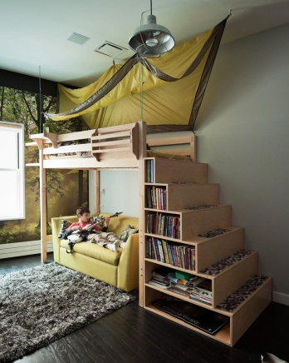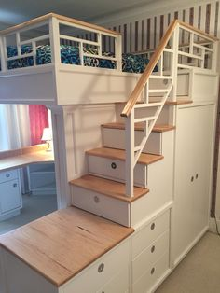
Photos from: HGTV
Having stairs for the child’s bunk bed enables you to store books on its hollow space.
- Children’s room bookcases
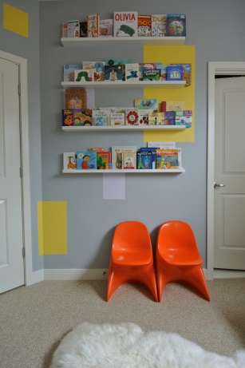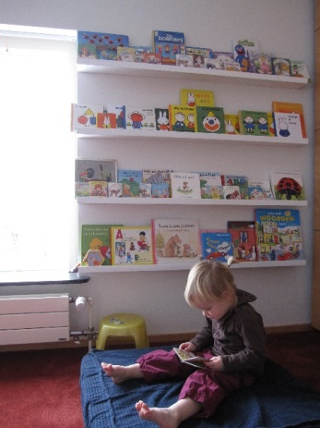
Photos from: HGTV, Babble
Children’s book covers are such a work of art, why not display them as such, rather than tossing them in a pile or placing them so that only the spine shows? Narrow shelves that allow you to display books with the cover out add pops of bright color and interest, helping children make that all-important decision about what story to read before they go to sleep.

