ERWIN HERMANTO  Personal Data  Place of Birth : Bandung  Date of Birth : 31 - 07 – 1993  Gender : Laki-laki  Religion : Islam  Citizen : Indonesia  Status : Single  Addres : Jl. Cimuncang Gg. Kretek IV No.103/208c Kec. Cibeunying Kidul Kel. Padasuka Kota Bandung  Contact  Phone : 081223486798  Email : erwinhermanto31@gmail.com  Organizational Experience  BEM STMIK BANDUNG  - Koordinator Hubungan Masyarakat 2013  BEM STMIK BANDUNG  - Ketua BEM 2014  Perhimpunan Mahasiswa Bandung  - Sebagai Anggota Biasa 2014 2014 | CURRICULUM VITAE  Experience  Diskominfo Jawa Barat  Apprentichesip as a Programmer 2015  PT. Inovasi Tritek Informasi  - As a Web Programmer 2015  PT. Axelinsights  - As a Web Developer 2016  PT. Cakra Syntesis Indonesia  - As a Web Developer 2017  Education  STMIK BANDUNG 2012 – 2015  SMA MUHAMMADIYAH BERAU(KAL-TIM) 2009 – 2012  SMP MUHAMMADIYAH BERAU(KAL-TIM) 2006 – 2009  SDN CIMUNCANG 3 BANDUNG 2000 – 2006  Non-Formal Education  LIPI Bandung dan UPI  - Temu Ilmiah Peneliti dan Mahasiswa 2012  Universitas BSI  - Seminar Think Smart as Fast as AMD 2014  LIPI Bandung  - Workshop Open Source Software dan IGOS Nusantar 2014
 | Competence
 | Programming Languege  Php  Javascript  Java  Basic  C++  Pascal  Swift  Database  Mysql  Sql Server  Web Framework  CodeIgniter  Laravel  Spring  Git UI  Source Tree  Github UI | Repository  Github  Bitbucket  Gitlab  Task Management  Trello  Multimedia  Photoshop  Camtasia  Camstudio  Coreldraw  Content Management System  Wordpress  Joomla  Blogspot

IT PROJECT EXPERIENCE 1

Project Name | Manajemen Organisasi Puskesmas Jakarta Timur
Project Description | Hospital organization management jakarta using berbasisi application website where web-based application that provides the management of the hospital in east Jakarta, financial applications, sms gateway for the data community health center services contain patient data community health center services in east Jakarta.
Period (mm-yyyy) | November-2015 | Until | Feb-2016
Company Name | PT Inovasi Tritek Informasi
Client’s Name | Ministry of Health
Role/ Position | Web Programmer
Programming Language | Php Framework Codeigniter 2
Database | Mysql Phpmyadmin
Development Tools | XAMPP,Sublime Text, source tree , navicat, and trello
Description of personal job assignment | - Create master data modules  - Create master data modules
Developer Team | - 1 IT Project Manager
 | - 1 IT Analyst
 | - 1 Software Tester
 | - 3 Programmer

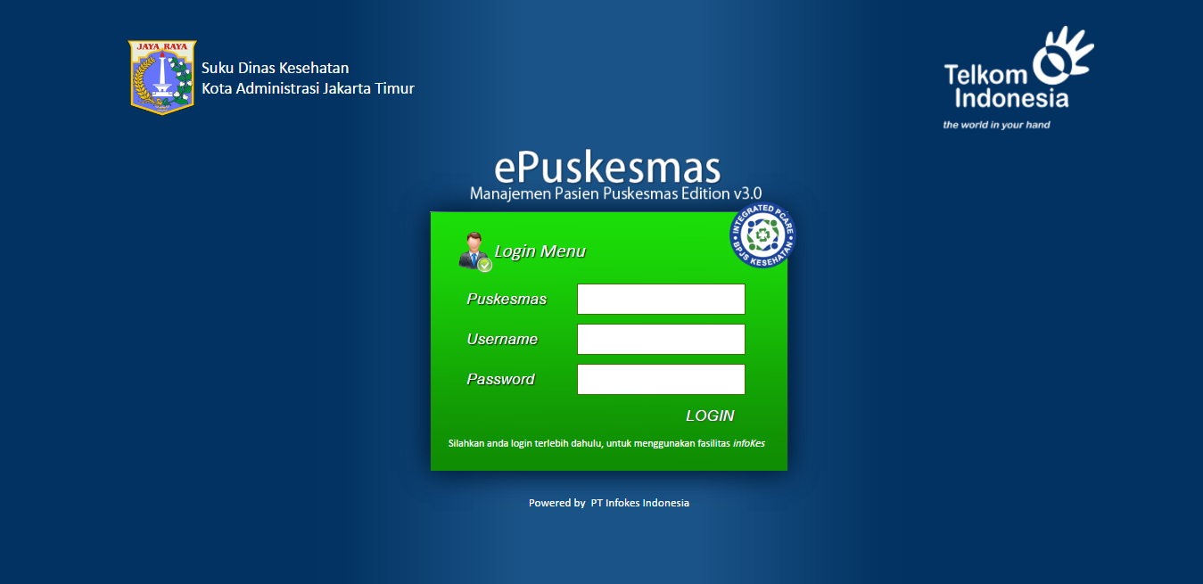
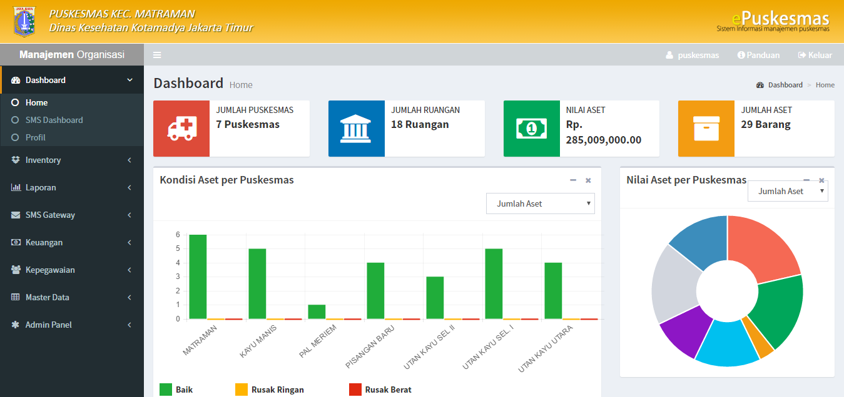
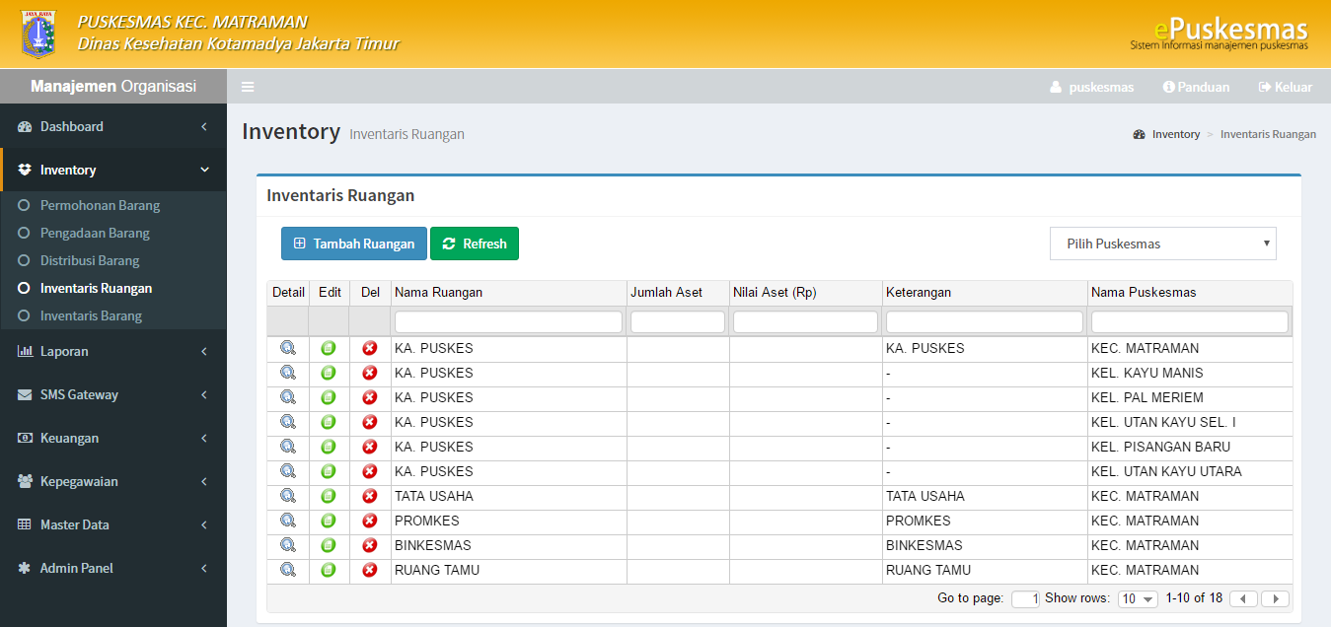

IT PROJECT EXPERIENCE 2

Project Name | Analysis Development Unit Price
Project Description | This application contains the price of building materials and labor price of existing buildings throughout Indonesia that are tailored to different prices in each province.
Period (mm-yyyy) | Feb-2015 | Until | April-2016
Company Name | PT Axelinsights
Client’s Name | Center for Research of housing and public works ministry settlements
Role/ Position | Front End Devepoler
Programming Language | Php Framework Codeigniter 2
Database | Mysql Phpmyadmin
Development Tools | XAMPP,Sublime Text, source tree , navicat, and trello
Description of personal job assignment | - Make an appearance on the application
Developer Team | - 1 IT Project Manager
 | - 1 IT Analyst
 | - 1 Software Tester
 | - 2 Programmer

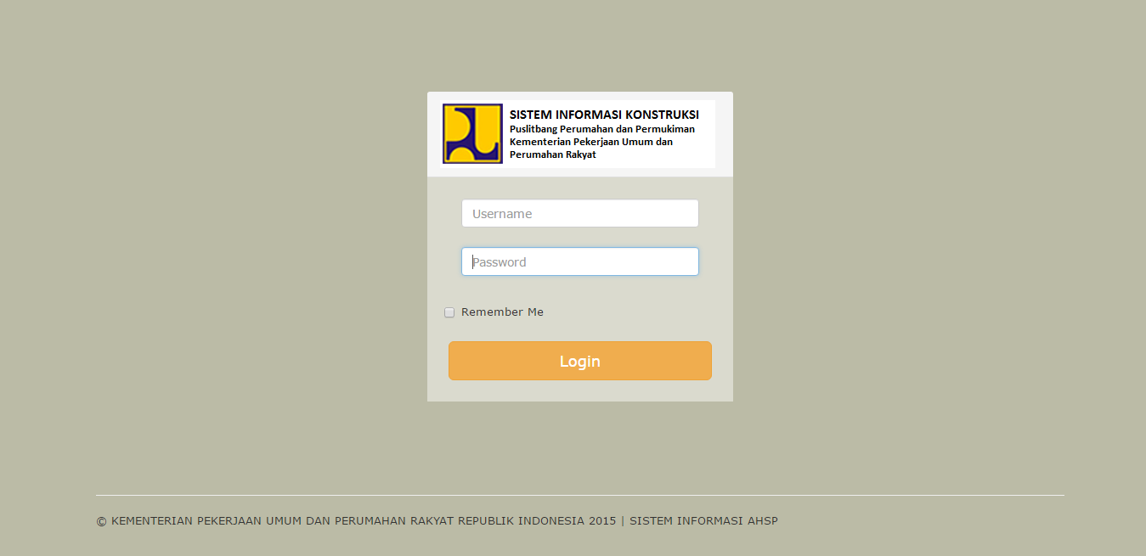
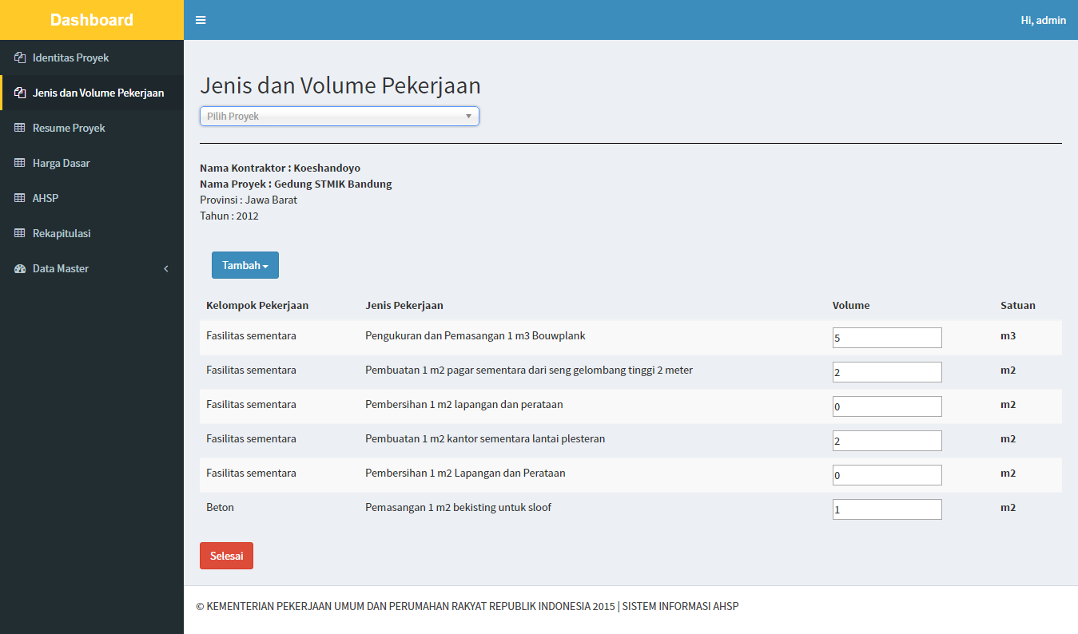
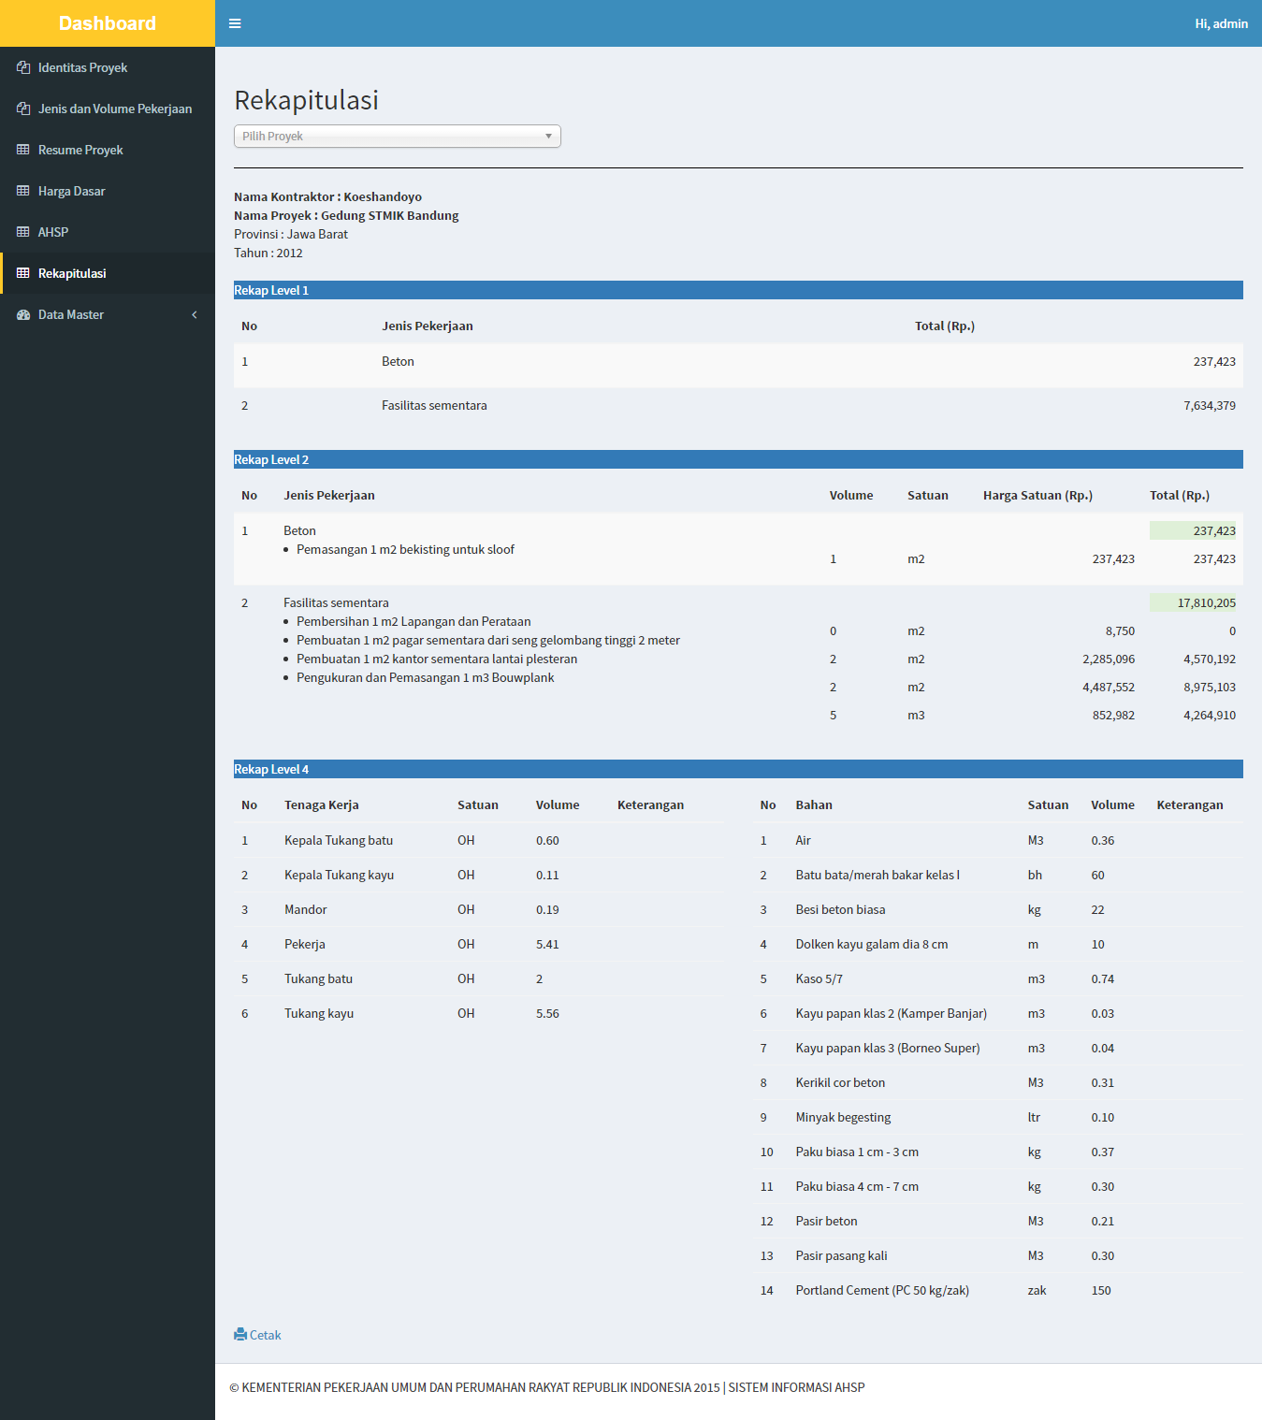

IT PROJECT EXPERIENCE 3

Project Name | Publik Fire Information System
Project Description | This system contains information fires throughout Indonesia which is presented in the form of maps that contain the coordinates of the fire using geo server and also lists fire data in table form.
Period (mm-yyyy) | Desember-2015 | Until | Feb-2016
Company Name | PT Axelinsights
Client’s Name | Center for Research of housing and public works ministry settlements
Role/ Position | Web Developer
Programming Language | Php Framework Codeigniter 2
Database | Mysql Phpmyadmin
Development Tools | XAMPP,Sublime Text, source tree , navicat, and trello
Description of personal job assignment | - Make a list of fire data that exist throughout Indonesia in the form of a table list  - Make a list of fire data that exist throughout Indonesia in the form of map that shows the location coordinates of fires
Developer Team | - 1 IT Project Manager
 | - 1 IT Analyst
 | - 1 Software Tester
 | - 1 Programmer
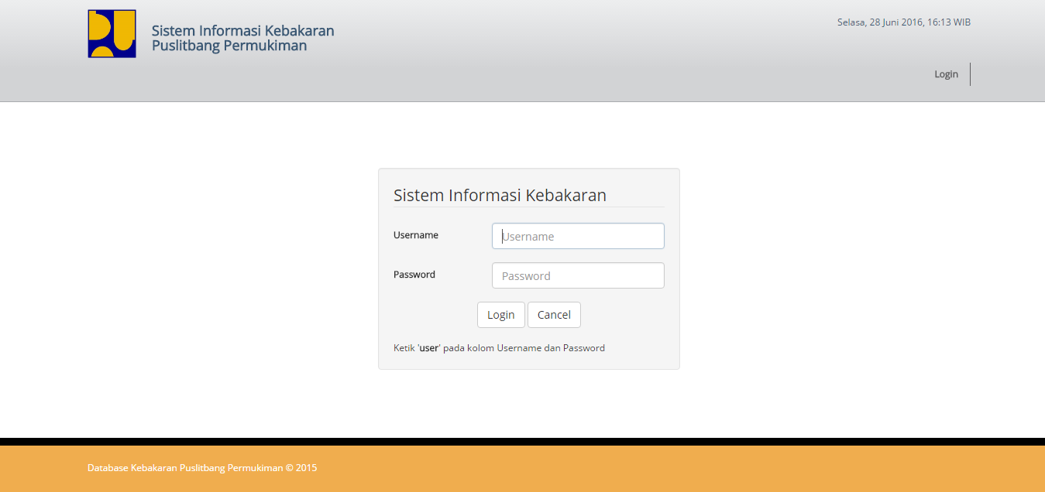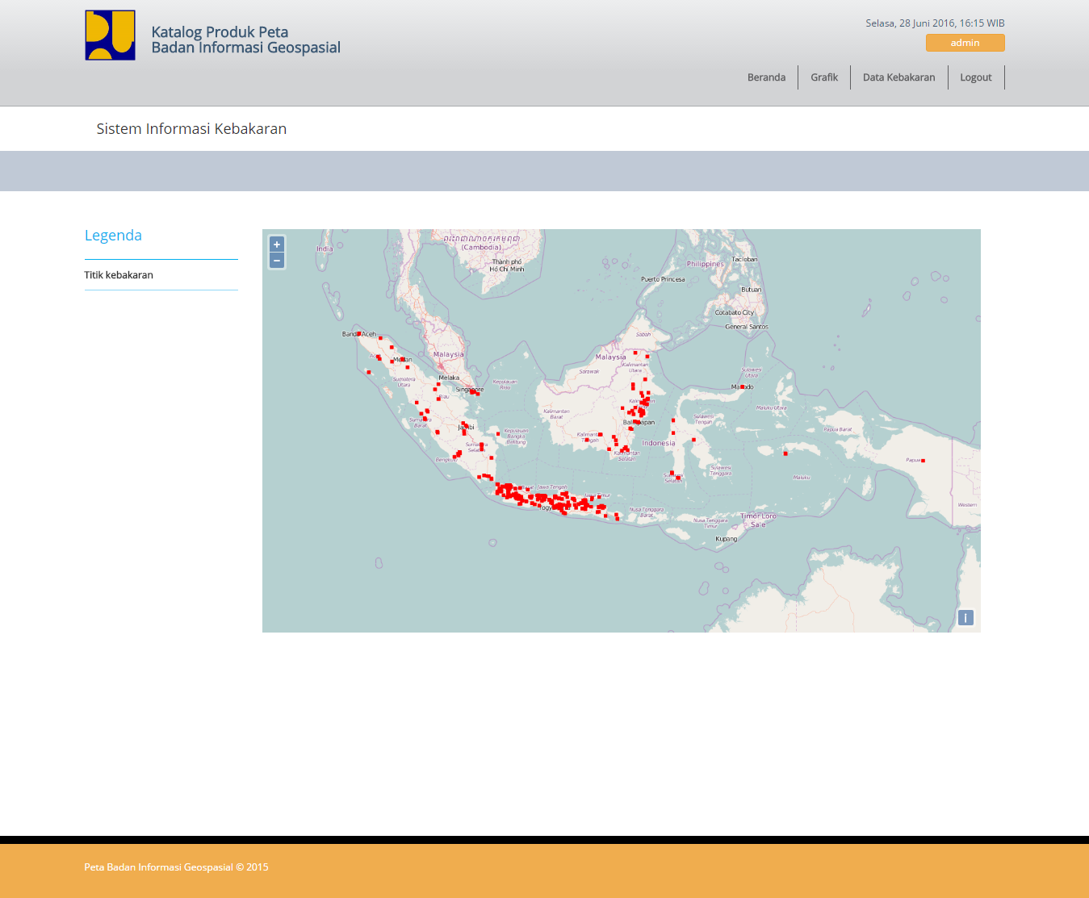
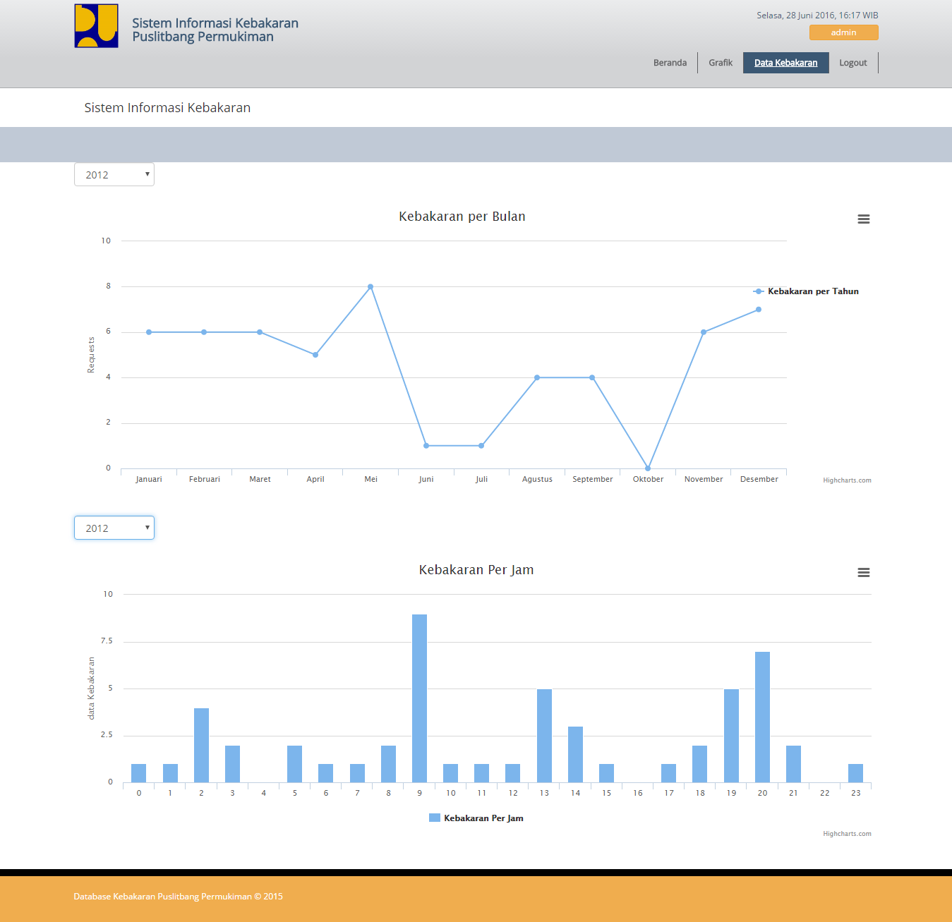
IT PROJECT EXPERIENCE 4

Project Name | SOP Management / Document Management System
Project Description | The document management system application that is used to manage documents in the company mainly S.O.P or standard operating procedures, applied, there are modules to create the document or send the document to kepegawai or part of the company untuklangsung S.O.P read her sent to the relevant.
Period (mm-yyyy) | Januari-2016 | Until | Mei-2016
Company Name | PT Axelinsights
Client’s Name | PT Aganza International
Role/ Position | Web Developer
Programming Language | Php Framework Codeigniter 3
Database | Mysql Phpmyadmin
Development Tools | XAMPP,Sublime Text, source tree , navicat, and trello
Description of personal job assignment | - create a module for user management  - make access to shipping documents
Developer Team | - 1 IT Project Manager
 | - 1 IT Analyst
 | - 1 Software Tester
 | - 1 Programmer
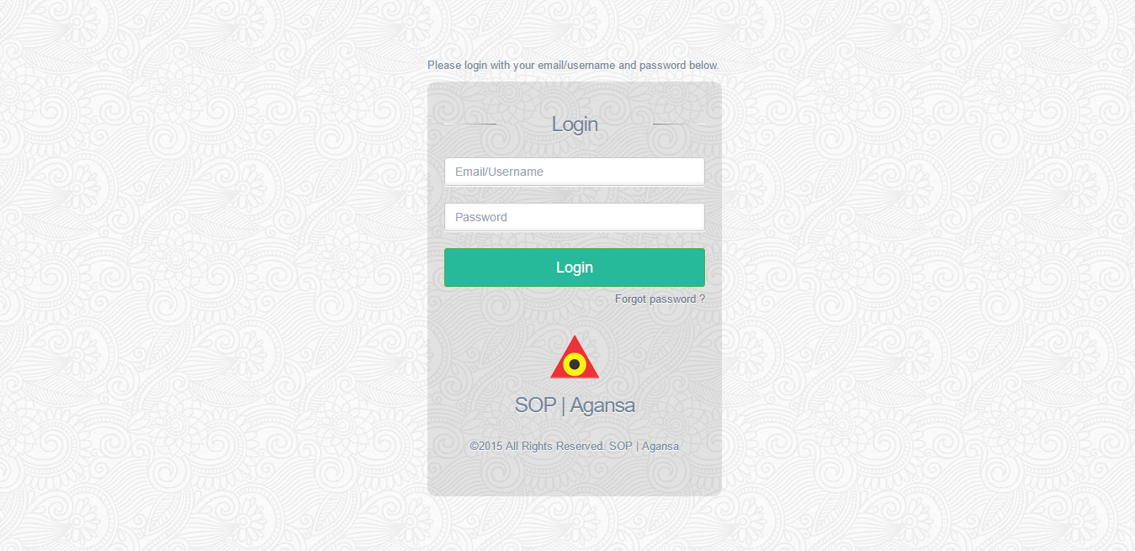
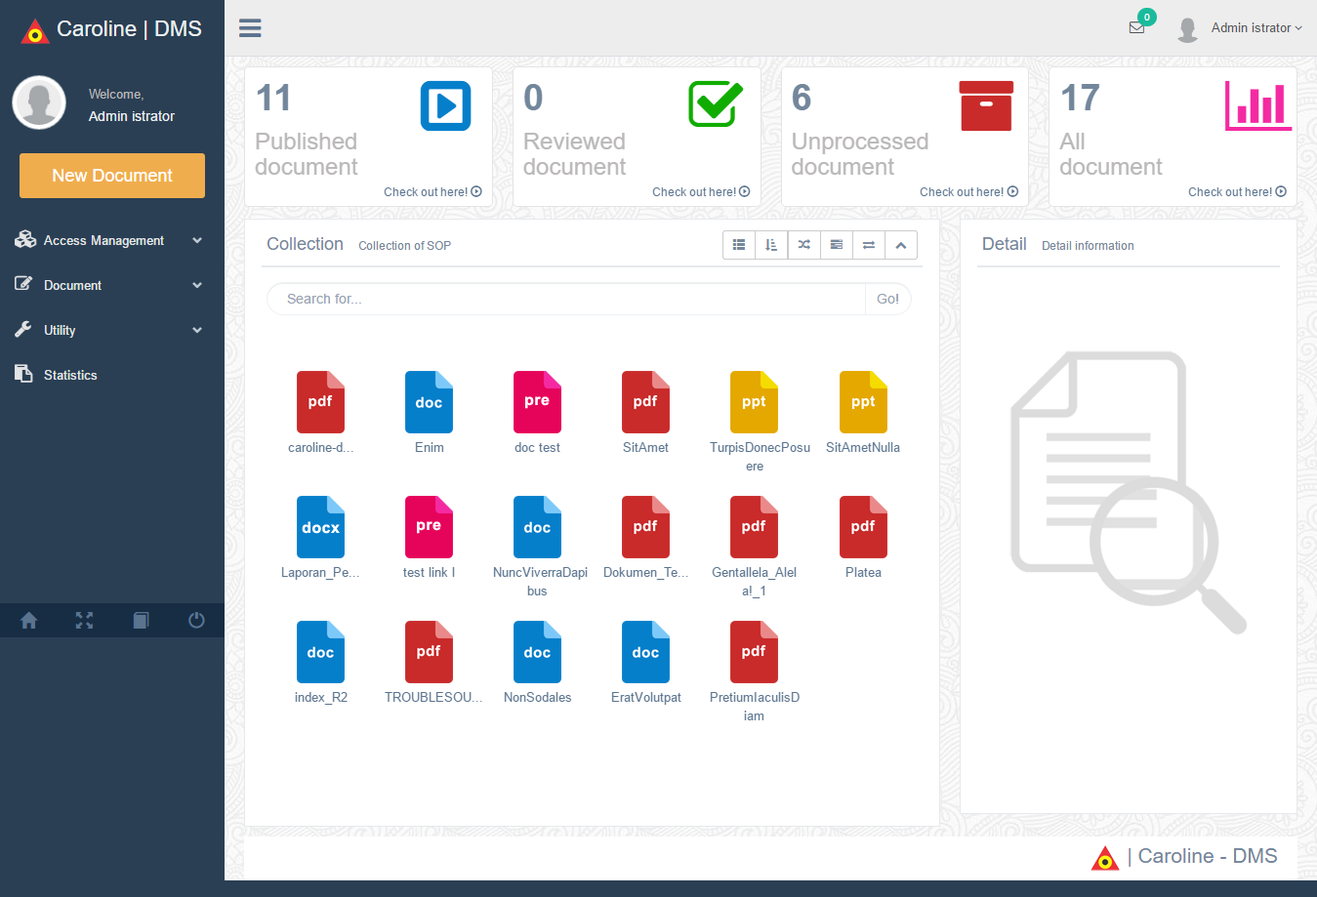
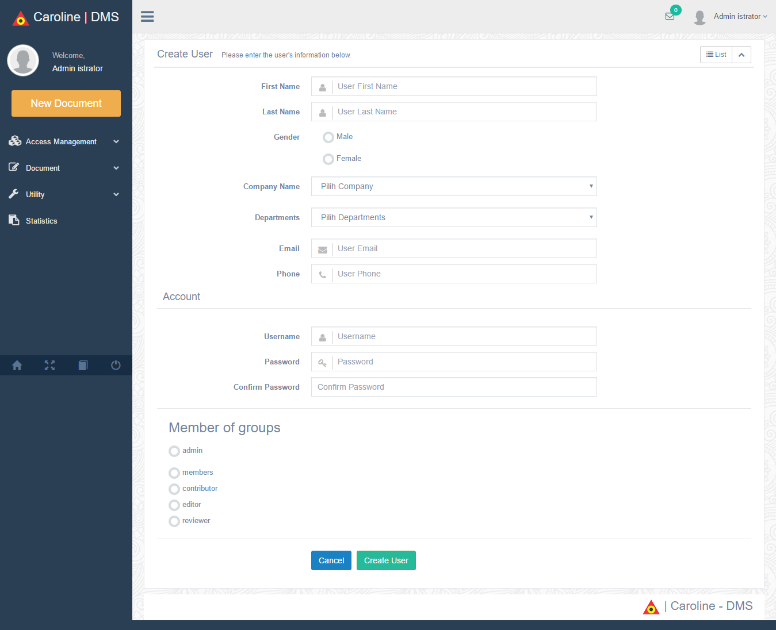

IT PROJECT EXPERIENCE 5

Project Name | Management Information Systems Licensing Broadcasting / SIMP3 KOMINFO
Project Description | Management information system of broadcast licensing is used to open up business opportunities for entrepreneurs who want to make the permission of broadcasters both television and radio, in this system there are three important features that permits for new applicants, license extensions and changes to the data.
Period (mm-yyyy) | April-2016 | Until | Oktober-2016
Company Name | PT Axelinsights and PT Tritech Consult Indonesia
Client’s Name | KEMKOMINFO RI
Role/ Position | Web Developer
Programming Language | Php Framework Codeigniter 3
Database | Mysql Phpmyadmin
Development Tools | XAMPP,Sublime Text, source tree , navicat, and trello
Description of personal job assignment | - make almost all applications, especially related to the business of the licensing process  - Make database  - Proses Business analysis
Developer Team | - 1 IT Project Manager
 | - 1 IT Analyst
 | - 1 Software Tester
 | - 2 Programmer
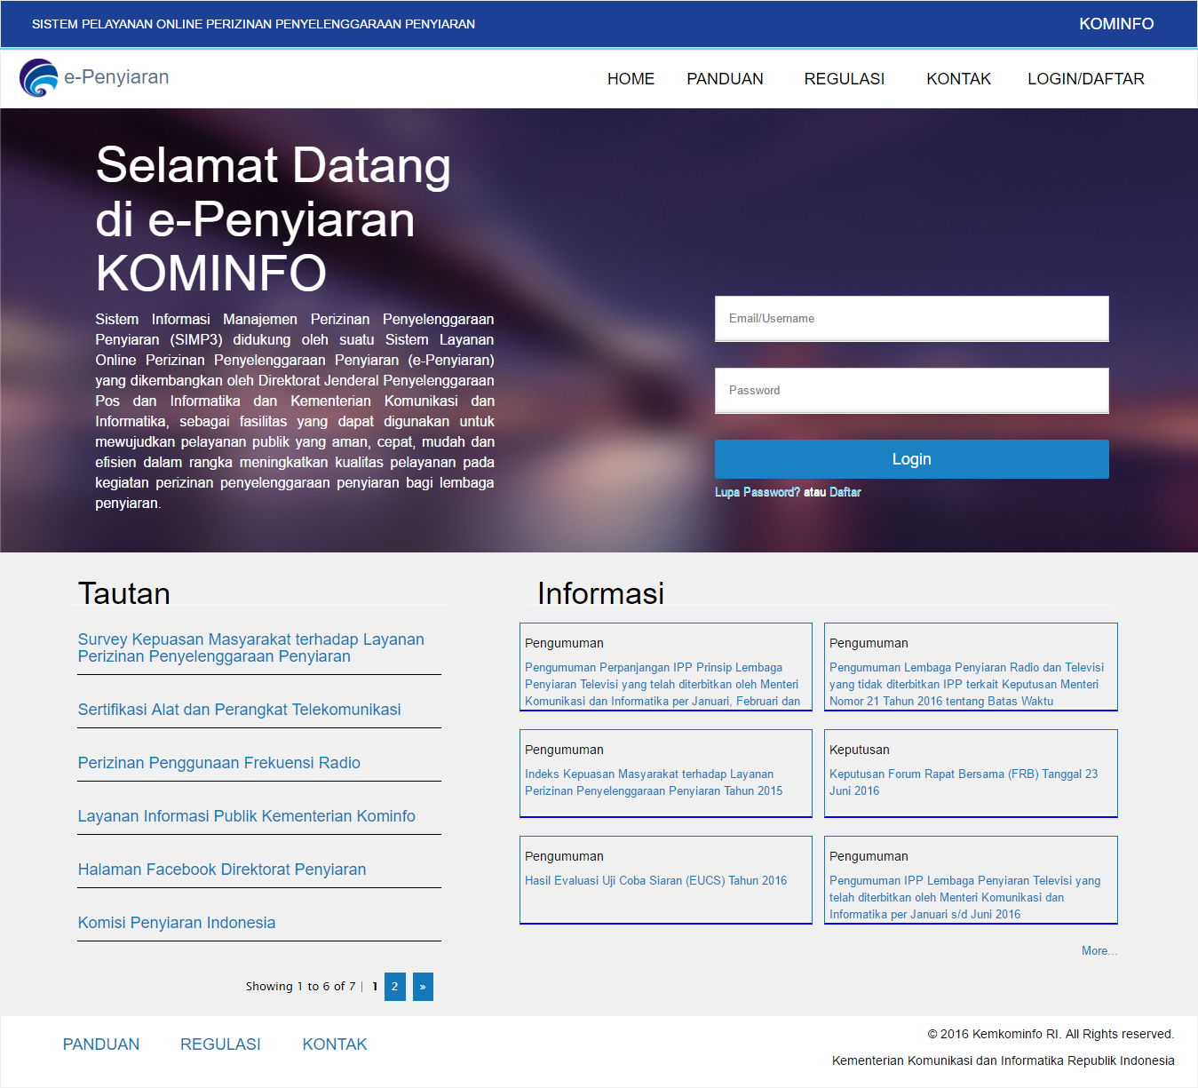
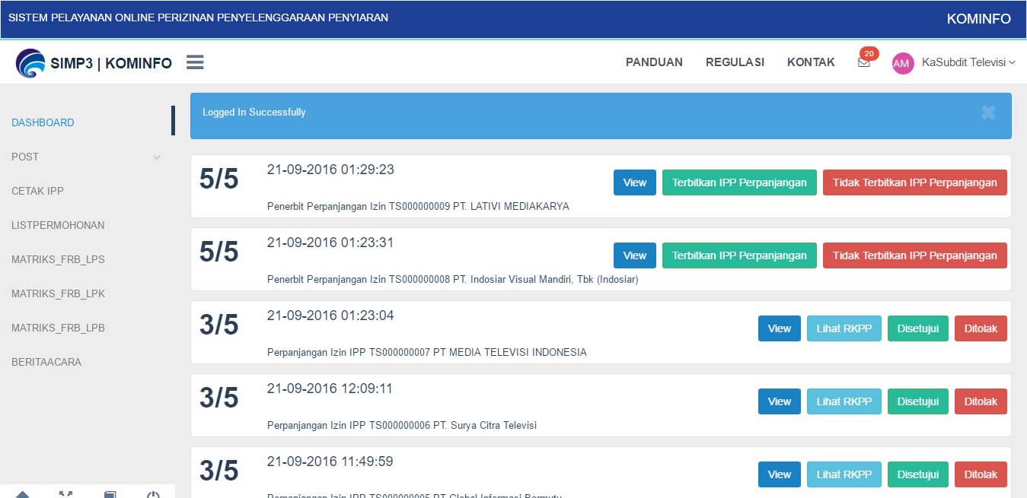
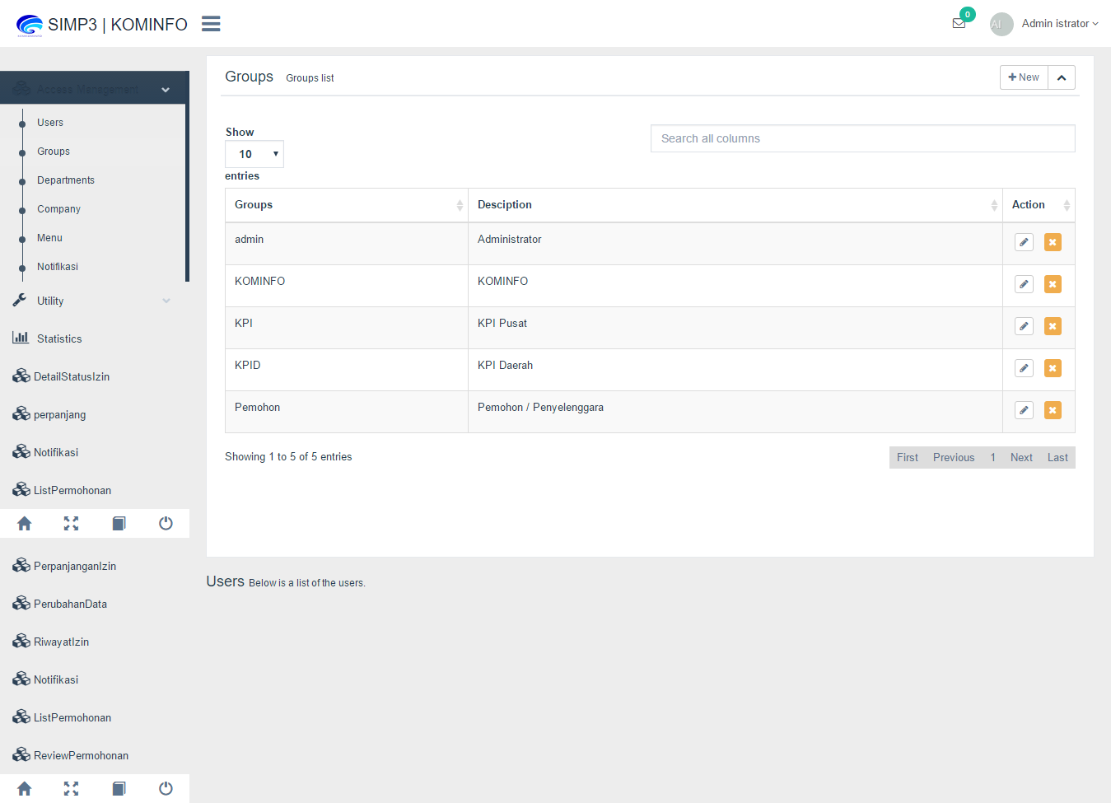
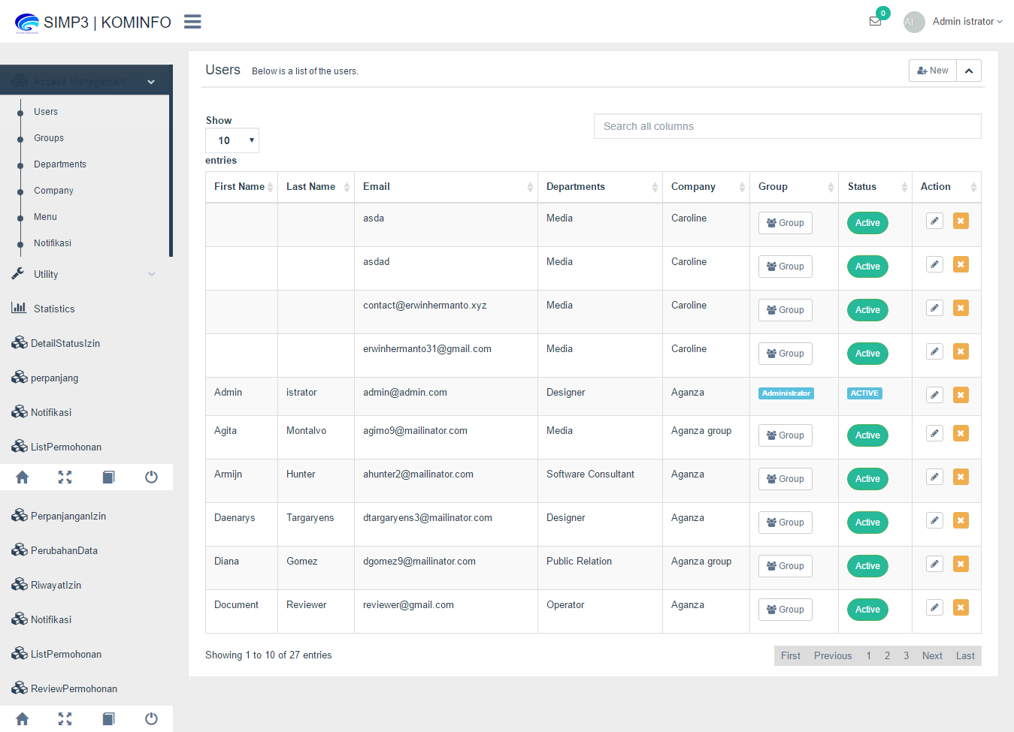

IT PROJECT EXPERIENCE 6

Project Name | Sistem Kerja Audit Internal
Project Description | This application helps in BJB Syariah Bank audit process, from the examination process the paperwork until the budget plan.
Period (mm-yyyy) | November-2016 | Until | Januari-2017
Company Name | PT Cakra Syntesis Indonesia
Client’s Name | Bank BJBSyariah
Role/ Position | Main Web Developer
Programming Language | Php Framework Laravel 5.3
Database | PgSql
Development Tools | XAMPP,Sublime Text, source tree , navicat, and trello
Description of personal job assignment | - make almost all applications, especially related to the business of the licensing process  - Make database  - Proses Business analysis
Developer Team | - 1 IT Project Manager
 | - 1 IT Analyst
 | - 1 Software Tester
 | - 2 Programmer

