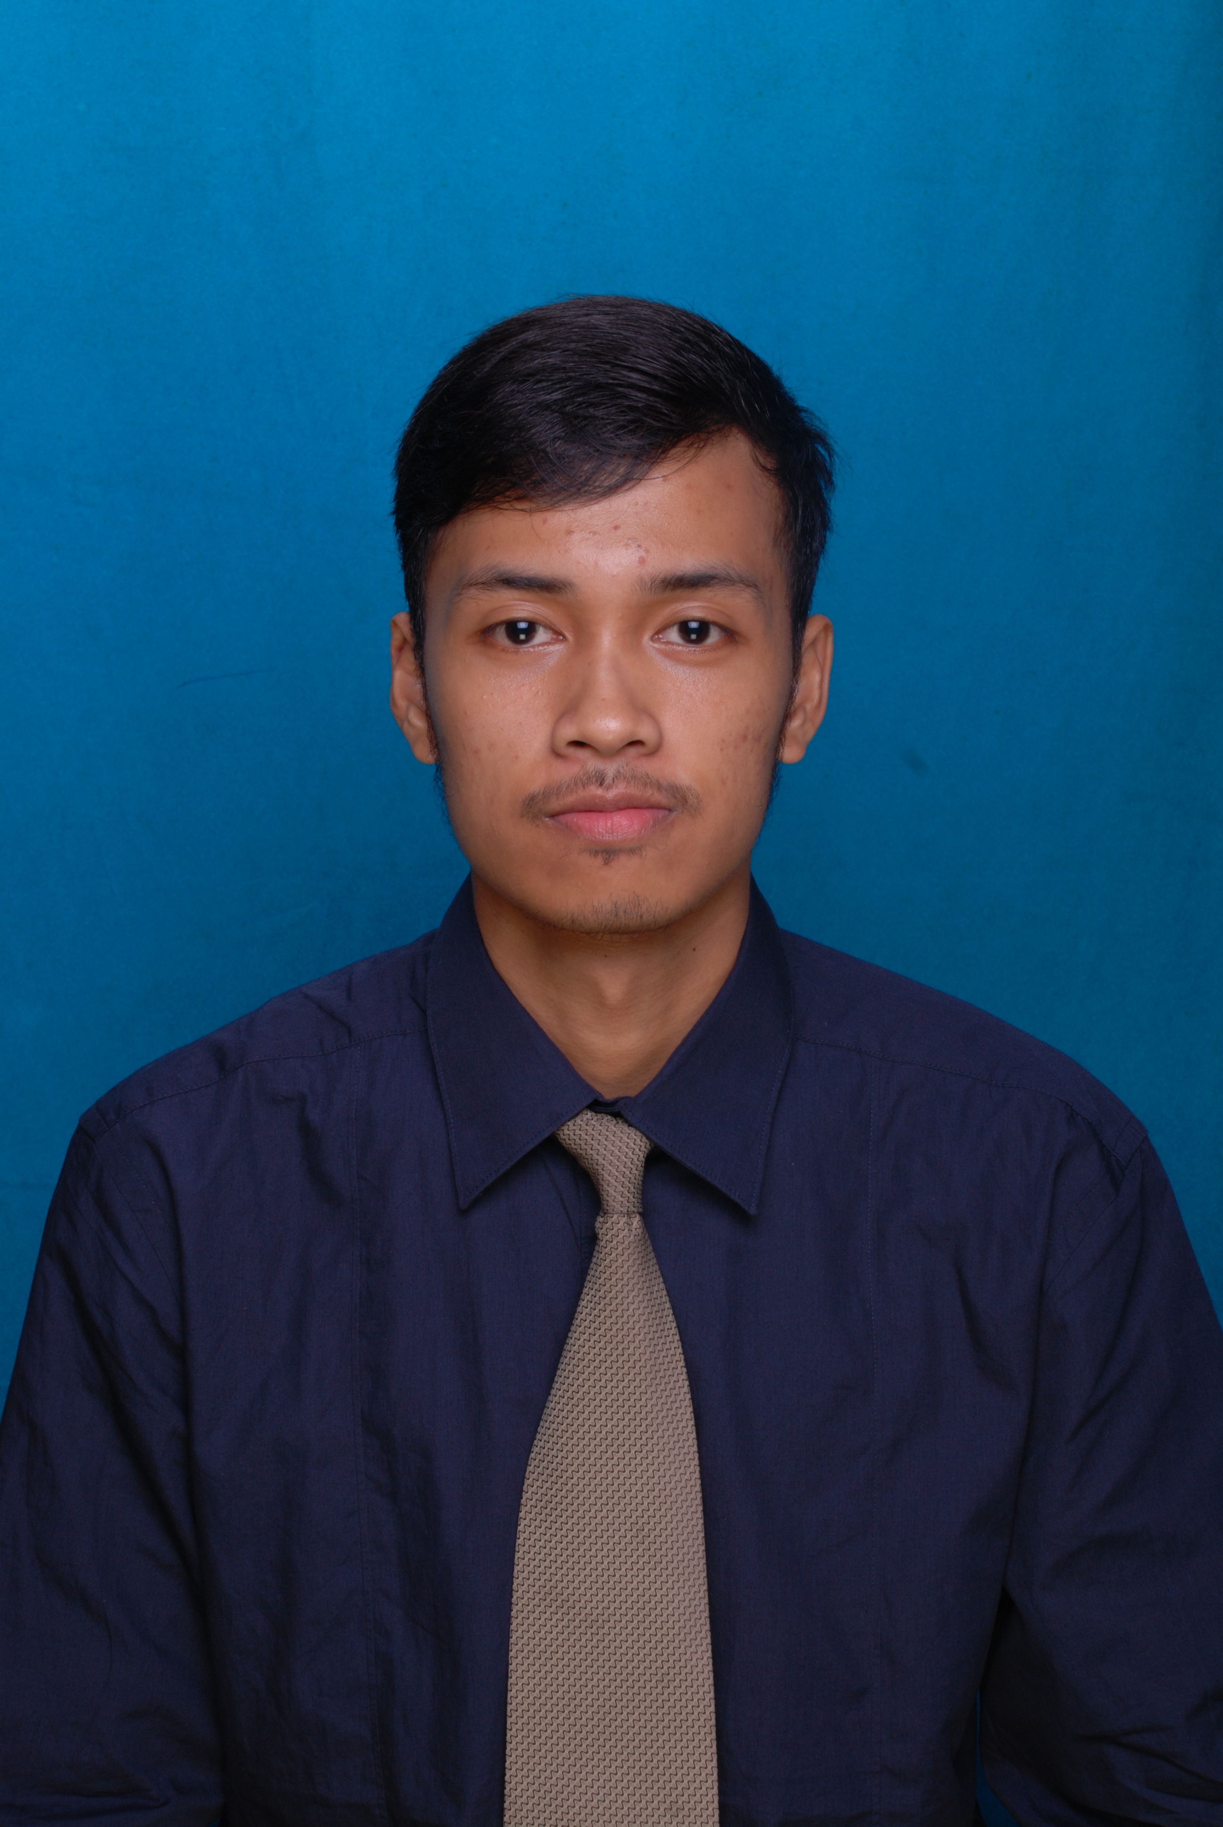
Curriculum Vitae

PERSONAL IDENTITY
Name | Yulius Triatmoko
Place, Date Of Birth | Semarang, May 30th, 1992
Nationality | Indonesian
Sex | Male
Religion | Catholic
Blood type | AB
Address | Pondok Hijau Golf, Cluster Garnet, Garnet Timur 3/66, Summarecon, Serpong Tangerang
E-Mail | tri_yulius@yahoo.co.id
Mobile Phone | +6285747017717
Marital Status | Single
GPA | 3.01 (Scale 4.00)

Education
No | Education Institution | Location | Year
`1. | Science of Communication, Journalism, Multimedia Nusantara University | Tangerang | 2010-..
2. | SMA Taruna Nusantara | Magelang | 2007-2010
3. | SMP Pangudi Luhur 1 Yogyakarta | Yogyakarta | 2004-2007
4.  5. | SD Kanisius Demangan Baru  SD Pangudi Luhur Don Bosko Semarang | Yogyakarta  Semarang | 2000-2004  1998-2000

ORGANIZATION EXPERIENCES
No. | Experiences |  | Position | Year
1. | “Kompas Sport” Kompas TV (Internship) |  | Production Assistant | Jun-Aug 2013
2. | “ULTIMAGZ” Campus Magazine |  | Reporter of Sport Desk | 2012-2013
3. | “UMN Radio” Campus Radio |  | Operator & Reporter | 2010-2011
4. | Multimedia Nusantara University Footsal |  | Player | 2010-2012
5. | ''Gladi Dasar VII'' Solo 2011 |  | Photographer | 2011
6. | Volunteer of Earthquake in Jogja | Staf of Logistic |  | 2006

REWARDS AND ACHIEVEMENTS
No. | Event | Achievement | Notes
1. | Canon Photo Marathon Indonesia 2011 | Participant | 2011
2. | “Memotret Sepak Bola” Liga Kompas Gramedia 2010 | Participant | 2010
3. | “Photo talk” Communication Festival 2012 | Big 10 | 2012
4. | IKASTARA CUP BANDUNG 2013 Footsal | Winner | 2013
5. | Atma Jaya “GEN-X in Action 2012 Mini Soccer | Runner up | 2012
6. | Compress Modeling Photo Contest | Big 10 | 2014

ABILITIES
1. | Operating computer program : Final Cut Pro, Adobe Premiere, Adobe Audition, Ms. Word, Ms. Excel, Ms. PowerPoint,
2. | Passive and active in English
3. | Photography and Videography
4. | Working in both individual and team

