CURRICULUM VITAE

PERSONAL DATA:  FULL NAME : BENNY BAIJUMI KARDJAN  Address : 514-0001 (Postal Code)  Mie Ken, Tsu Shi Edobashi I-Chome 92  Bannchi 27, Mezonriveru A-107  Mobile : 050-6868-7802  e-mail : beebaykard@gmail.com  Marital Status : Married  Date of Birth : 20/December/1977  Gender : Male  Country of Origin : Indonesia | 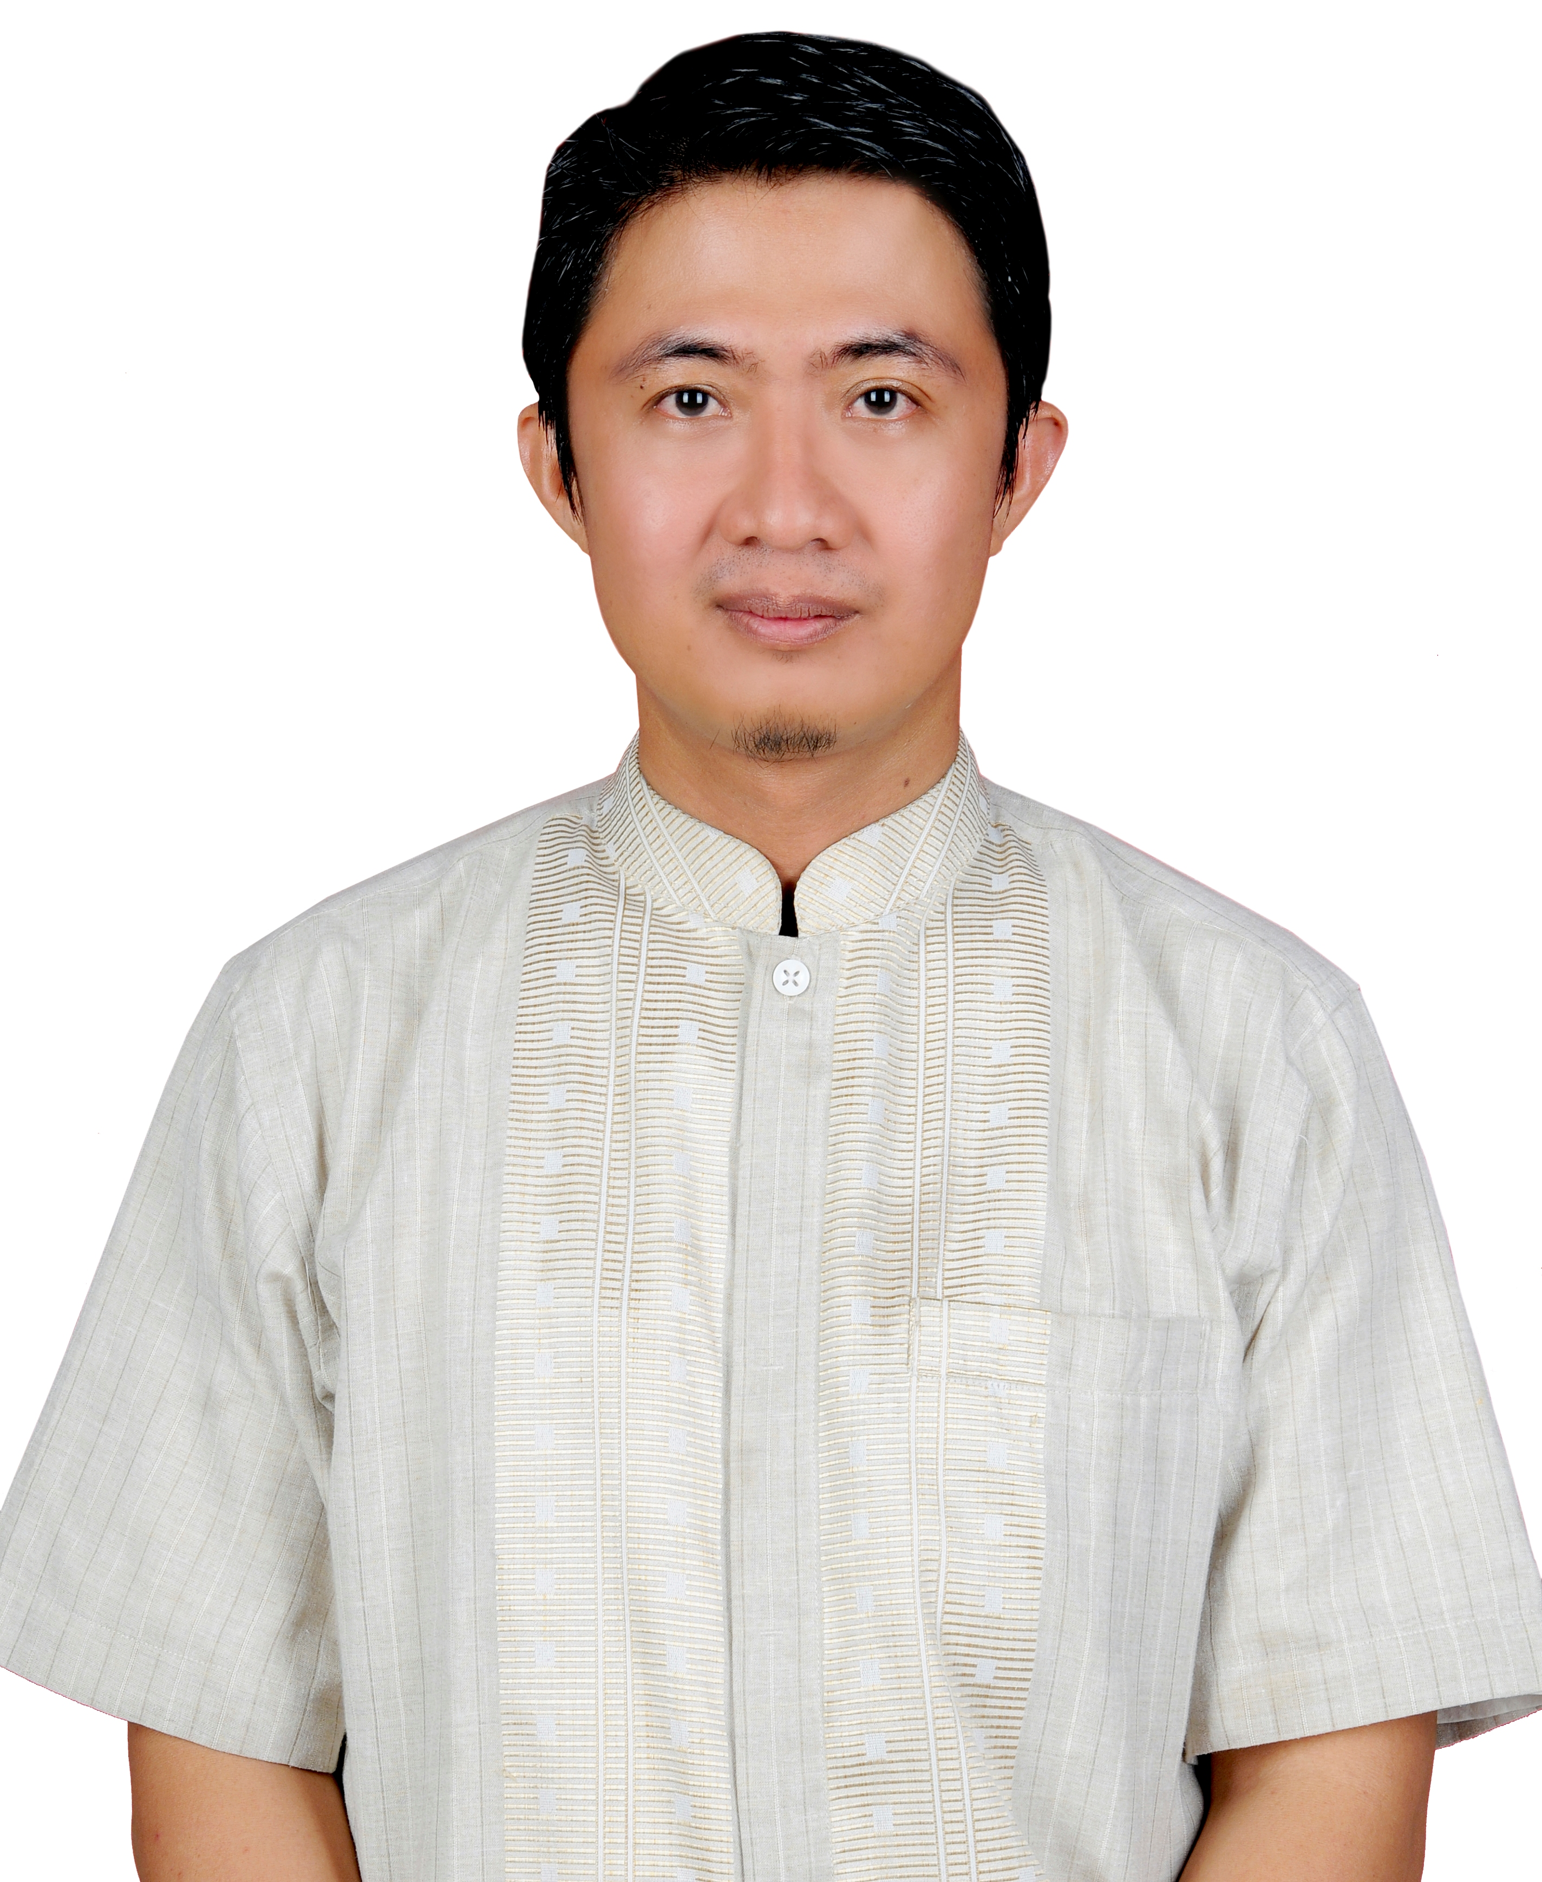

EDUCATION:

I. Formal Education
Period/Year |  |  | School / University
1983 | - | 1989 | Elementary School Number 61 Bengkulu
1989 | - | 1992 | Junior High School Number 6 Bengkulu
1992 | - | 1995 | Senior High School Number 2 Bengkulu
1995 | - | 2002 | Faculty of Economic, University Bengkulu

II. Non Formal Education / Training – Seminar
Year | Institutions | Clasification / Training
1993 | Walhi Bengkulu | Basic Organitation
1994 | PKBI Bengkulu | Reproduction Health Training for Beginners
1996 | PKBI Yogyakarta | National Outreach Training of Marginalized Group
1997 | PKBI Surabaya | National Training of Trainer for Reproduction Health
2001 | RRI Bengkulu | 7 Days of Announcer and Broadcasting Training
2002 | BTv Bengkulu | Television Reportage
2004 | Rakyat Bengkulu Newspaper | Basic Training in Journalism
2006 | Rakyat Bengkulu Newspaper | Writing and Reportage Training on Conflict Area
2013 | PWI - Dirjen Dikbud | National Training and Seminar for Culture Reporter

WORK HISTORY:
Period |  |  | Institution / Company | Position
2015 | - | 10/2015 | Sumsel Post Newspaper and Online | Managing Editor
2010 | - | 2014 | Radar Bengkulu Newspaper | Managing Editor
2010 | - | 2014 | Radar Bengkulu Newspaper | Advertising Manager
2004 | - | 2010 | Rakyat Bengkulu Newspaper | Journalist
2001 | - | 2004 | Indonesian Republic Radio Program 2 Bengkulu | Program Coordinator
1997 | - | 2004 | NGO – CCRR PKBI | Main Coordinator
1995 | - | 1997 | NGO – CCRR PKBI | Division Coordinator
1993 | - | 1995 | NGO – Friend of The Earth Indonesia/Walhi Bengkulu | Member
1989 | - | 1993 | Cultural Park Bengkulu | Member

