CURRICULUM VITAE
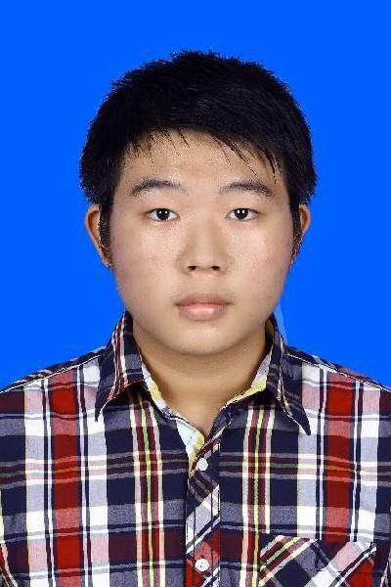
PERSONAL INFORMATION
Name : Rendy Saputra
Date Of Birth : Jambi, August 26th, 1995
Religion : Buddha
Gender : Male
Address : Jalan Masjid Al-Farouq Number 42
Depok, West Java
Current GPA : 3.57 of 4.00
Phone : +6289624508218
Email : rendy.saputra_ti2013@yahoo.com

EDUCATION
- University : University of Indonesia
Graduated Year : (until present)
- Senior High School : Xaverius 1 Jambi Senior High School
Graduated Year : 2013
- Junior High School : Xaverius 1 Jambi Junior High School
Graduated Year : 2010
- Elementary School : Xaverius 2 Jambi Elementary School
Graduated Year : 2007

ORGANIZATIONAL EXPERIENCE
- Keluarga Mahasiswa Buddhis Universitas Indonesia
Period : 2015
Position : Head of Research and Evaluation Department
- Ikatan Mahasiswa Teknik Industri
Period : 2014
Position : Staff of Research and Development Division
- Keluarga Mahasiswa Buddhis Universitas Indonesia
Period : 2014
Position : Staff of Research and Evaluation Department

COMMITTEE EXPERIENCE
- Malam Keakraban KMBUI 2014
Position : Staff of Funding Division
- Malam Keakraban TI 2014
Position : Staff of Equipment Division
- Dari UI Untuk Jambi X
Position : Staff of Equipment Division
- Lomba Keilmuan Teknik Industri 2014
Position : Staff at Equipment Division
- Waisak KMBUI 2014
Position : Staff of Accomodation,Transportation, and Security Division
- Pekan Penghayatan Dharma KMBUI 2014
Position : Head of Equipment Division
- Kathina KMBUI 2014
Position : Staff of Equipment Division
- Bakti Sosial KMBUI 2015
Position : Head of Equipment Division
- Lomba Keilmuan Teknik Industri 2015
Position : Head of Equipment Division

JOB EXPERIENCE
- Ergonomics Centre Laboratory Assistant
Period: March 2015- present

ACHIEVEMENT/SCHOOLARSHIP
- Oracle Supply Chain Management Training Certificate (January-February 2015)

SKILLS
Language | Bahasa Indonesia (first language)
 | English (US) (fluent both oral and written)
Computer | Microsoft Office Basic Skill
 | Autodesk AutoCAD and Inventor Basic Skill
 | Adobe Photoshop Basic Skill
Softskill | Good at time management
 | Good at leading team
Seminar | Seminar Pengembangan Wawasan Industri: "Quo Vadis Transportation Planning: Intregated Mass Transportation System and Low-Cost Green Car"
I declare that the details stated above are true.

Best Regards,

Rendy Saputra

