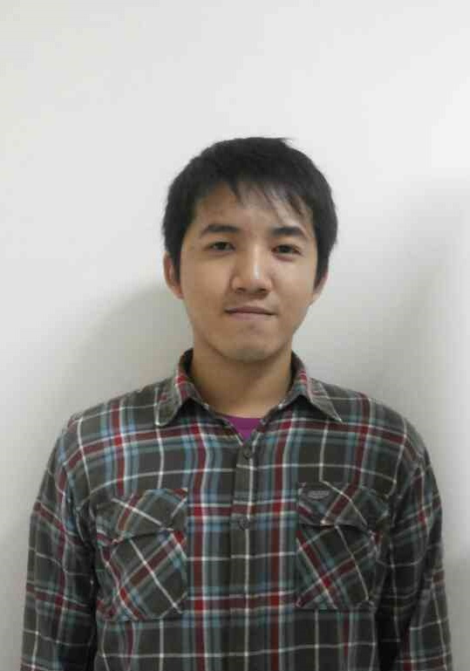
EDUCATION
INSTITUT TEKNOLOGI HARAPAN BANGSA, Bandung, Indonesia March 2016
Sarjana Sistem Informasi.
GPA 3.29

Certiplus Program December 2014
at ITHB Career Resource Center
Completed a series of professional training in computer, Simply Accounting and career planning skill

SAP University Alliance Program May 2014
at ITHB Career Resource Planning
Completed the SAP Introduction to SAP ERP with Global Bike Incorporation V2.1

EXPERIENCE
Information System Seminar “Youth in Action” at ITHB, Bandung January – April 2014
A seminar about Entrepreneurial Opportunities and E-Business Incubation with Speaker Mr. Hendrik Tio – CEO (Chief Executive Officer) of Bhinneka.com and Mr. Natali Ardianto – CTO of Tiket.com
Advisor of the Committee
Gave advice and monitoring the committee to make seminar run successfully
- Successfully mentored the committee to hold the event run smoothly.

ITHB, Bandung August – December 2013
Courses that teach about the basic operation of the Java programming language.
Assistant Lecturer of Java Fundamental I
Taught about Java Fundamental I to entire 2013 Information System student
- Nearly 90 percent of the students, passed from this course and understand how to apply outside of class hours.

Information System Seminar “The Young Technopreneur” at ITHB, Bandung August – November 2012
A seminar about how to be a Young, Creative and Responsible Technopreneur. With Speaker Mr. Muhammad Lukman- CDO (Chief Design Officer) of Pixel People Project as known as Batik Fractal and Mr. Vidiyama Sonekh – Business Director at XMGravity and Technical Advisor at Internet Survey Indonesia.
Head of Committee
Managed the entire seminar committee to made seminar run successfully
- Successfully managed the seminar how to be a Young, Creative and Responsible Technopreneur for public.

ORGANISASI SISWA INTRA SEKOLAH at SMAK TALENTA, Bandung July 2009 – June 2010
A student association consist of Senior High School student to leaded, arranged and organized events held for a year.
Head Chairman
Managed the organization to held various events
- Successfully managed the organization to make various events at the school for a year.

ADDITIONAL INFORMATION
- Highly proficient in the following technologies:
Database : MySQL
Operating Systems : Windows server, Linux, UNIX
Application : Microsoft Office Word, Visio, PowerPoint, Access
Application Development and Programming Technologies: Java and VB.Net
- Achieved TOEFL Practice Test Score (2012) : 465

