Curiculum Vitae

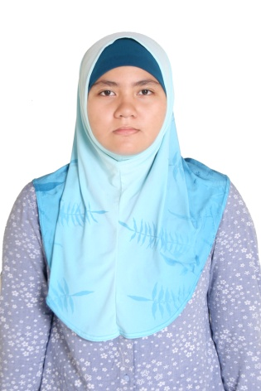
Name : Melati Hupasandha Risangmaya
Date of Birth : Surabaya, September 1st 1995
Nationality : Indonesian
Gender : Female
Religion : Moeslim
Addres : Jalan Teknik Geodesi P-5 ITS Surabaya
Phone : 087855720260
E – mail : risangmaya@gmail.com
Hobby : Swimming, reading, and writing

Formal Education
Year | School
2001 – 2007 | Public Elementary School Kertajaya XII Surabaya
2007 – 2009 | Public Junior High School 1 Surabaya
2009 – 2012 | Public Senior High School 2 Surabaya
2012 – now | Industrial Engineering,  Institut Teknologi Sepuluh Nopember

Informal Education
Year | Intitution
1998-2008 | Hiu Swimming Club
2000-2005 | Melodia Music Course
2006-2007 | Primagama Education Course
2008-2010 | YPIA English Course
2008-2009 | Primagama Education Course
2010-2012 | Sony Sugema Education Course
2013-now | English First

Organitation Experiences
INSTITUTION | POSITION | YEAR
Student Council of Public Junior High School 1 Surabaya | Staff division of Appreciation and Art Creation | 2007//2008
Industrial Engineer Student Association FTI – ITS | Staff departement of Media and Information | 2013/2014

Training Experiences
INSTITUTION | ACTIVITY | YEAR
Public Junior High School 1 Surabaya | Basic Leadership Training of Student Council | 2007
Public Senior High School 2 Surabaya | Jurnalistic and Photography Training | 2011
ITS | ESQ Leadership Training | 2012
Executive Council of Student FTI -ITS | Pre- Basic Leadership and Management Student Training | 2012
Industrial Engineer Student Association FTI – ITS | Scintific Paper Training  Basic Jurnalistic Training  Basic Leadership and Management Student Training  Design Training | 2012  2012  2013  2013
Executive Council of Student ITS | Media School | 2014
Laboratorium of System Manufactur | AUTOCAD Software Training | 2012
Laboratorium of Ergonomic and Work Designing | 3D MAX Software Training | 2014
Laboratorium of Computation and Optimation Industry | Arena Software Training | 2015
Scout Divers of Indonesia | One Star Diving Training | 2015

COMMITTEE
INSTITUTION | ACTIVITY | YEAR
Student Council of Public Junior High School 1 Surabaya | - Division of Art at Open Air Public Junior High School 1 Surabaya | 2007
Student Council of Public Senior High School 2 Surabaya | - Coordinator Committee of Orientation School Public Senior High School 2 Surabaya  - Secretary of Class Meeting | 2010  2010
Executive Council of Student ITS | - Publication and Documentation of ITS for Future Indonesia (IFFI)  - Vice Coordinator Operating Committee of Publication and Dosumentation for Gerigi ITS  - Instructor Committee for Gerigi ITS | 2013  2013  2014  2014
Industrial Engineer Student Association FTI – ITS | - Head of Committee for Basic Jurnalistic Training  - Steering Committe for Orientation of Industrial Engineer Student (SISTEM)  - Staff of Media, Publication and Documentation Committee for IE FAIR  - Head of Publication and Documentation Committeefor Design Training  - Head of Publication and Documentation Committee for Basic Leadership and Management Student | 2013  2013  2013  2013  2014

ACHIEVMENT
INSTITUTION | TYPES OF AWARDS | YEAR
Indonesia Swimming Union | - 3rd Place 50 m Backstroke Age Group 95 HUT Surabaya City  - 1st Place 50 m Butterfly Age Group 95 HUT Surabaya City  - 1st Place 50 m Freestyle Age Group 95 HUT Surabaya City  - 3rd Place 50 m Breaststroke Age Group 95 HUT Surabaya City  - Peserta Terbaik MOS  - 3rd Place Waterpolo National Championship  - 3rd Place Indonesia Waterpolo League | 2003  2003  2003  2003  2003  2010  2010

