Curriculum Vitae

Personal Information
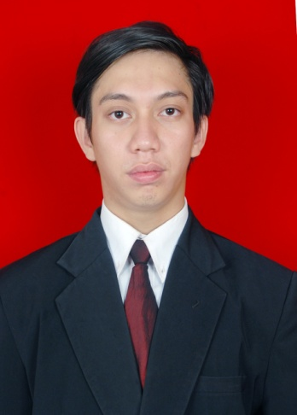

Name | : | Dzikri Akbar
Place, Date of Birth | : | Jakarta, June 16th1991
Gender | : | Male
Present Address | : | Jalan Guru Serih Raya No.09, RT.09, RW.10, Kelurahan Kalisari, Kecamatan Pasar Rebo, Jakarta Timur
Mobile Phone | : | 0878 8632 6708
Home Phone | : | 021- 8706188
E-mail Address | : | dzikriakbar91@yahoo.com ; dzikriakbar91@gmail.com
Nationality | : | Indonesian
Religion | : | Islam
Marital Status | : | Single
Blood Type | : | A+
Nationality | : | Indonesia

Educational Background
September 2009 – November 2013 | : | Bina Nusantara University, West Jakarta; Faculty of Computer Science;  Majoring Information Technology;Speciality of Software Engineering;  Graduated with overall GPA 2,56
July 2006 – June 2009 | : | Senior High School at SMA Islam Al Ma’ruf, East Jakarta
July 2003 – June 2006 | : | Junior High School at SMP Negeri 179, East Jakarta
July 1997 – June 2003 | : | Elementary School at SD Negeri 01, East Jakarta

Informal Education
February 2012 | : | “Treasurer Training”; held by SCDC of BINUS University
December 2011 | : | “Latihan Keterampilan Manajemen Mahasiswa” for Leaders;  held by SCDC of BINUS University
September 2011 |  | “Secretary Training”; held by SCDC of BINUS University
July 2011 | : | “Latihan Keterampilan Manajemen Mahasiswa”41 ;  held by SCDC of BINUS University
February 2010 | : | “Laihan Dasar Kepemimpinan”; held by SWANARAPALA (Mahasiswa Bina Nusantara Pecinta Alam)
October 2009 – July 2011 | : | “Pendidikan dan Latihan Pecinta Alam” include SAR (Search and Rescue);  held by SWANARAPALA (Mahasiswa Bina Nusantara Pecinta Alam)

Organization Experiences
January 2013 – now | : | Division Head of Rock Climbing SWANARAPALA (Mahasiswa Bina Nusantara Pecinta Alam)
January 2012 – January 2013 | : | Chairman of SWANARAPALA (Mahasiswa Bina Nusantara Pecinta Alam)
December 2011 –September 2013 | : | Education and Training Instructor of SWANARAPALA (Mahasiswa Bina Nusantara Pecinta Alam)
July 2010 – Januari 2012 |  | Secretary of SWANARAPALA (Mahasiswa Bina Nusantara Pecinta Alam)
December 2009 – June 2010 | : | Public Relation of SWANARAPALA (Mahasiswa Bina Nusantara Pecinta Alam)
November 2010 – December 2010 | : | Logistic Division of PORSINARA (PekanOlah Raga danSeni Bina Nusantara)
July 2007 – June 2008 | : | Leadership and Disciplinary Division of Student Council SMA
July 2003 – July 2006 |  | Members of Pramuka SMP

Job Experiences
January 2014 – now | : | PT Batu Sarana Persada.  Administration Staff  Job Description:  - Input Sales Data.  - Make a Delivery Order.  - Make a Sales Report.  - Controling Sales  Others:  - Input and Controling Petty Cash Dump Truk.
March 2012 – June 2012 | : | Departemen Kebudayaan dan Pariwisata  Junior Application Developer (for apprentice program)  Job Description:  - Supporting application development.
Computer, Technical, and Social Skills
Computer Skill: Windows Operating System, Microsoft Office (Microsoft Word, Microsoft Excel, Microsoft Power Point, Microsoft Visio), MySQL

Social Skill: I able to work both in team and individual very well, associate with anyone very well, could adapt easily in new environment, fast learner, and analytical thinking.

Interests and Hobbies
Interests: website analytic, website content management, text copywriting, website news, learning new things.

Hobbies: event organizing, swimming, playing football, outdoor activities (hiking, climbing) , writing story, people development, looking for somethings new.

I certify that all of the information and data made in this CV are true and correct, then this was made in good faith with my best knowledge.

I Interested in joining your company and I can learn more to develop my abilities if I join with your company. Thank you for taking time look at my curriculum vitae. I am waiting for a call interview.

