Curriculum Vitae

Personal Details
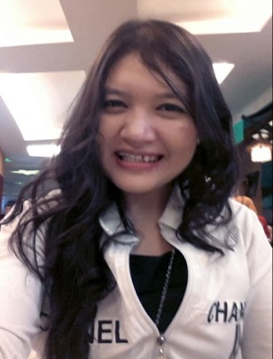
Name : Zoraya Bilqis
Address : Jl Bratang binangun IX/17 Surabaya
Phone : +62 81 23 999 8876
Email : zoraya.bilqis@gmail.com
Sex : Female
Date of Birth : December, 11th 1989
Nationality : Indonesia
Marital Status : Single
LinkedIn : id.linkedin.com/in/zorayabilqis

Personal Description
I love to meet new people, face the challenge, hardworking, confident, and enjoy working in a team.

Education Profile

- Formal Education
- 2012 : Bachelor Degree Major of Accounting, Airlangga University
- 2007 : Graduate Senior High School from SMA Negeri 5 Surabaya
- 2004 : Graduate Junior High School from SMP Negeri 6 Surabaya
- 2001 : Graduate Elementary School from SD Khadijah Surabaya

Ability
Languages: Good command of written and spoken English and Indonesia
Computer:
• Office Suite : MS Office
Others : Client servicing, presentation, event, corporate communication

Experience

Work Experience :
- Employee of Voila Indonesia as Senior Account Executive (June 2014 – present)
Client such as Sampoerna, Telkomsel, ANZ, Semen Indonesia, and Garuda Indonesia
Job description :
- Maintain good relationship with existing client
- Prospect new client, and educate them
- Create proposal for communication strategic planning, advertising, public relation program, and client’s campaign
- Develop overall program budget, including sales and competitor analysis, pricing and discount policy, marketing and sales strategy, distribution and activity plans
- Attend site meetings, provide after sales service support and follow up
- Achieve business target in terms of sales volume and revenue
- Supervising project
- Report to Account Manager

- Employee of Voila Indonesia as Account Executive (November 2012 – June 2014)
- Employee of Voila Indonesia as Finance&Accounting (January 2012 – October 2012)
- Employee of Voila Indonesia as Project Officer (October 2011 - December 2011)
- Employee of Jawa Pos as surveyor (September 2009 - December 2010)
- Event Organizer of DBL Indonesia Jawa Pos (November 2009 - September 2010)
- Event Organizer of DETEKSI CONVENSION Jawa Pos (September 2009 - December 2010)

Organization Experience :
Senior High School
1. Student Organization SMAN 5 Surabaya Surabaya (PMR)
Position : Public Relation Department (2005-2006)

Institute
1. Accounting Organization
Position : Human Resource Development. (2008-2009)

Project Experience :
- 2014 : Content Department at HelloFest 10, 2014
- 2014 : Client Service at Tupperware ELC Gathering Surabaya, Solo, and Malang
- 2014 : Client Service at Sampoerna 101th years Aniversary
- 2014 : Client Service at Telkomsel Extraordinary Gadget Party
- 2014 : Client Service at Retail Outlet Community (ROC) East Java, Telkomsel
- 2014 : Assitant Team Leader at Book Launching Road to Semen Indonesia
- 2013 : Team Leader at Huawei LFP Campaign – Car Free Day Bandung Surabaya
- 2013 : Client Service at Family Gathering RSUD dr. Soedono Madiun
- 2013 : Client Service at Sampoerna 100th years Anniversary
- 2013 : Team Leader Garuda Indonesia Gallery Opening at Ciputra World Surabaya
- 2012 : Treasury at Employee Appreciation and Motivation Day Sampoerna
- 2011 : Project Officer at Sampoerna Best Student Visit 2011
- 2011 : Project Officer at Sampoerna Internal Communication Contributor Workshop
- 2010 : Coordinator Food and Health Honda DBL East Java Series 2009
- 2009 : Secretariat Departmen at Axis DetEksi Convention 2008

