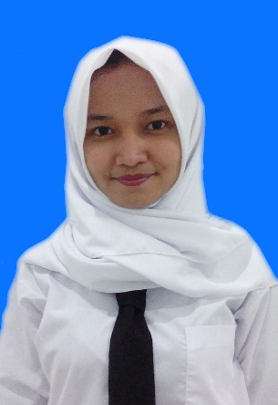

Deviani saskia putri

I am college student of Public Health, Diponegoro University Semarang. I am now in a organization in a field of Communication and English Development. I am very well with English, hard worker, and fast learner. Fluent in Bahasa and English.
Core Competencies :
Health knowledge ● English skills ● Public speaking ● Bussiness plan ● Digital marketing

Personal details

Place, Date of Birth : Jakarta, 27th December 1997
Home Address : KS Tubun IV/22 street, Slipi, West Jakarta
Current Adress : Jatisari V/12 street, Tembalang, Semarang
Handphone : 085780426063
Email : devianisaskia27@gmail.com
Blood type : 0
Life motto : Be (the best version of) yourself.

Education

2009 – 2012 111 Junior High School, Jakarta
2012 – 2015 78 Senior High School, Jakarta
2015 Faculty of Public Health, Diponegoro University Semarang

Organization / COMMITEE experience

2016 Youth Staff of CED (Communication and English
Development) BEM FKM UNDIP
2016 School of Speaking “English Conversation Class”
2016 PCMI Goes To Campus

Semarang, 20th August 2016

Deviani Saskia Putri

