CURRICULUM VITAE
Personal Details
Name : Rizaf Ahdiat
Place, date of birth : Makassar, April 26, 1991
Sex : Male
Address : Permata Harapan Baru Blok C1/21, Bekasi
Marital Status : Single
Religion : Islam
Height / Weight : 170cm / 58kg
Hobby : Travelling, playing music and singing, soccer, footsal,
Basketball, etc.
Mobile phone : 0821 9409 1369
e-mail : rizaf.ahdiat@gmail.com

Education Details
- 1996-2002 SDN 187 Bontomanai, Bulukumba.
- 2002-2005 SMPN 3 Bulukumba.
- 2005-2008 SMUN 6 Makassar.
- 2008-2012 Public Administration at Universitas Veteran Republik Indonesia (UVRI) Makassar. IPK 3.31 (scale 4)

Work Exprience
- PT. AXA MANDIRI (Sales (freelance))
- Megah Country Village (Marketing (freelance))
- PT. Bank Rakyat Indonesia (Sales KPR)

Skills
- Computer literate ( MS Office, MS Word, MS Excel, MS PowerPoint, Photoshop, Corel Draw).
- Work well in teams or individuals.
- Driving license A and C.

Strength
- Likes challenges and new things.
- Glad to hang out and make friens with anyone.
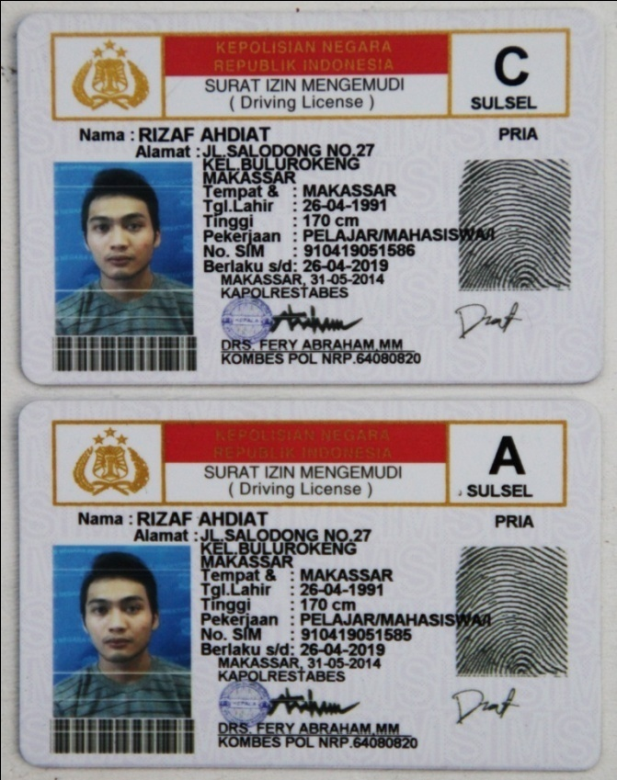
- Good communication and leadership.

