C:\Program Files (x86)\Microsoft Office\MEDIA\CAGCAT10\j0149481.wmfC:\Program Files (x86)\Microsoft Office\MEDIA\CAGCAT10\j0233018.wmf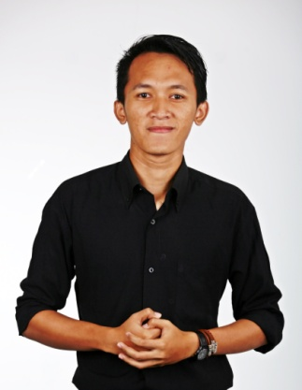

**Skill**

Communication

Facillitator

Teaching

Business Analyze

Writing

Marketing

Management Business

Accounting

Business

Sales & Management

Jurnalist

**Interest**

**Working Experience**

* **Internship Assisstant of Training Specialist Development (PT. Bank Negara Indonesia, Tbk.)**

Designing the module or Learning Master Course of training and analyzing concepts of training.

* **Education Improvement Facilitator (Yayasan Gerakan Indonesia Mengajar)**

Four areas of duty are curricular, extracurricular, community development, and regional involvement.

* **Copy Writer (Kompas Gramedia Surabaya)**

Interviewing and collecting data from client about the product which is writing in bulletin.

**Education**

Bachelor of Science 2009-2014

**Universitas Negeri Surabaya**

Graduate of Senior High School 2006-2009

**SMA Wachid Hasyim 2 Sidoarjo**

**Profile**

Realized that all my life, my values were based upon typical middle-class Indonesian values : hard work, doing good, living well, owning things, following the rules, and being the best I can be. I focus on improving six goals as follows : revenue, branding, lead generation, product on service sales, visitor conversions, ang engagement. Although I really think most projects can be broke down into five distinct areas.

**082231121191**

**Jl.Anggrek Desa Trosobo, Taman-Sidoarjo, 61257**

[**ardi_nesia@yahoo.com**](mailto:ardi_nesia@yahoo.com)

**www.therealardifai.tumblr.com**

ARDI RIFAI