CURICULLUM VITAE

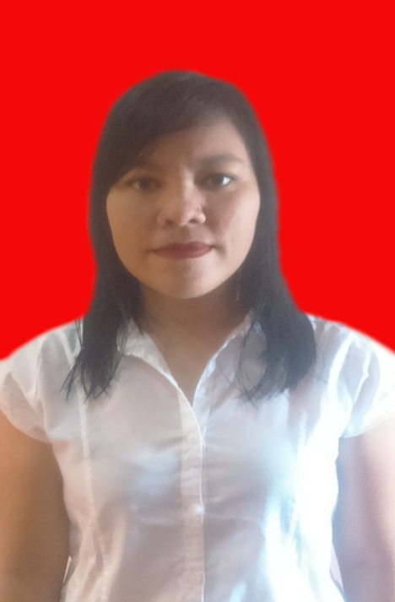
Donita Paskalina Tamba

Pekan Baru, September 05Th, 1989
Hp : 0813 9675 1245, Email donitapt@gmail.com donitapaskalina.blogspot.co.id
I stay at jl. tembok No 10 Pulo Gadung Jakarta Timur
My Hobbies is reading novel. Travelling, writing, cooking and all that make me happy. I love try new things (experience). Iam an independent. I want to learn many things, self confident. And I’ve no problems team working

Education
2009 - 2014 university HKBP Nommensen Medan, Becholer of Law.

Organizational experience
- 2011 BEM- Faculty of law HKBP NOMMENSEN Medan
- 2012-2013 Chairman LKPPH PERMAHI Medan
- 2014 sept – 2015 feb Chairman KOMPETENSI

work Experience
- Jan, 2014 - May 2014 Marketing in Asuransi sinarmas
- Des 2014 – April 2016 Staff HRD in Splash INternational

Skill
Analysis, control microsoft word and excel, internet, good english, good communication.

*I would like to be a successful only if you will have the courage to give me an opportunity

My Regards

Donita Paskalina Tamba

