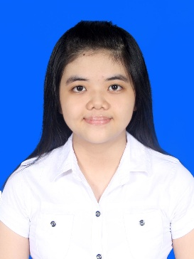
ERLINA

PROFILE
My name is Erlina. I am 19 years old. I am a person who like to try something new. I am interested in having new environment & friends. I am independent, hard worker and love challenges. I always try doing anything till the end.
Address : Jl. Jambi no 27-29E Medan
Email : erlinatung30@gmail.com
Phone : 087868025741

EDUCATION
2008 SD SWASTA SISINGAMANGARAJA TANJUNG BALAI
2011 SMP SWASTA SISINGAMANGARAJA TANJUNG BALAI
2014 SMA SWASTA SUTOMO 1 MEDAN

ORGANIZATION EXPERIENCE
2015 Mentoring

ADDITIONAL SKILLS
Microsoft word, Microsoft Excel, Microsoft Power Point, Vb. Net, English, Mandarin.

