CURRICULUM VITAE

**Personal Details**

Name : Riki Rizaldi

Gender : Male

Place and Date of the birth : HST, Kalimantan Selatan, 30th July 1997

Marital Status : Single

Religion : Islam

Address : Desa : Murung Panggang

Kecamatan : Amuntai Selatan

Kabupaten : Hulu Sungai Utara

Provinsi : Kalimantan Selatan

Negara : Indonesia

Nationality / Civil Status : Indonesia

E-mail : riki_rizaldi30@yahoo.com

Handphone Number : +62 82240731185

**Computer Softwares**

I can use microsoft office as Microsoft office and excel, Internet, adobe reader, and etcetera.

**Languages Skill**

-Bahasa Indonesia ( *Native* )

-Malayu (*Intermediate In speaking and fluent In understanding*)

-Banjar ( *Native* )

-English ( *Fluent In writing and understanding and Intermediate In speaking* )

-Arabic ( *Fluent In understandinng,elementary In listening,and Intermediate In speaking* )

**Formal Education**

2009-2012 MTs Darul Ilmi,Banjarbaru

2012-2013 MA Darul Ilmi,Banjarbaru

2013-2015 MA NIPA RAKHA (Islamic-studies programme), Amuntai.

**Informal Education**

2009-2013 Pondok Pesantren Darul Ilmi,Banjarbaru

2015 ELFAST, Pare on Writing and Translation programmes

2015 Manggala on the second-speaking programme

2015 Faster English on Speaking and Listening programmes

2016 ELFAST on IELTS programme

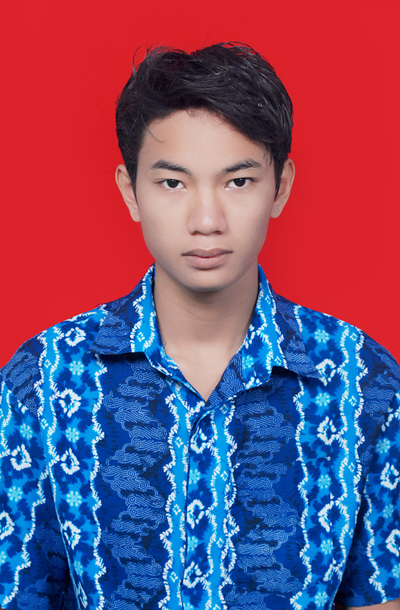

Yours sincerely,

Riki Rizaldi

**Awards and special skills**

|  |  |  |  |  |
| --- | --- | --- | --- | --- |
| **No.** | **Competition** | **Level** | **Year** | **Number** |
| 1 | MQK IV | Province | 2011 | The First Champion |
| 2 | Mufakat | Nationally | 2011 | Harapan I Marhalah Ula bidang Tarikh |
| 3 | Cerdas Cermat | Islamic college | 2012 | The secondary champion by group |
| 4 | Seleksi MQK V | District/Regency | 2014 | The Secondary Champion at marhalah wustho’ bidang Tarikh |
| 5 | Musabaqah Qira’atil Kutub on STIQ’s anniversary | District/Regency | 2014 | The Secondary Champion |
| 6 | Chess Competition | Islamic High School | 2014 | The First Champion |
| 7 | Chess Competition on Religion Department’s anniversary | District | 2015 | The First Champion |

**Activities / Interests**

**-Hobbies -Organization**

-Playing Chess - Muharrik Allughah (In 2013) as a Muhaddatsah part leader,

-Translating (Eng-Ind) (Arb-Ind) when I was studying In Islamic college.

-Listening Music