Curriculum Vitae

KARINA NUR WULANDARI

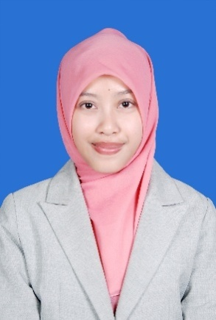
+62 81 321288901, wulandarikarin21@gmail.com
Setiabudhi Regency Wing I No. 36 A-4
RT 006 / RW 018, Kel. Ciwaruga, Kec Parongpong

Bandung 40559

AUTOBIOGRAPHY
Date Of Birth  Age  Sex  Marital  Religion  Nationality | Bandung, July 21st, 1992  22 years old  Female  Single  Islam  Indonesian

EDUCATIONAL BACKGROUND

Formal
2007 - 2010  2010 - 2014 | SMA Negeri 4 Bandung  S1 degree majoring in Livestock Science, Faculty of Animal Husbandry, Padjadjaran University, Jatinangor  GPA : 3,51 (Cum Laude)
Non-formal
2006 - 2007  2007 - 2008 | General english course, First Steps to Communicating in English and English for Adults : Elementary Levels at LBPP LIA Martadinata Bandung  General english course, English for Adults : Intermediate Levels at LBPP LIA Martadinata Bandung

WORK EXPERIENCES
2012  2013  2014  2015 | Apprentice at JIMMY’S FARM Pacet, Cianjur  Apprentice at Balai Inseminasi Buatan (BIB) Lembang, Bandung Barat  Online shop business  Fundraiser at World Wide Fund for Nature (WWF) Indonesia

ORGANIZATION EXPERIENCES
2007  2007  2011  2012 - 2013  2013-2014  2014 | Member of Writing Competition with theme “The Importance of Immunization for Health” at PT Bio Farma (Persero)  The Runner Up as a Class Representative for English Musical Poetry at SMAN 4 Bandung  Committee of “Kontes Ayam Pelung Piala Rektor Universitas Padjajaran”, Faculty of Animal Husbandry, Padjajaran University  Member of Kelompok Profesi Ternak Unggas (KPTU) Universitas Padjajaran, as a Staff from Division of Welfare Organization  Faculty of Animal Husbandry Scholarship  Member of “Bedah Tuntas Swasembada Daging Sapi dan Kerbau 2014” Talkshow

ADDITIONAL SKILLS
Language  Software | - English (oral and written)  ITP TOEFL : 483  - MS Office (Word, Excell, Power Point)

