DAFTAR RIWAYAT HIDUP

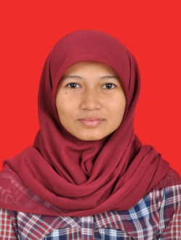
Ridha Sabrina, A.Md
Jl. Perkasa no. 22, Kuta Alam, Banda Aceh
HP : 081324487475
E-mail : ridhasabrina08@gmail.com

Data Pribadi
Data Pribadi

Tempat Lahir : Lhokseumawe
Tanggal Lahir : 05 Maret 1991
Jenis Kelamin : Perempuan
Agama : Islam
Status : Belum Menikah
Hobi : Membaca, Browsing, desain.
Kebangsaan : Indonesia

Pendidikan
Pendidikan

TK 3 Taman Siswa 1997 - 1998
SD 3 Taman Siswa 1998 - 2002
SD 1 YAPENA 2002 - 2003
MTsn Ma’had Alzaytun Indramayu 2003 - 2006
SMA YAPENA 2006 - 2009
DIII Manajemen Informatika Unsyiah 2009 - 2014

S1 FKIP Bahasa Indonesia 2008 - 2013

Kemampuan

- Mampu mengoperasikan komputer (Microsoft Office)
- Mampu mengoperasikan aplikasi desain grafis (CorelDraw dan Photoshop)
- Mampu mengoperasikan aplikasi animasi 2D (Adobe Flash CS4)

Pengalaman Kerja

- Bekerja sebagai admin CV 3003 (mitra TelkomVision), Banda Aceh

Hormat saya,

Ridha Sabrina, A.Md

